Reception week 34 Theme- Getting To Know Routines, ‘Handa’s Surprise’ and ‘The Princess and the Wizard’ Week Commencing: 08.06.20
Staff | Info | Focus Children
Mrs Griffiths and Mrs Batchelor bubble 1  Miss Andow and Mrs Derby bubble 2 | Mon- Fri- Bubble 1 all day  Wed- Fri- Bubble 2 home at 12 | Rotate the focus around the children in your bubble

Monday |  | Tuesday |  | Wednesday |  | Thursday |  | Friday
8:50  Soft start  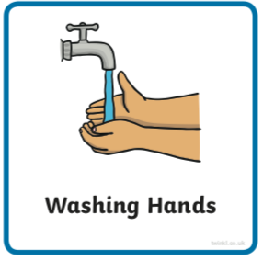 | Whilst chn arrive encourage them to use the image to create a conversation between the chn https://www.pobble365.com  Can you talk in full sentences? Can you make sure your sentence has a ‘who’ and a ‘what’ in it? Use your imagination as much as you like- there is no wrong or right! | 8:50 | https://www.pobble365.com | 8:50 | https://www.pobble365.com | 8:50 | https://www.pobble365.com | 8:50 | https://www.pobble365.com
9:00  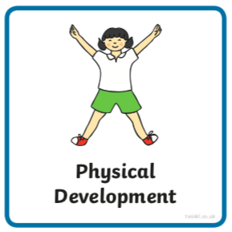  If these links don’t load find ‘Kids Get Moving’ channel on youtube | Adult led- Try this Harry Potter ‘Book of Spells’ workout to make sure you’re awake and ready for the day  https://www.youtube.com/watch?v=GZrvByulAHg&t=57s | 9:00 | Adult led- Try this Frozen ‘Elsa’s workout today  https://www.youtube.com/watch?v=R-dpQ2JjJCw | 9:00 | Adult led- Try this Star Wars ‘Jedi Training’ today https://www.youtube.com/watch?v=6wVo6HmfIds | 9:00 | Adult led- Try this super hero workout today  https://www.youtube.com/watch?v=TGex6z_t4Mk | 9:00 | Adult led- Try this Avenger’s training academy ‘Spiderman Workout’ today  https://www.youtube.com/watch?v=YC_V8hnU2PY
9:10- 9:30  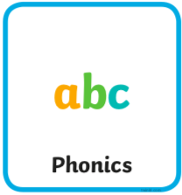 | Adult led- Phonics  See powerpoint | 9:30- 9:30 | Adult led- Phonics  See powerpoint | 9:10- 9:30 | Adult led- Phonics  See powerpoint | 9:10- 9:30 | Adult led- Phonics  See powerpoint | 9:10- 9:30 | Adult led- Phonics  See powerpoint
9:30- 10:30  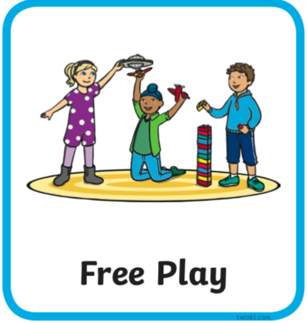 | Child led- Play in continuous provision  Resource idea- Bucket/ container of clean water and brush/ sponge can you ‘clean’ the (real) car? Or maybe clean/ ‘paint’ the shed/outside of your home?  Adult 1 child led- Support play (IMP*)  Adult 2 led- 1:1 reading | 9:30- 10:30 | Child led- Play in continuous provision  Resource idea- Instruments or pots, pans and spoons  Adult 1 led- 1:1 reading  Adult 2 child led- Support play (IMP*) | 9:30- 10:30 | Child led- Play in continuous provision  Resource idea- Double sided tape on card. Can you collect pieces of nature to attach?  Adult 1 child led- Support play (IMP*)  Adult 2 led- 1:1 reading | 9:30- 10:30 | Child led- Play in continuous provision  Resource idea- Chalk lines/ zones outside with number of points in and a ball/ scrumpled paper  Adult 1 led- 1:1 reading  Adult 2 child led- Support play (IMP*) | 9:30- 10:30 | Child led- Play in continuous provision  Resource idea- Table/ tuff tray with a label ‘observation station’. Can you find interesting things to add to the table for others to enjoy looking at?  Adult 1 child led- Support play (IMP*)  Adult 2 led- 1:1 reading
10:30/45- 11 | Playtime- All children outside | 10:30/45- 11 | Playtime- All children outside | 10:30/45- 11 | Playtime- All children outside | 10:30/45- 11 | Playtime- All children outside | 10:30/45- 11 | Playtime- All children outside
11:00  11:50 | Child led- Play in continuous provision  Adult 1 led- Writing groups (at home write a sentence using one of the pictures in phonics)  Adult 2 led- Writing groups  Tidy up | 11:00  11:50 | Child led- Play in continuous provision  Adult 1 led- Writing groups (at home write a sentence using one of the pictures in phonics)  Adult 2 led- Writing groups  Tidy up | 11:00  11:50 | Child led- Play in continuous provision  Adult 1 led- Writing groups  (at home write a sentence using one of the pictures in phonics)  Adult 2 led- Writing groups  Tidy up | 11:00  11:50 | Child led- Play in continuous provision  Adult 1 led- Writing groups  (at home write a sentence using one of the pictures in phonics)  Adult 2 led- Writing groups  Full tidy up inside and outside | 11:00  11:50 | Child led- Play in continuous provision  Adult 1 led- Writing groups  (at home write a sentence using one of the pictures in phonics)  Adult 2 led- Writing groups  Tidy up
12:00- 13:00  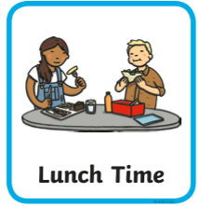 | Lunchtime | 12:00- 13:00 | Lunchtime | 12:00- 13:00 | Lunchtime | 12:00- 13:00 | Lunchtime | 12:00- 13:00 | Lunchtime
13:10- 13:30  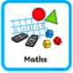 | Adult led- Maths  https://whiterosemaths.com/homelearning/early-years/  You will need to find ‘The Princess and the Wizard’ story on youtube | 13:10- 13:30 | Adult led- Maths  https://whiterosemaths.com/homelearning/early-years/  You will need 2 folded pieces of paper and some music | 13:10- 13:30 | Adult led- Maths  https://whiterosemaths.com/homelearning/early-years/  You will need some space to play two games | 13:10- 13:30 | Adult led focus- Maths  https://whiterosemaths.com/homelearning/early-years/  Use your WB or paper portrait. You many need to unifix to help you check you have 20 ingredients | 13:10- 13:30 | Adult led-Maths  https://whiterosemaths.com/homelearning/early-years/
13:30 | Child led- Play in continuous provision  Adult 1 child led- Support play (IMP*)  Adult 2 child led- Support play (IMP*) | 13:30 | Child led- Play in continuous provision  Adult 1 child led- Support play (IMP*)  Adult 2 child led- Support play (IMP*) | 13:30 | Child led- Play in continuous provision  Adult 1 child led- Support play (IMP*)  Adult 2 child led- Support play (IMP*) | 13:30 | Adult led- Physical exercise  - Daily mile  - Bikes on the field path  - Walk to the pond  - Parachute games  - Relays in the MUGA  - Track races on the field  - Roll the dice action game | 13:30 | Child led- Play in continuous provision  Adult 1 child led- Support play (IMP*)  Adult 2- Book changes and restocks
14:30  14:45 | Adult 1 Full tidy out  Adult 2 Full tidy in | 14:30  14:45 | Adult 1 Full tidy in  Adult 2 Full tidy out | 14:30  14:45 | Adult 1 Full tidy out  Adult 2 Full tidy in | 13:30- 14:45 |  | 14:30  14:45 | Adult 1 Full tidy out  Adult 2 Full tidy in
14:45  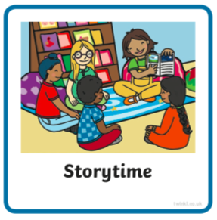 | Adult led- Communication and language  Talk through this page and watch the videos  https://ashtonvaleprimary.weebly.com/class-blog---penguin/preparing-for-restarting-school | 14:45 | Adult led- Communication and language  Read ‘Handa’s Surprise’ (youtube if no book) first without the illustrations.  Ask chn to describe to their talk partner what they could picture as you read.  Scribe their ideas so that you have a record of this version.  Read the story again showing the children the illustrations. Read to the end without stopping to comment or question.  Invite the children to describe what has happened in the story for a second time. How has seeing the pictures changed their descriptions of what happened?  Why is Handa surprised at the end? We knew about what the animals got up to? Did Handa? | 14:45 | Adult led- Communication and language  Revisit this page, watch the videos and reflect on how today had similarities and differences since before the school closure  https://ashtonvaleprimary.weebly.com/class-blog---penguin/preparing-for-restarting-school | 14:45 | Adult led- Communication and language  Handa is from the Luo tribe of south-west Kenya.  http://news.bbc.co.uk/cbbcnews/hi/pictures/galleries/newsid_2658000/2658491.stm  Talk about these African photos together.  Can you remember the names of the fruits? Can we find different pictures of them online? Which ones have seeds in? What colour are they? Which ones have you tried? Which ones would you like to try? Can you draw/ write it. Pay attention to the details. | 14:45 | Adult led- Communication and language  Blow up a balloon and let it go. How did the class feel? Did the have a surprised feeling?  Talk partner- was it right that the animals took the fruit Handa had collected?  Why not?  Discuss stealing together.  What does it mean?  Draw a surprised face or a situation where you may have a surprised feeling.
15:05 | Collect belongings for home time  Reflection of the day/ singing | 15:05 | Collect belongings for home time  Reflection of the day/ singing | 15:05 | Collect belongings for home time  Reflection of the day/ singing | 15:05 | Collect belongings for home time  Reflection of the day/ singing | 15:05 | Collect belongings for home time  Reflection of the day/ singing

*IMP
- Focus on children of the week  - Check child’s cover sheet for focuses (areas of the curriculum or other focuses)  - Observe and wait for a suitable moment where you feel you can extend the child in some way (interact not interfere)  - Teach the next step to the child when appropriate (this could be by providing a suitable environment or resources, or by using the following teaching methods encouraging, explaining, questioning, facilitating, modeling, showing, setting challenge)  - Note the outcome- record on ILD during or after interaction (focus on interaction not the documenting)  Cycle:  Observe (and possibly assess), wait for a moment where you can make a difference and  Teach the appropriate next step,  Record the outcome (evidence that learning has happened) | 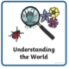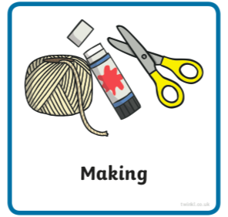  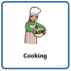

Provision
Individual | To be confirmed  Limited cleanable options in classroom for weekly rotation after clean |  | To be confirmed  Limited cleanable options outside for weekly rotation after clean
Packs  Pencil  Colouring pencils/ crayons  Paper/ blank exercise book  Glue stick  Scissors  Tape  Whiteboard  Pen  Sponge rubber  Clipboard | Numicon  Unifix  Stencils  Cars  Plastic small people  Duplo  Plastic only junk modeling | Counting sticks  Counting teddies  Rubbing plates  Planes and trains  Animals  Lego  Plastic only junk modeling | Area outside Rec  Bubble’s own box with  Bats  Balls  Quoits  Hoops  Hudles  Bikes  Wheelbarrow  Plastic large construction  Mud kitchen plastic/ metal equipment  Blue water tray for cleaning | Area outside Y1  Bubble’s own box with  Bats  Balls  Quoits  Hoops  Hurdles  Foam construction  Plastic dolls  Plastic dinosaurs  Tuff tray with mud kitchen plastic/ metal equipment  Blue water tray for cleaning

