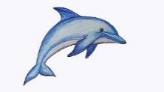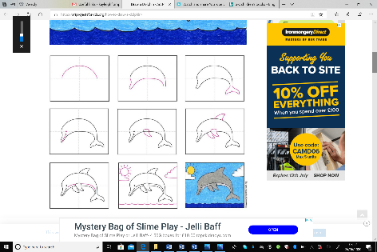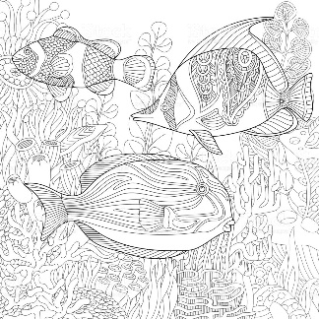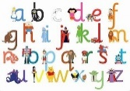Image result for rainbow kids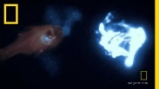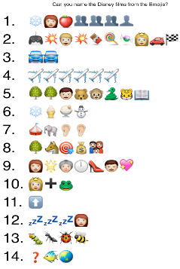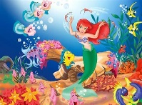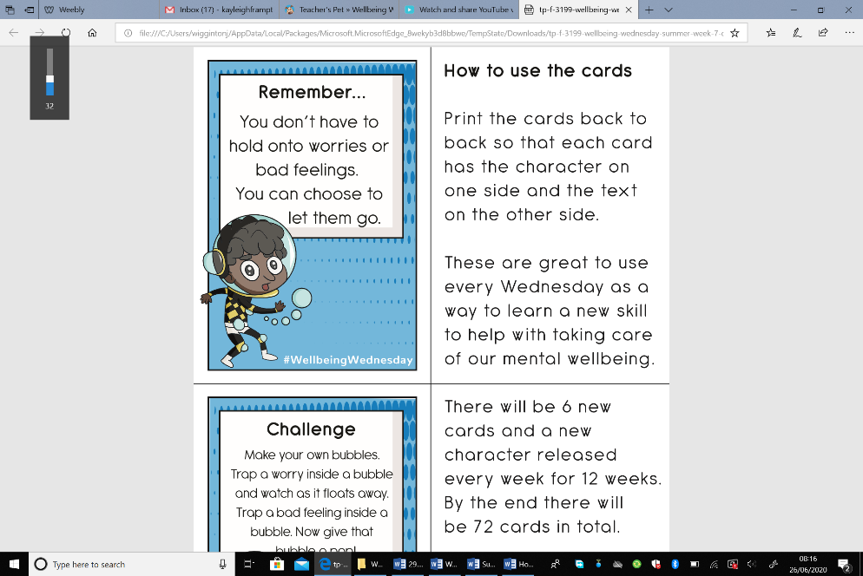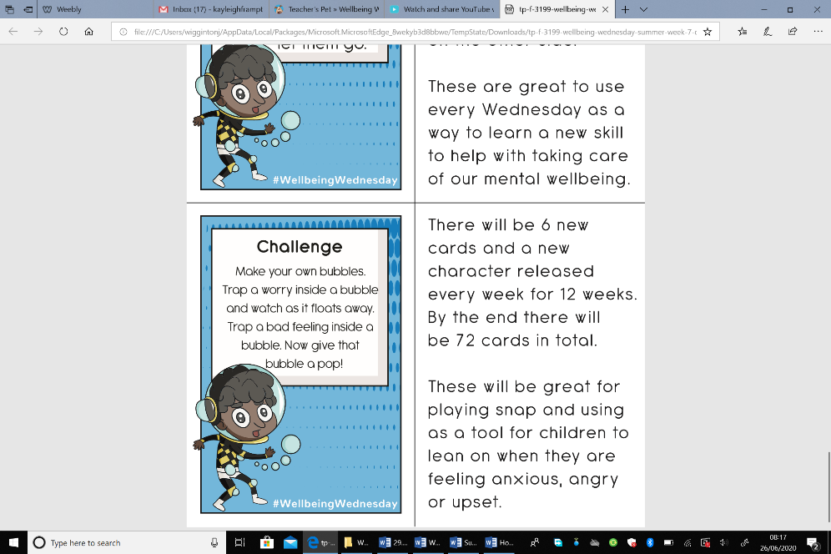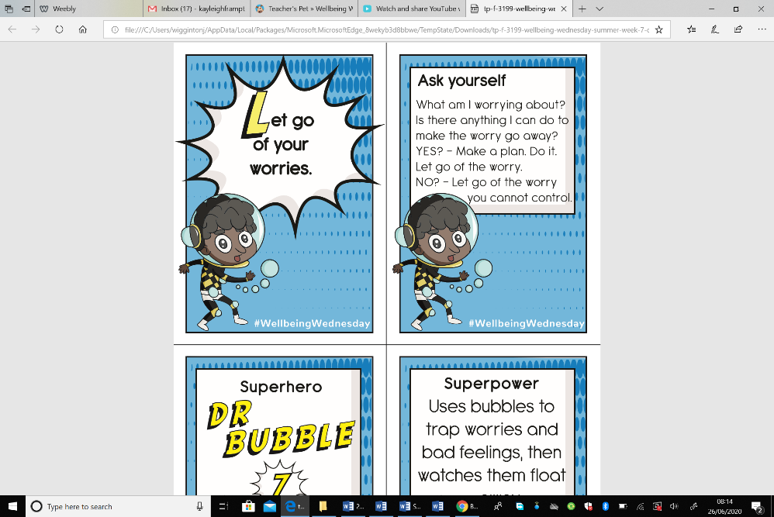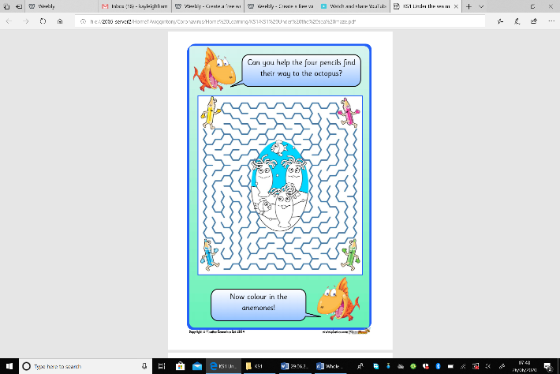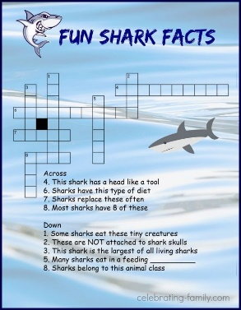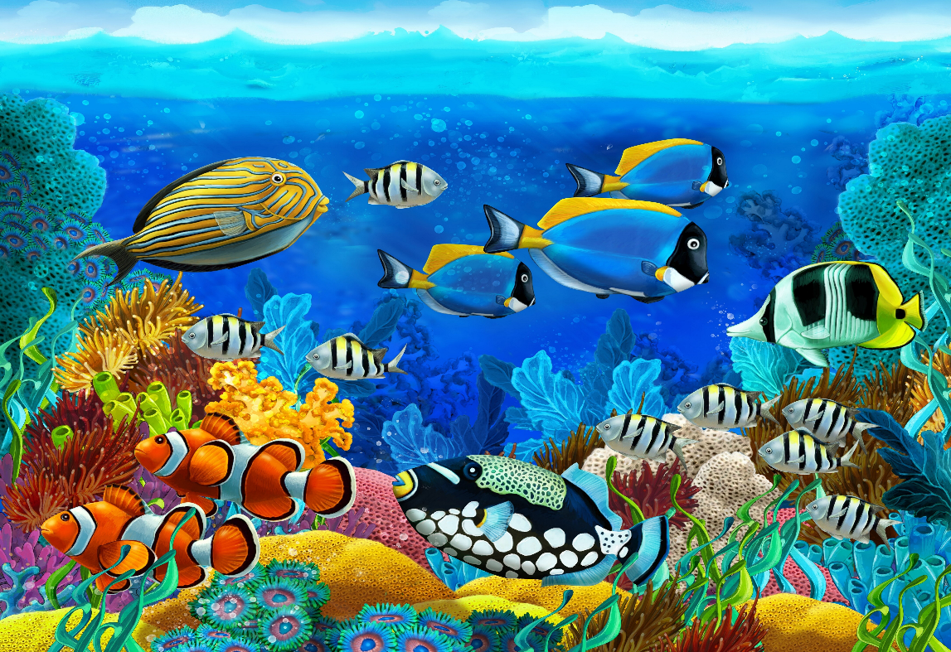 |

**Under the sea scene drawing**

*Each week we will learn how to*

*draw something new to add to a*

*sea scene picture.* This week we

are going to learn how to draw a

DOLPHIN. Click below for guides:

[Simple dolphin](https://artprojectsforkids.org/how-to-draw-a-dolphin/)

[Dolphin video tutorial](https://safeYouTube.net/w/uZ5M)

**Asda Posters**

Did anyone make a rainbow picture for Asda? If you did please email them to Mrs Frampton. There’s still time to do one if you would like to.

***We hope you like the activities on this page, they are shorter activities helping to keep us busy and calm. You can choose as many of these as you like. Don’t forget to share your ideas on the blog or email photographs to Mrs Frampton (***[***kayleighframpton@ashtonvale.bristol.sch.uk***](mailto:kayleighframpton@ashtonvale.bristol.sch.uk)***) so she can upload them to the blog.***

**A-Z Blog Challenge**

*Focus– Books & Stories*

Together

can we

think of an object for

every letter of the alphabet? [Click here](https://ashtonvaleprimary.weebly.com/home-learning-blog) to share your ideas on the blog.

**Yoga**

Have a go at some Under the Sea themed yoga.

KS1 join [Mimi the Mermaid](https://safeYouTube.net/w/rZQJ)

KS2 try [Popcorn the Dolphin](https://safeYouTube.net/w/SXQJ)

**Videos**

[Watch the starlight camera](https://safeYouTube.net/w/oY5M) capture sea creatures' bioluminescent paths, and the ocean glow with light.

[Here you can watch](https://safeYouTube.net/w/8Y5M)

feeding time within the

octopus tank.

**Internet Safety Quiz**

[Here is an e-safety quiz](https://www.safekids.com/quiz/q1.htm) to remind you how to keep yourselves safe online!

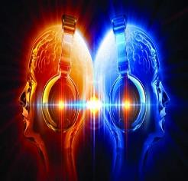

**Minute of Listening**

Listen to Bristol1# 5 [here](https://www.minuteoflistening.org/minute/brc1-5/) (you will need to make a free account)

What sound in Bristol could this be?

Do you think the sounds came from something that was moving or stationary?

The music had a very regular rhythm why do you think that is?

You will have heard a long continuous note underneath the melody being played by the pipes – this is called a drone and this can be heard in many other musical styles and genres.

**Little Ninjas**

Remember you do not need any props for this you can just practise in the air. There is a fitness challenge that goes with the KS2 video this week.

[KS1 video](https://safeYouTube.net/w/aW5M)

[KS2 video](https://safeYouTube.net/w/hX5M) [Fitness Challenge](https://safeYouTube.net/w/sX5M)

**Wellbeing Wednesday**

Meet Agent Cyber Sense she uses her senses to help practise being mindful.

Ask yourself: What am I worrying about? Is there anything I can do to make the worry go away?

YES? - Make a plan. Do it. Let go of the worry.

NO? - Let go of the worry you cannot control.

**Virtual Summer Games – Cricket**

[Click here](http://www.wesport.org.uk/active-education/school-games/2020-summer-virtual-school-games/) for this week’s challenge card. Don’t forget to submit your scores by Sunday!

**Brainteasers**

Try this fun shark fact cross word or have a go at this under the sea maze!

**Emoji Disney Film Quiz**

Can you guess the Disney films from

these emojis? What emojis could

you use for other Disney films that

you know?

Share any you make on this week’s

blog post or email them to Mrs

Frampton.

**Mindful Colouring**

You could colour one picture each

week and then put them all together

to create a sea scene. If you cannot

print the sheets you could have

a go at drawing the outline and

then using shapes to fill the inside

with colour.

**Disney Dance-along**

[Click here](https://safeYouTube.net/w/LV5M) for this

week’s dance along to

‘Under the Sea’ from The Little Mermaid.

**Favourite songs**

Listen or join in with one of our [favourite songs](https://safeYouTube.net/w/irAM). Leave a blog comment with your favourite song we sing in school and maybe yours will be next week!

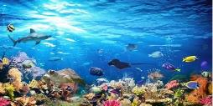

**Under the Sea and Oceans**

**29th June 2020**