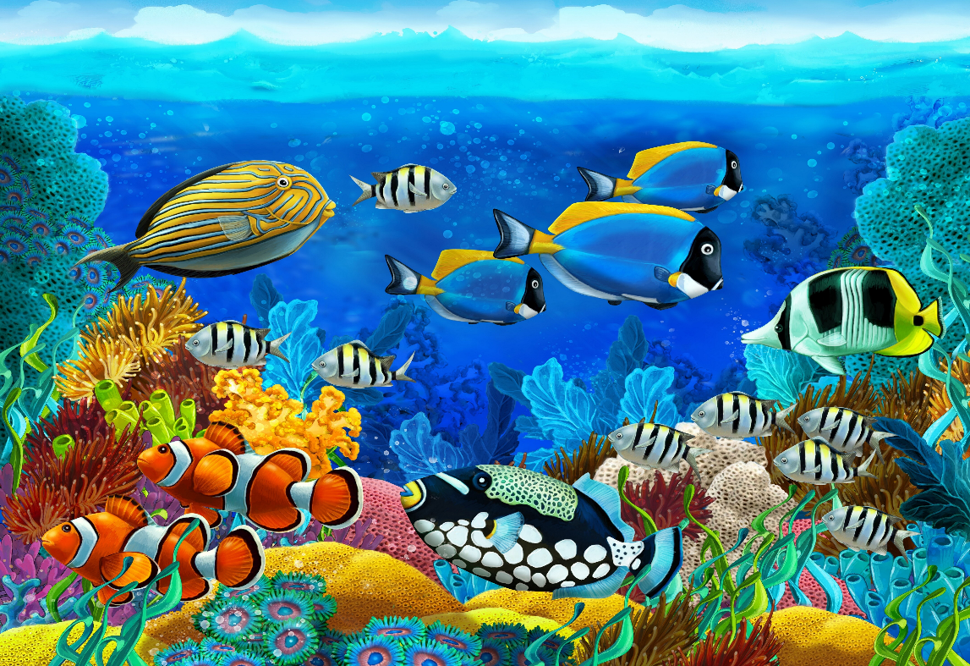Image result for rainbow kids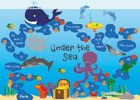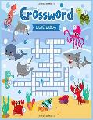 video thumbnail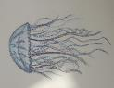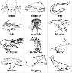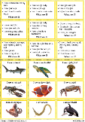See the source image |

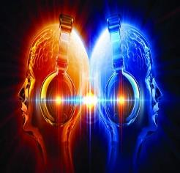

**Minute of Listening**

Listen to Bristol1# 4 [here](https://www.minuteoflistening.org/minute/brc1-4/) (you will need to make a free account)

What sound in Bristol could this be?

Where did it feel like you could have been standing?

Were you close by or far away from the sound?

Were the bells playing in a familiar order – such as a scale – or were they in a more complicated or intricate pattern?

**Little Ninjas**

Remember you do not need any props for this you can just practise in the air. There is a fitness challenge that goes with the KS2 video this week.

[KS1 video](https://safeYouTube.net/w/fo8L)

[KS2 video](https://safeYouTube.net/w/5o8L) [Fitness Challenge](https://www.youtube.com/watch?v=YzcrgL0iNjs)

**Wellbeing Wednesday**

Meet Agent Cyber Sense she uses her senses to help practise being mindful. Try to focus your mind each day by

Naming 5 things you can see, 4 things you can hear, 3 things you can feel, 2 things you can smell and 1 thing you can taste.

***We hope you like the activities on this page, they are shorter activities helping to keep us busy and calm. You can choose as many of these as you like. Don’t forget to share your ideas on the blog or email photographs to Mrs Frampton (***[***kayleighframpton@ashtonvale.bristol.sch.uk***](mailto:kayleighframpton@ashtonvale.bristol.sch.uk)***) so she can upload them to the blog.***

**Internet Safety**

Join Kara, Winston and the SMART Crew to find out how to stay safe [here](https://www.childnet.com/resources/the-adventures-of-kara-winston-and-the-smart-crew).

**Asda Posters**

Could you draw, colour, paint or collage a keyworker picture to go up in our local Asda store? It could be a rainbow and will need to have your name, school and class on the back so they can return them back to you.

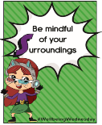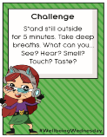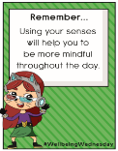

**Virtual Summer Games – Tennis**

[Click here](http://www.wesport.org.uk/active-education/school-games/2020-summer-virtual-school-games/) for this week’s challenge card. Don’t forget to submit your scores by Sunday!

**Brainteasers**

Can you solve this under the sea themed brain teaser or play this under the sea game?

**Under the sea scene drawing**

*Each week we will learn how to*

*draw something new to add to a*

*sea scene picture.* This week we

are going to learn how to draw a

jelly fish. On [this page](https://www.wedrawanimals.com/how-to-draw-a-jellyfish-for-kids/) there are a

variety of ways that you can draw

jellyfish in different styles

**Ocean Animal Riddles**

Can you solve these ocean

Animal riddles?

Can you write your own riddles

For ocean creatures?

**Colouring and Mindful Colouring Pages**

You could colour one picture each

week and then put them all together

to create a sea scene. If you cannot

print the sheets you could have

a go at drawing the outline and

then using shapes to fill the inside

with colour.

**Yoga**

Have a go at some Under the Sea themed yoga.

KS1 join [Norris the Seahorse](https://safeYouTube.net/w/hYQJ)

KS2 try [Bye Bye Boat](https://safeYouTube.net/w/LYQJ)

**Disney Dance-along**

[Click here](https://safeYouTube.net/w/IHyL) for this

week’s dance along to ‘You’re Welcome’ from Moana.

**A-Z Blog Challenge**

*Focus– foods*

Together can we think of an object for every letter of the alphabet? [Click here](https://ashtonvaleprimary.weebly.com/home-learning-blog) to share your ideas on the Home Learning Blog Page.



**NMA Videos**

Here are two videos

from the National

Marine Aquarium.

[Relax](https://safeYouTube.net/w/bOyL) in the Atlantic Ocean Tank

[Live feeding time with the sharks and turtles](https://safeYouTube.net/w/lOyL)

**Favourite songs**

Listen or join in with one of our [favourite songs](https://safeYouTube.net/w/avVL). Leave a blog comment with your favourite song we sing in school and maybe yours will be next week!

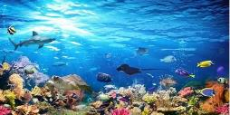

**Under the Sea and Oceans**

**22nd June 2020**