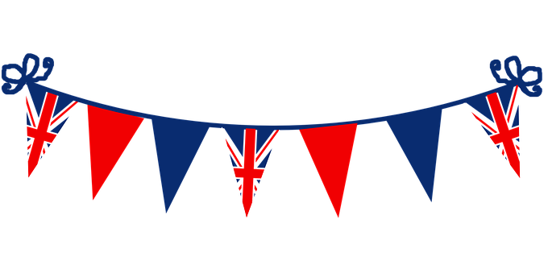
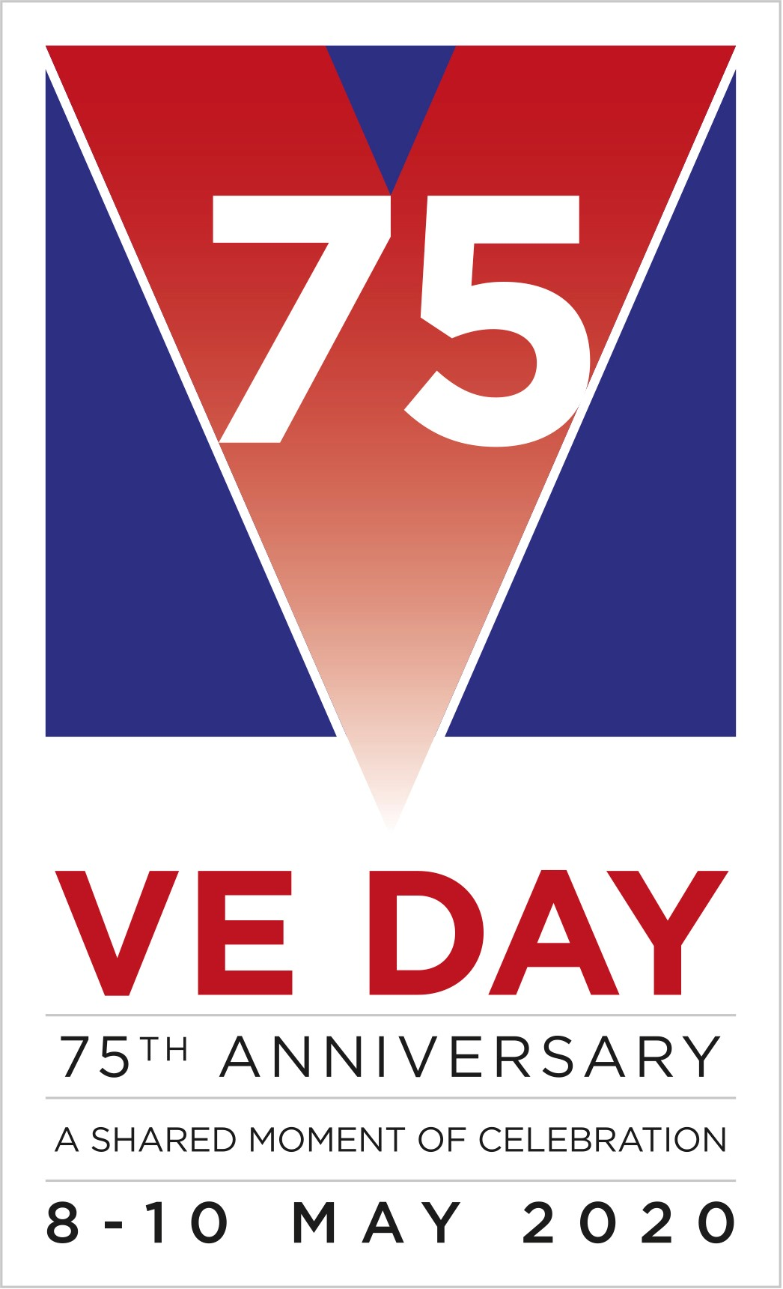

Find out more about VE Day 2020 here www.veday75.org

Ashton Vale Primary School VE Day Challenges

Can you use the numbers 7and 5 in a creative way to complete a challenge on this special bank holiday weekend? Perhaps you could use the numbers 7, 5, 5.7, 7.5, 57, 75, 570, 750, 5700 or even 7500 for your challenge.

Here are some challenge ideas; remember you can choose a different number to suit you (make sure you still use a 5 and 7 in the number though!). Don’t forget to share your challenge attempts by emailing them to the school schoolashtonvalep@bristol-schools.uk. If you give permission to share the photo on the school website and twitter please write this in your email too.
- Walk 5.7 kilometres

- Do 57 handstands

Bake 7.5 cakes, you could deliver them to friends and family

Wear fancy dress for 7.5 hours

Build a 75cm (or higher) tower of Lego

Learn to sign 7.5 letters of the alphabet
- Run up and down the stairs 57 times

- Have a 7.5 minute bath

- Catch the ball 75 times

- Stroke your pet 57 times

- Hop on each leg 75 times

- Make a daisy chain with 7.5 daisies

- Meditate for 5.7 minutes

- Make the numbers 7 and 5 on a walk, cycle or running route map app

- Donate £5.70 to charity

- Do 5700 or 75000 steps over a day

- Dance non-stop for 5.7 minutes

- Stay silent for 75 minutes

- Do 7.5 costume changes in a day

- Travel differently and roly poly 7.5 or even 75 metres

- Do 750 bounces on the trampoline

- Complete 5 puzzles in 7 days

- Invite 7 + 5 toys to a VE day tea party in your home

- Make 57 paper chains for VE day decorations

- Make 7 + 5 pieces of bunting for VE day decorations, you could even sew them

- Sing songs for 57 minutes

- Set up an obstacle course with 7.5 stations (a drink stop could be your .5 stop)

- Do 57 star jumps

- Wear 7.5 pieces of red, white and blue clothing

- Can you name 75 countries involved in WW1? There were 190!

- Use 57 shapes to create a Union Jack flag

- Listen to music for 57 minutes, popular artists from the second world war include Ella Fitzgerald, The Andrews Sisters, Vera Lynn, and Benny Goodman

- Use 75 words to write a newspaper article about VE day

