Under the Sea Cookies
- Sugar cookies, baked and cooled*
- vanilla buttercream frosting, colored blue
- chocolate rocks
- Swedish fish/ blue shark gummy candies
- Dory fish candy {I found ours at Michael’s craft store}
- 1 crushed graham cracker
Vanilla Buttercream Frosting: Whisk ½ cup butter with an electric mixer for 1 minute. Add 3 cups of powdered sugar, 1 cup at a time. Add in 1 tsp vanilla and 2 TBSP milk. Mix until smooth. I added 20 drops of blue food coloring.
Spread frosting on cooled cookies. Arrange a few chocolate rocks near the bottom. Sprinkle a little crushed graham cracker over and around the rocks, trying to stick to the bottom of the cookie. Place 1 shark gummy and/or Swedish fish on each cookie, as well as a Dory fish candy and a few other tiny fishy candies.
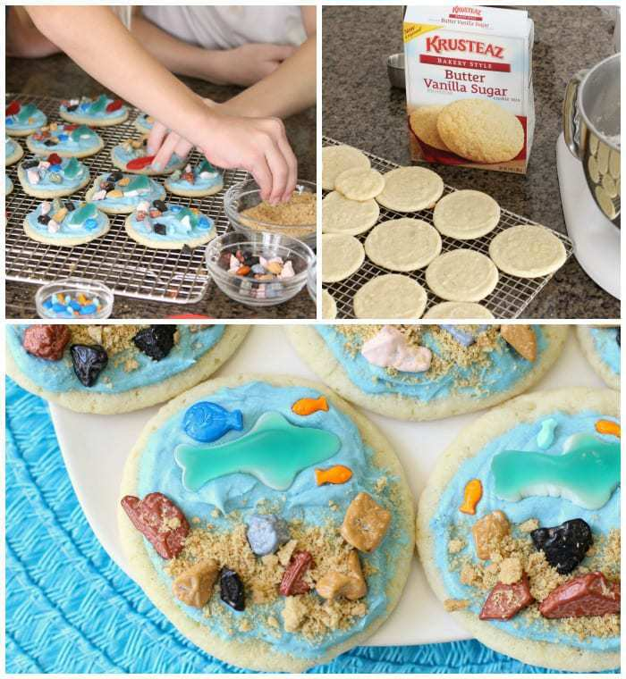
That’s it! Enjoy your under the sea dessert!

