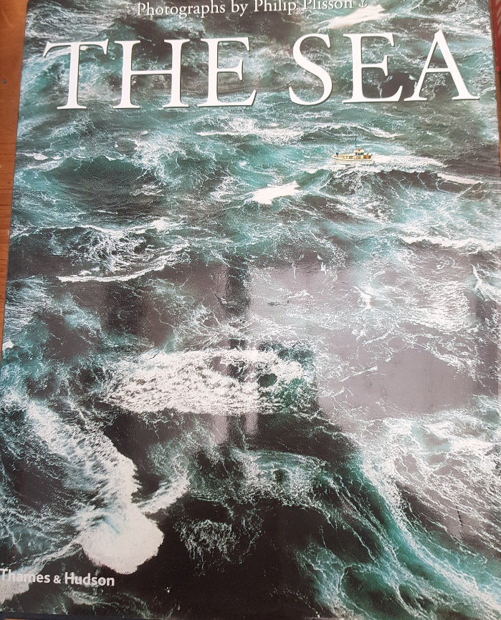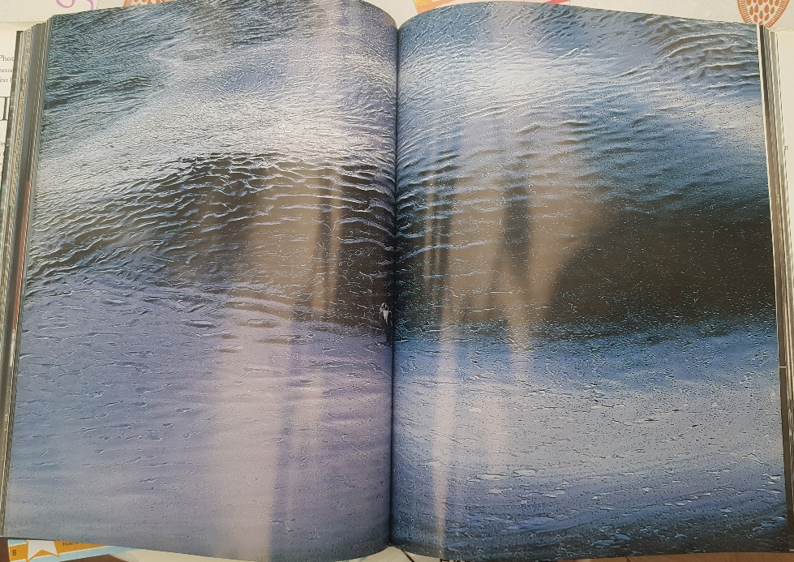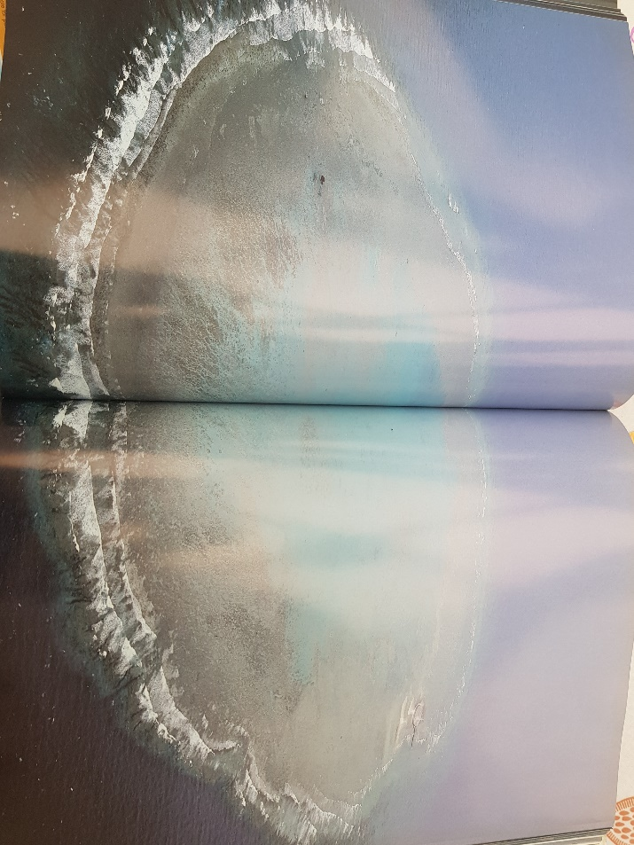

**Here are two of my favourite photographs from this beautiful book all about the sea.**

Could you create a piece of art in the style of these photographs?

Maybe you could write facts about the ocean around the photos?

Have you ever taken a photo of the sea?

Could you write a poem using these photographs as inspiration?