THE PRESSURE OF WATER
To try it, you will need:
A deep bowl or sink filled with water and a plastic bag.
First, stick your hand into the water. How does it feel? Wet, right? What else do you feel? Not much, probably. We are used to the sensation of having our hands in water, so you don't notice anything strange.
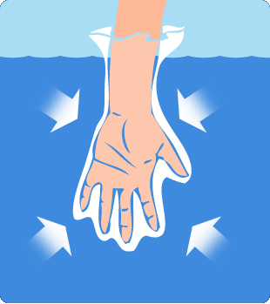
Next, put your hand into the plastic bag and then put it back into the water. Be sure that the water does not flow into the bag. What do you feel this time? Pressure! You can feel the water pushing the plastic bag against your hand. The pressure is pretty much the same as before (slightly more due to the size of the bag), but this time the water presses on the bag, which presses on your hand. This is a less familiar sensation, so you notice the pressure more.
Put both hands into the bag and spread them apart. This time, you feel more pressure and you can see the water pushing the sides of the bag inwards. As you move your hands apart, you may be surprised at how much pressure the water is exerting.
When you put your hand into the water, your hand pushes some of the water out of the way. You hand is now taking up space that was occupied by water, and the water is pushing back. When you put both hands into the bag and spread them apart, the water is pushed back harder. If you measured it carefully, you would find that the water was pushing with a force equal to the weight of the amount of water that you push out of the way. When you spread your hands apart, the bag takes up more space, pushing more water out of the way. You then have more force pushing inwards and you feel more pressure.
Taken from https://www.submarinesafaris.com/kids_experiments.php

