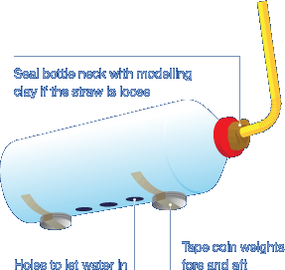Make a submarine with buoyancy tanks! Can you make your submarine

float at different levels? [Click here](https://www.submarinesafaris.com/kids_build_your_own_submarine.php) for a great guide.

