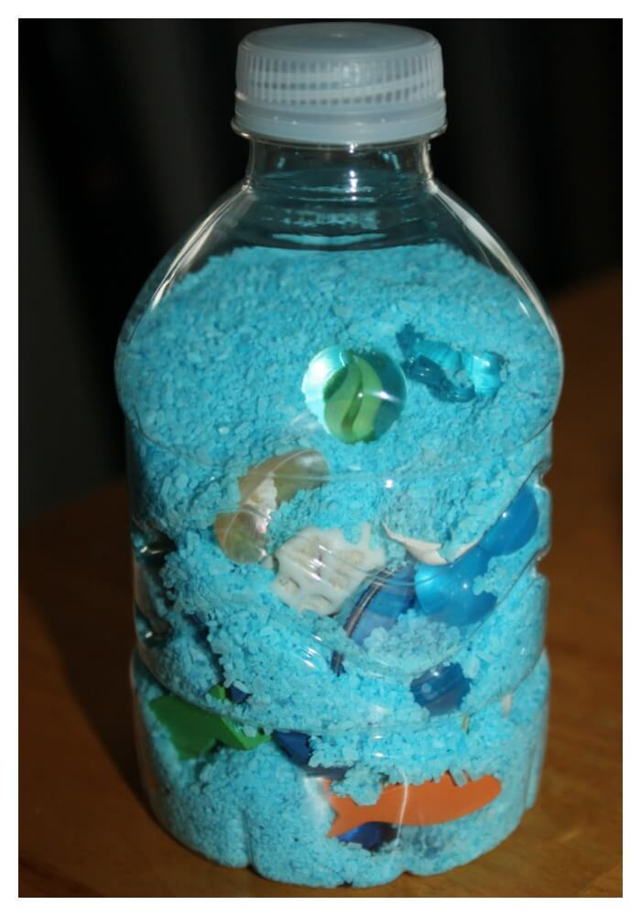**[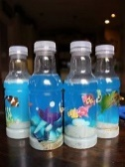](https://www.bing.com/images/search?q=under+the+sea+sensory+jar&id=AA9D4DB10770BED7B844C51018A4C7247BC30AE0&FORM=IQFRBA)[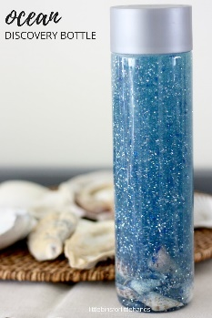](https://littlebinsforlittlehands.com/6-awesome-ocean-science-activities-kids/)**

