09:00- 09:30 | Joe Wicks Workout | 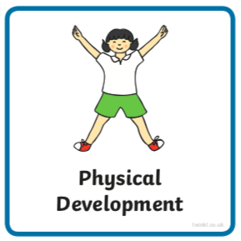 | Find Joe Wick’s live daily workouts via YouTube.
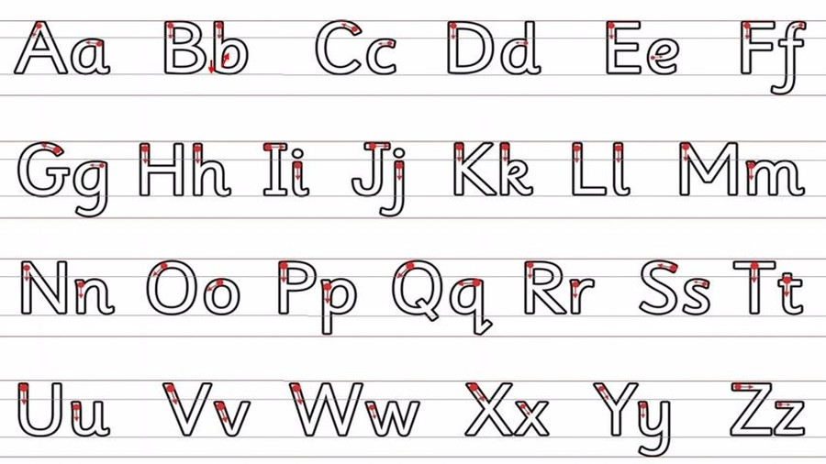  09:30- 10:00 | Literacy-  Adult Led | 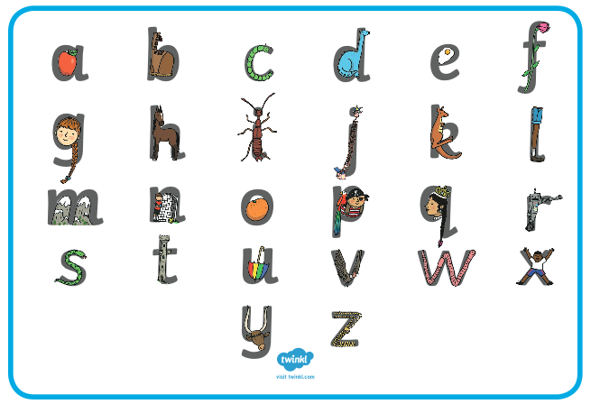  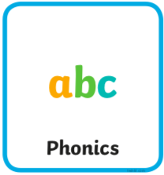 | Flashcards- Write ‘ar’, ‘or ‘and ‘ur’ on pieces of paper or card, practice reading them as someone flicks through them and then play the game below. Add the sounds from Monday and Tuesday in too.  Segment and Blend- play https://www.youtube.com/watch?v=oTtSg1avtxc  Write- Recap question marks if needed. Read and write the question below. Think about what your reply is.  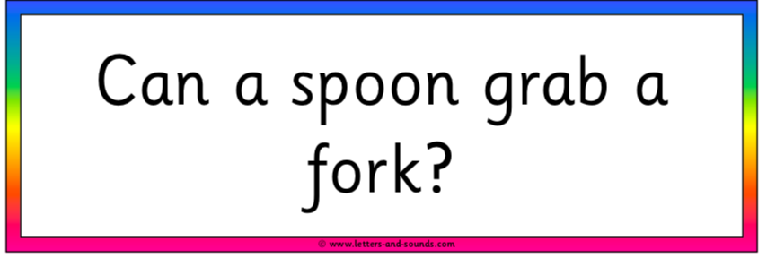  - Draw lines for your child to write onto. Use paper or boards landscape.  - Ask your child to remember the things we need to use when writing a sentence. If they don’t remember tell them: a capital letter at the beginning, finger spaces between words and a full stop or question mark at the end.  - Ask your child to say the sentence a couple of times first with help, then independently. They should try and ‘hold the sentence’ in their head.  - Without looking at the above (if possible), begin to work on the first word. Show them the capital letter chart below to help. They should aim to sound the word before or as they are writing it. They can look at the charts below to help as they write.  - If they miss out a sound try not to correct them as they write. Let them know once they have completed the whole sentence (focus on just one correction).  - If your child finds this tricky, write two words separated by a finger space.  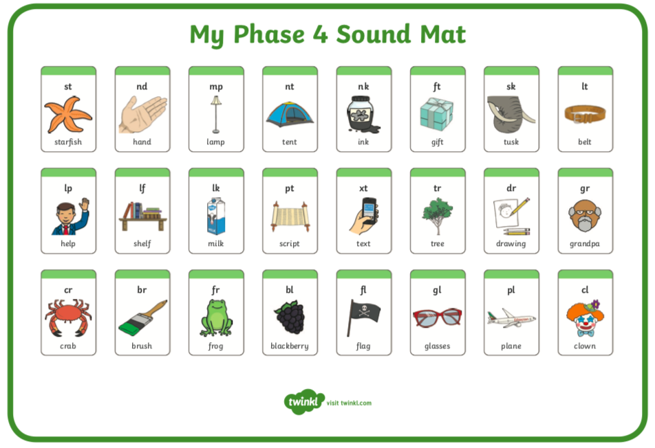  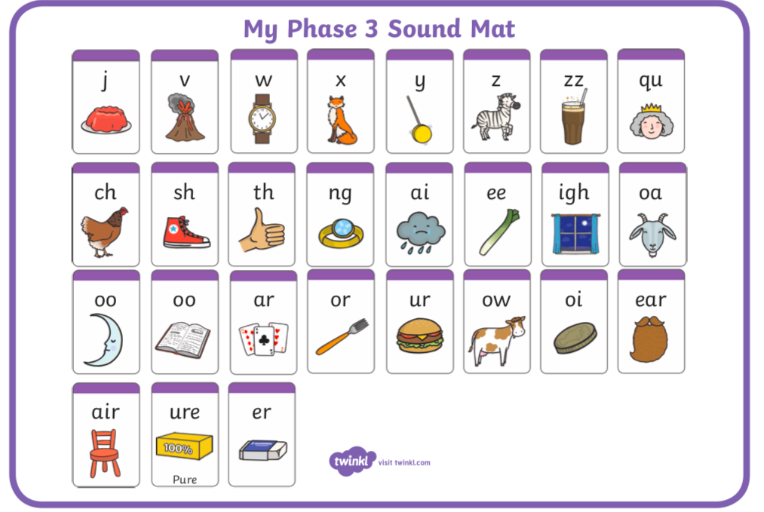
10:00- 11:00 | Inside and Outside Play-  Child Led | 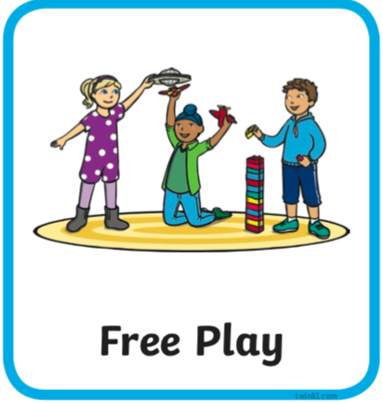 | Resource idea- ‘Juice Pong!’ cups, ball (can be made with foil), tube (or hand)  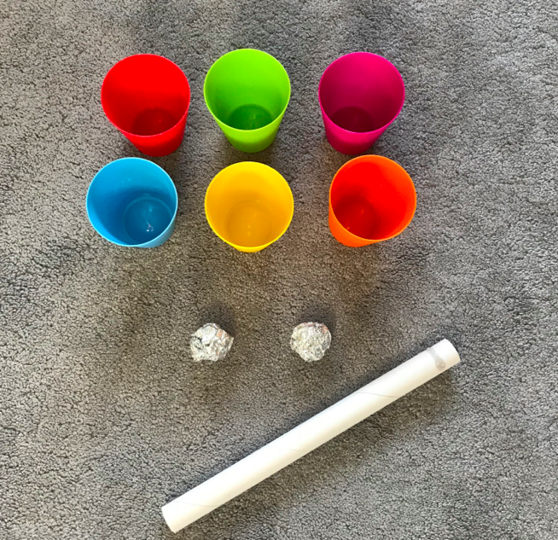
11:00- 11:30 | Snack and Chill | 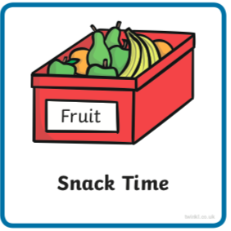 | Screen time, picnic or more playing after you’ve eaten- you choose!
11:30- 12:00 | Maths-  Adult Led | 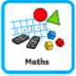 | Watch this lesson clip https://www.bbc.co.uk/bitesize/clips/zwdq6sg  Can you create a ‘sister or brother’ adding fact for  2+6  3+7  Can you calculate the totals using objects in your home? Can you record your number sentences on paper?
12:00- 12:30 | Prepare For Lunch | 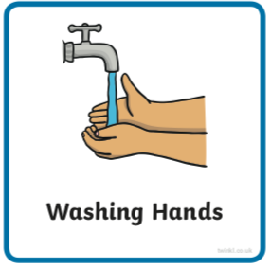 | You could help your grown up by setting the table, getting things from the fridge, chopping or pouring the drinks.
12:30 – 13:30 | Lunch and Chill | 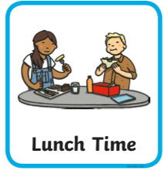 | Screen time, picnic or more playing after you’ve eaten- you choose!
13:30- 14:00 | Explore-  Adult Led | 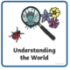 | How many of these things can you find on this scavenger hunt?  Can you answer a why question asked by an adult about something you find?
14:00- 15:00 | Inside and Outside Play-  Child Led |  | Refresh the resource from this morning.
15:00- 15:15 | Tidy Up Time | 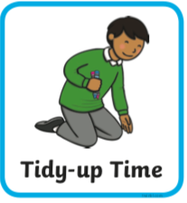 | Playing a song on may help keep things positive.
15:15- 15:30  or Bedtime | Story Time-  Adult or Child Led | 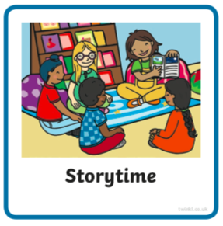 | Read ‘The Island of Bum Bum Ba Loo’  https://www.freechildrenstories.com/the-island-of-bum-bum-ba-loo  Can you spot any rhyming words? Can you spot a real and alien rhyming word?
More links for stories if you’re getting a little fed up with the selection you have |  |  | Can you choose a story from home or from one of these websites for an adult to share with you?  https://www.freechildrenstories.com/age-3-5  https://www.freechildrenstories.com/age-5-8-1https://www.bbc.co.uk/cbeebies/stories  https://www.booktrust.org.uk/books-and-reading/have-some-fun/storybooks-and-games/  https://www.storyberries.com/category/5-min-stories/ | Can you choose a story from this website for you to share with an adult?  First you need to register on the website for free here  https://www.oxfordowl.co.uk/user/sign_up.html  Once you are logged in this link should take you to the children's e reading books. If you look closely you will see a little blob of colour on the virtual front cover of the book, you should choose the colour book your child is currently reading.  https://www.oxfordowl.co.uk/for-home/find-a-book/library-page/?view=image&query=&type=book&age_group=Age+4-5&level=&level_select=&book_type=&series=#

Key Skills
These key skills are important in giving children a good foundation for year one.
These are the key skills covered in today’s timetable. You may like to cover them in a different way to suggested in the timetable or do some further exploration of them in addition to the timetable.

Prime Key Skills | Literacy Key Skills | Maths Key Skills
Use pencils effectively for writing by forming most letters correctly. | Write words in a way that match children’s spoken sounds. | Add and subtract within single digits using objects or equipment.
Respond to stories after listening to them with comments and questions or anticipating what’s coming next. | Understand the use of a finger space to separate words. Use finger spaces appropriately.
 | Write a simple sentence.
 | Use phonic knowledge to decode regular words and read them aloud accurately.
 | Read simple sentences.

