09:00- 09:30 | Joe Wicks Workout | 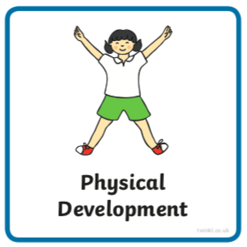 | Find Joe Wick’s live daily workouts via YouTube.
09:30- 10:00 | Literacy-  Adult Led | 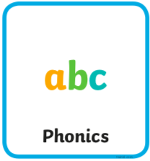 | Can you write your first name and surname forming the letters of your name correctly? Use the below chart to help you.  Don’t forget the finger space in between your two names.  Can you sit the letters on a line?  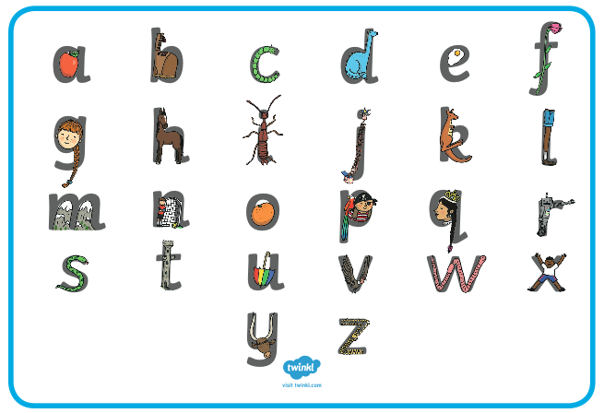  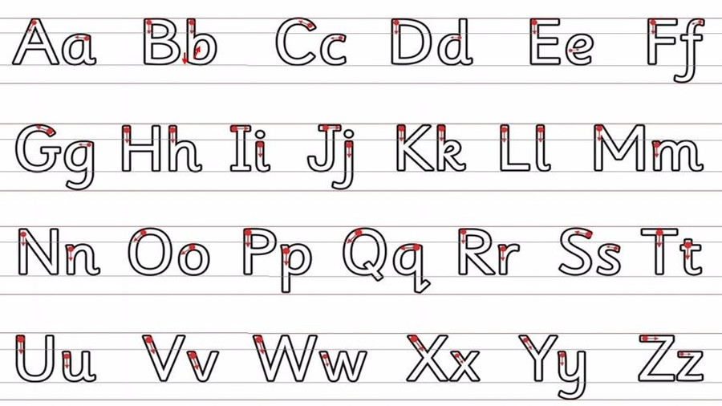
10:00- 11:00 | Inside and Outside Play-  Child Led | 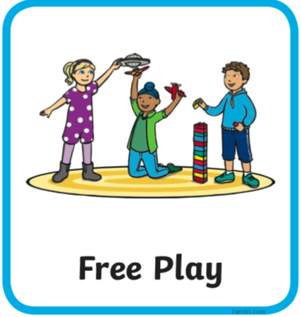 | Resource idea- Use some soft balls or scrunched up paper to experiment with rolling down the stairs.
11:00- 11:30 | Snack and Chill | 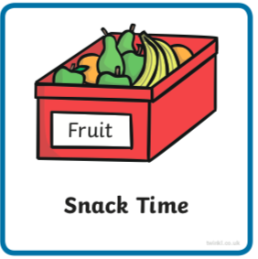 | Screen time, picnic or more playing after you’ve eaten- you choose!
11:30- 12:00 | Maths-  Adult Led | 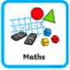 | Watch ‘Count With Rod Adding 1-6’ https://www.bbc.co.uk/teach/class-clips-video/maths-ks1-adding-1-to-6/zrwqxyc  Record one of Rod’s number sentences using the addition and equal symbols.
12:00- 12:30 | Prepare For Lunch | 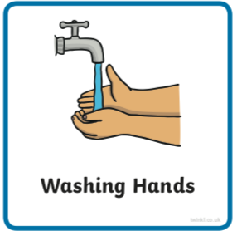 | You could help your grown up by setting the table, getting things from the fridge, chopping or pouring the drinks.
12:30 – 13:30 | Lunch and Chill | 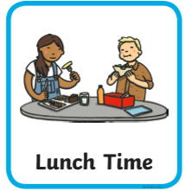 | Screen time, picnic or more playing after you’ve eaten- you choose!
13:30- 14:00 | Explore-  Adult Led | 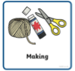 | Can you create a monster from a toilet roll tube? Whilst making ask a how or why question e.g. ‘Why did you choose to give them 2 eyes?’ ‘How will they hear?’ (core skill).  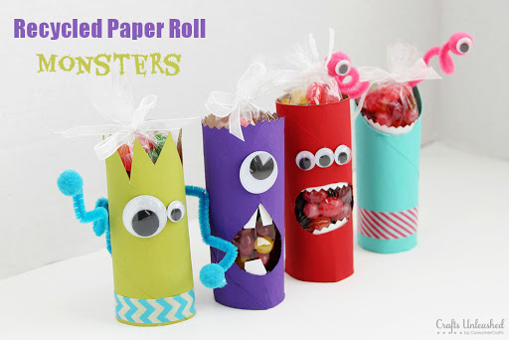
14:00- 15:00 | Inside and Outside Play-  Child Led |  | Refresh the resource from this morning.
15:00- 15:15 | Tidy Up Time | 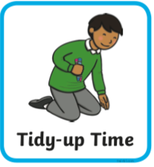 | Playing a song on may help keep things positive.
15:15- 15:30  or Bedtime | Story Time-  Adult or Child Led | 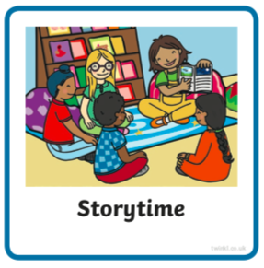 | Can you choose a story from home or from one of these websites for an adult to share with you?  https://www.freechildrenstories.com/age-3-5  https://www.freechildrenstories.com/age-5-8-1https://www.bbc.co.uk/cbeebies/stories  https://www.booktrust.org.uk/books-and-reading/have-some-fun/storybooks-and-games/  https://www.storyberries.com/category/5-min-stories/ | Can you choose a story from this website for you to share with an adult?  First you need to register on the website for free here  https://www.oxfordowl.co.uk/user/sign_up.html  Once you are logged in this link should take you to the children's e reading books. If you look closely you will see a little blob of colour on the virtual front cover of the book, you should choose the colour book your child is currently reading.  https://www.oxfordowl.co.uk/for-home/find-a-book/library-page/?view=image&query=&type=book&age_group=Age+4-5&level=&level_select=&book_type=&series=#

Core Skills
These core skills are important in giving children a good foundation for year one.
These are the core skills covered in today’s timetable. You may like to cover them in a different way to suggested in the timetable or do some further exploration of them in addition to the timetable.

Prime Core Skills | Literacy Core Skills | Maths Core Skills
Use pencils effectively for writing by forming most letters correctly. | Write own name with correct letter formation. | Add and subtract within single digits using objects or equipment.
Answer how and why questions in relation to their experiences.

