09:00- 09:30 | Joe Wicks Workout | 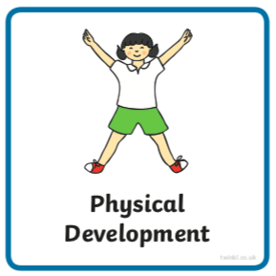 | Find Joe Wick’s live daily workouts via YouTube.
09:30- 10:00 | Literacy-  Adult Led | 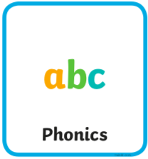 | Flashcards- Go to this website https://new.phonicsplay.co.uk/resources/phase/2/flashcards-speed-trials , log in using these details username march20 password home and select ‘phase 3’.  Segment and Blend- Play sentence substitution ‘phase 3’ choose the sentence ‘They might meet in the town.’ https://new.phonicsplay.co.uk/resources/phase/4/sentence-substitution-ph4  Write- Choose the funniest sentence you create to write, a different one from yesterday.  - If possible draw lines for your child to write onto. Where possible try using boards and paper landscape.  - Ask your child to remember the things we need to use when writing a sentence. If they don’t remember tell them: a capital letter at the beginning, finger spaces between words and a full stop at the end.  - Ask your child to say the sentence a couple of times first with help, then independently. They should try and ‘hold the sentence’ in their head.  - Without looking at the above, begin to work on the first word. Show them the capital letter chart below to help. They should aim to sound the word before or as they are writing it. Use the charts below to help.  - If they miss out a sound try not to correct them as they write. Let them know once they have completed the whole sentence (focus on just one correction).  - If your child finds this tricky, write two words separated by a finger space.  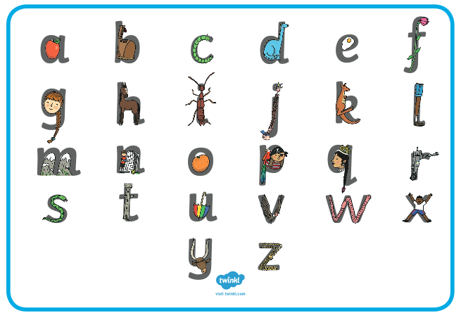  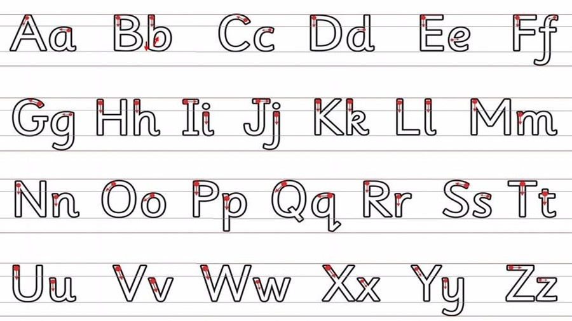
10:00- 11:00 | Inside and Outside Play-  Child Led | 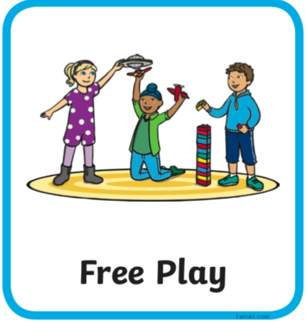 | Resource idea- Do you know how to use the hoover? If you have carpet can you make any shapes or patterns on it with the hoover?
11:00- 11:30 | Snack and Chill | 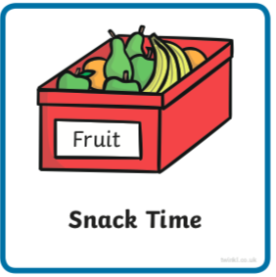 | Screen time, picnic or more playing after you’ve eaten- you choose!
11:30- 12:00 | Maths-  Adult Led | 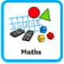 | Watch ‘Count With Rod’ https://www.bbc.co.uk/teach/class-clips-video/maths-ks1-adding-1-to-3/z7ps382.  Record one of Rod’s number sentences using the addition and equal symbols.
12:00- 12:30 | Prepare For Lunch | 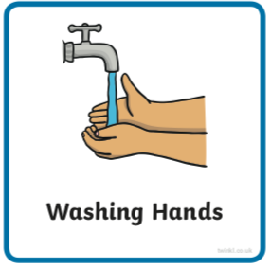 | You could help your grown up by setting the table, getting things from the fridge, chopping or pouring the drinks.
12:30 – 13:30 | Lunch and Chill | 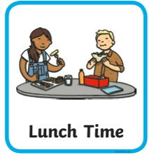 | Screen time, picnic or more playing after you’ve eaten- you choose!
13:30- 14:00 | Explore-  Adult Led | 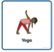 | Can you get changed into something sporty for your yoga session (key skill)?  Do ‘Cosmic Kids Yoga’ session, today it’s a space picnic https://youtu.be/d85dw-AcAaU.
14:00- 15:00 | Inside and Outside Play-  Child Led |  | Refresh the resource from this morning.
15:00- 15:15 | Tidy Up Time | 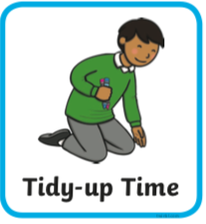 | Playing a song on may help keep things positive.
15:15- 15:30  or Bedtime | Story Time-  Adult or Child Led | 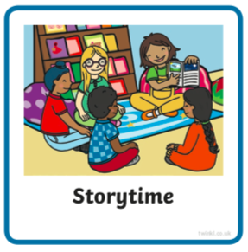 | Can you choose a story from home or from one of these websites for an adult to share with you?  https://www.freechildrenstories.com/age-3-5  https://www.freechildrenstories.com/age-5-8-1https://www.bbc.co.uk/cbeebies/stories  https://www.booktrust.org.uk/books-and-reading/have-some-fun/storybooks-and-games/  https://www.storyberries.com/category/5-min-stories/ | Can you choose a story from this website for you to share with an adult?  First you need to register on the website for free here  https://www.oxfordowl.co.uk/user/sign_up.html  Once you are logged in this link should take you to the children's e reading books. If you look closely you will see a little blob of colour on the virtual front cover of the book, you should choose the colour book your child is currently reading.  https://www.oxfordowl.co.uk/for-home/find-a-book/library-page/?view=image&query=&type=book&age_group=Age+4-5&level=&level_select=&book_type=&series=#

Core Skills
These core skills are important in giving children a good foundation for year one.
These are the core skills covered in today’s timetable. You may like to cover them in a different way to suggested in the timetable or do some further exploration of them in addition to the timetable.

Prime Core Skills | Literacy Core Skills | Maths Core Skills
Use pencils effectively for writing by forming most letters correctly. | Write words in a way that match children’s spoken sounds. | Add and subtract within single digits using objects or equipment.
Dress themselves independently. | Understand the use of a finger space to separate words. Use finger spaces appropriately.
 | Write a simple sentence.
 | Use phonic knowledge to decode regular words and read them aloud accurately.
 | Read simple sentences.

