09:00- 09:30 | Joe Wicks Workout | 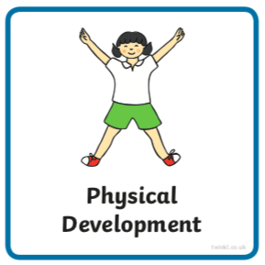 | Find Joe Wick’s live daily workouts via YouTube.
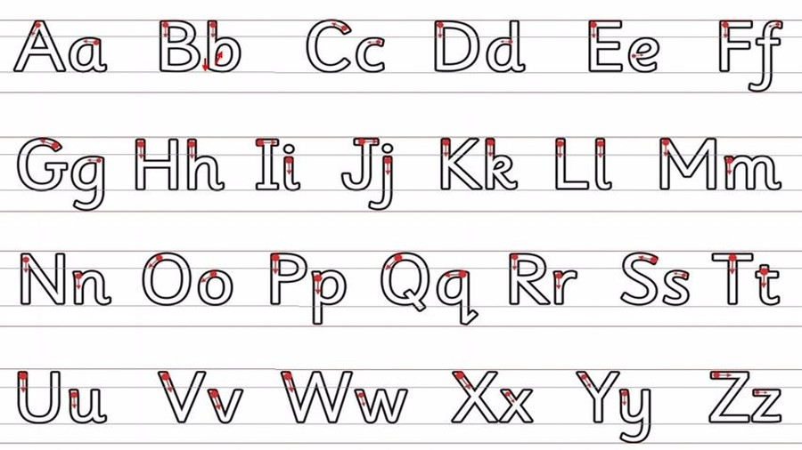  09:30- 10:00 | Literacy-  Adult Led | 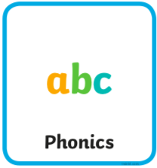 | Log in to https://new.phonicsplay.co.uk/ if this link doesn’t work on your device try https://www.phonicsplay.co.uk/#  username march20 password home  Flashcards- Choose the game ‘Flashcards Time Challenge’ and choose ‘phase 3’. How many sounds can you read in a minute? If you are unsure how they should be read use the charts below to help.  Segment and Blend- Start to read this funny book only up to the ‘Monday’ page https://new.phonicsplay.co.uk/resources/phase/4/interactive-story-book  Write- Can you write the silly sentence after you click on the sandwich? If you find it easier to simplify the sentence to write then do this.  - Draw lines for your child to write onto. Use paper or boards landscape.  - Ask your child to remember the things we need to use when writing a sentence. If they don’t remember tell them: a capital letter at the beginning, finger spaces between words and a full stop or question mark at the end.  - Ask your child to say the sentence a couple of times first with help, then independently. They should try and ‘hold the sentence’ in their head.  - Without looking at the above (if possible), begin to work on the first word. Show them the capital letter chart below to help. They should aim to sound the word before or as they are writing it. They can look at the charts below to help as they write.  - If they miss out a sound try not to correct them as they write. Let them know once they have completed the whole sentence (focus on just one correction).  - If your child finds this tricky, write two words separated by a finger space.  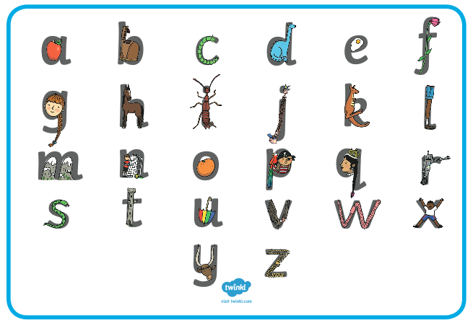  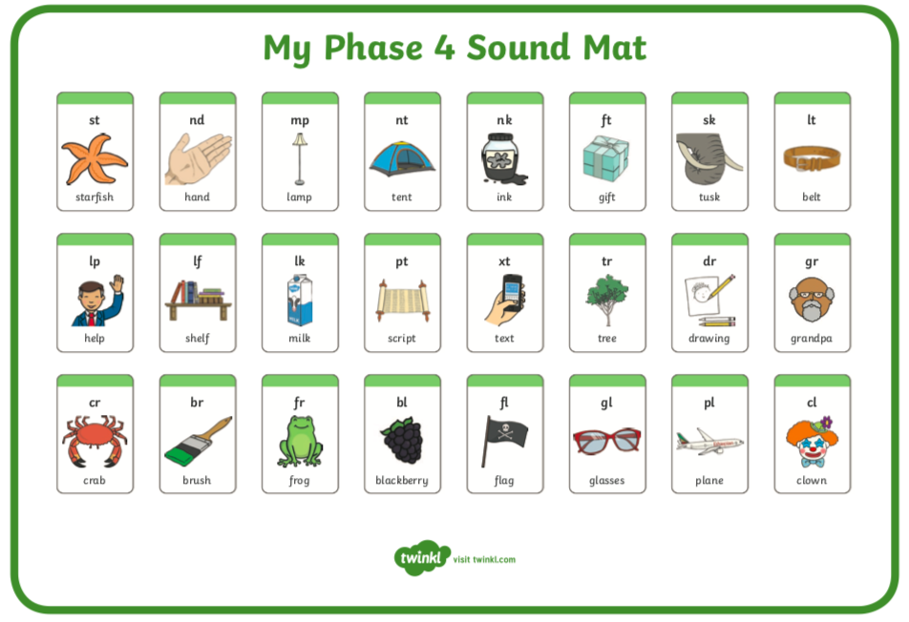  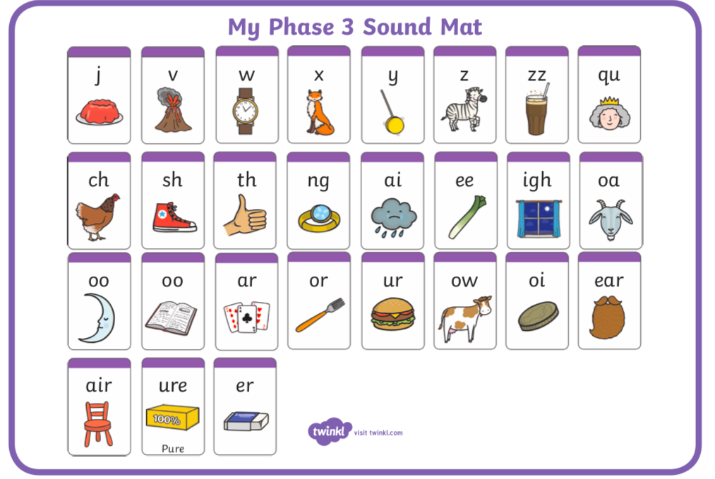
10:00- 11:00 | Inside and Outside Play-  Child Led | 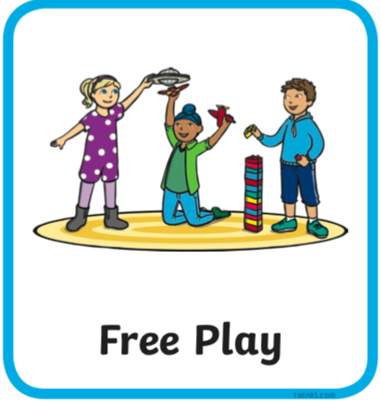 | Resource idea- Can you gather some pots to fill with water to freeze. Can you put a toy in any of them to try to free tomorrow!
11:00- 11:30 | Snack and Chill | 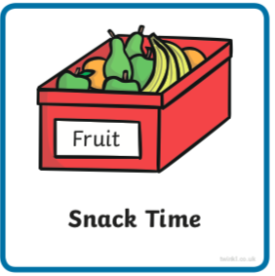 | Snack and chill
11:30- 12:00 | Maths-  Adult Led | 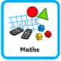 | Numbers beyond 20  Watch this https://www.bbc.co.uk/iplayer/episode/m0007g91/numberblocks-series-4-21-twenty-one-and-on  You may like to watch for a second time with an adult pausing a few times throughout this time to explain a little further or reiterate what Is being shown.  Can you ‘make two numbers’ as the numberblock suggests with larger numbers by grouping the tens and ones of these numbers 14, 18 and 21. You could use small objects to make these groups. Can you record this on paper by drawing what you see?
12:00- 12:30 | Prepare For Lunch | 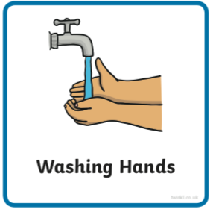 | You could help your grown up by setting the table, getting things from the fridge, chopping or pouring the drinks.
12:30 – 13:30 | Lunch and Chill | 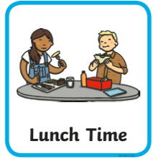 | Lunch and chill
13:30- 14:00 | Explore-  Adult Led | 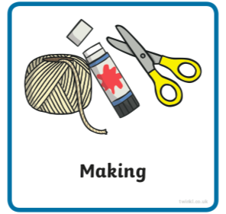 | Can you make a special pot from a toilet roll tube using the technique below? What special things could you keep in there?
14:00- 15:00 | Inside and Outside Play-  Child Led |  | Refresh the resource from this morning.
15:00- 15:15 | Tidy Up Time | 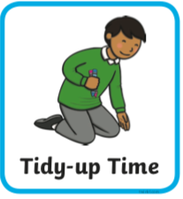 | Playing a song on may help keep things positive.
15:15- 15:30  or Bedtime | Story Time- | 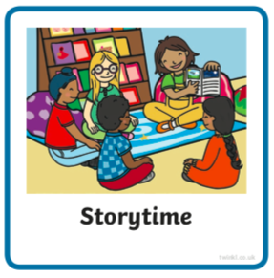 | Share ‘Hairy Maclary’ with a grown up-  https://www.booktrust.org.uk/books-and-reading/have-some-fun/storybooks-and-games/hairy-maclary/  Can you think of anything that rhymes with your name? It could be a made up word…  Now it’s your turn to share a story with your grown up. Choose a story from this website, remember to read the same book at least 3 times to improve your comprehension skills.  First you need to register on the website for free here- https://www.oxfordowl.co.uk/user/sign_up.html  Once you are logged in this link will take you to the children's e reading books. Look for a blob of colour on the virtual front cover of the book, you should choose the colour book your child is currently reading-  https://www.oxfordowl.co.uk/for-home/find-a-book/library-page/?view=image&query=&type=book&age_group=Age+4-5&level=&level_select=&book_type=&series=#
Links for more stories if you’d like a few new ones |  |  | https://www.freechildrenstories.com/age-3-5  https://www.freechildrenstories.com/age-5-8-1https://www.bbc.co.uk/cbeebies/stories  https://www.booktrust.org.uk/books-and-reading/have-some-fun/storybooks-and-games/  https://www.storyberries.com/category/5-min-stories/

Key Skills
These key skills are important in giving children a good foundation for year one.
These are the key skills covered in today’s timetable. You may like to cover them in a different way to suggested in the timetable or do some further exploration of them in addition to the timetable.

Prime Key Skills | Literacy Key Skills | Maths Key Skills
Use pencils effectively for writing by forming most letters correctly. | Write words in a way that match children’s spoken sounds. | Place the numbers to 20 in order
Understand what they have read by talking with others about what they have just read. | Understand the use of a finger space to separate words. Use finger spaces appropriately. | Create and describe patterns.
 | Write a simple sentence.
 | Use phonic knowledge to decode regular words and read them aloud accurately.
 | Read simple sentences.

