09:00- 09:30 | Joe Wicks Workout | 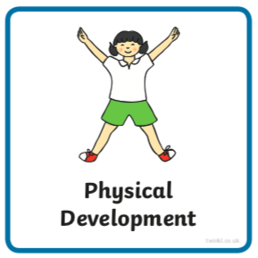 | Find Joe Wick’s live daily workouts via YouTube.
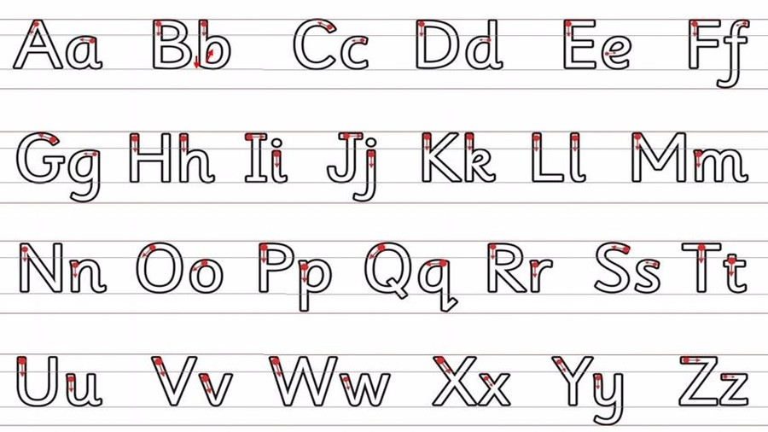  09:30- 10:00 | Literacy-  Adult Led | 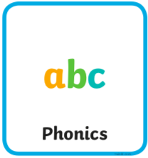 | Log in to https://new.phonicsplay.co.uk/ if this link doesn’t work on your device try https://www.phonicsplay.co.uk/#  username march20 password home  Tricky Words- Choose ‘Tricky Words Trucks’ https://new.phonicsplay.co.uk/resources/phase/4/tricky-word-trucks and select the set that is most suited to the ‘Pokemon Tricky Word Sheet’ you are currently working on.  Segment and Blend-  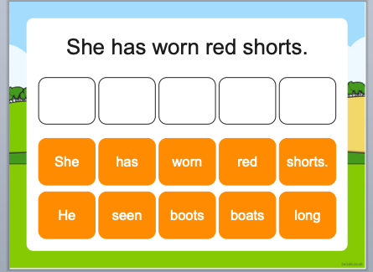  Write- Can you write what you have changed the sentence to?  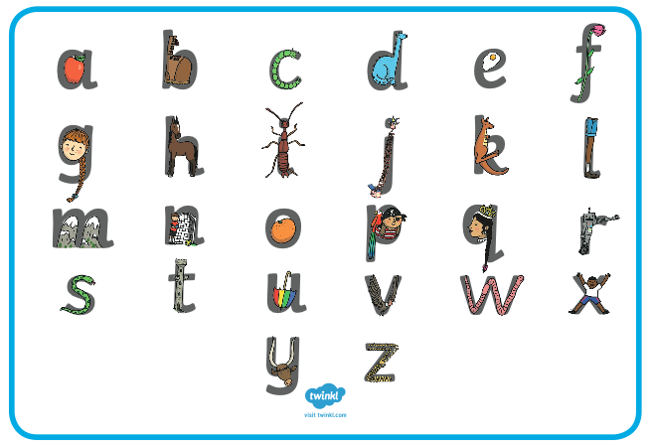  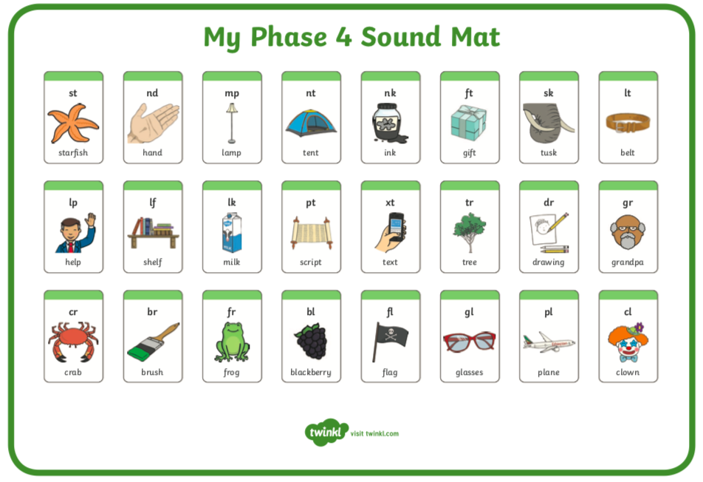  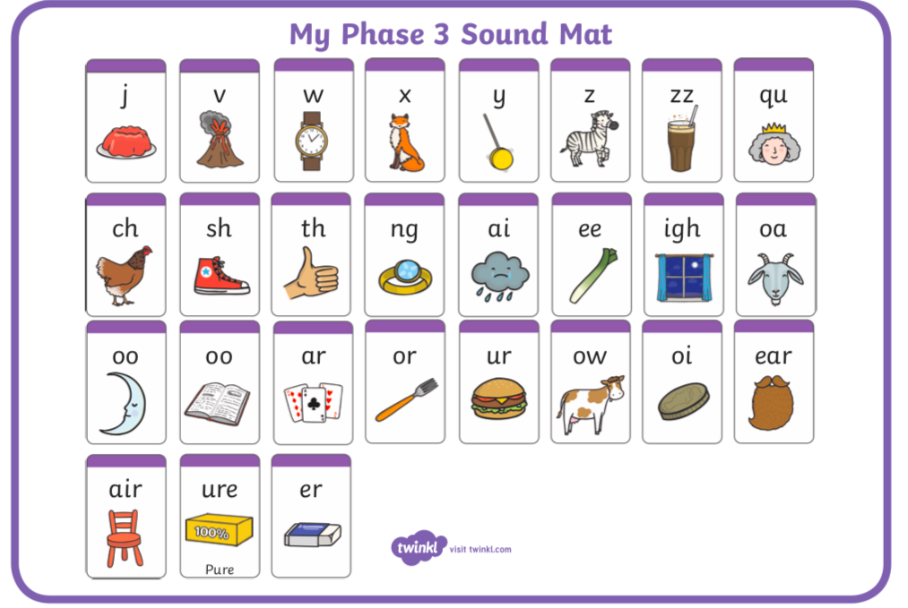
10:00- 11:00 | Inside and Outside Play-  Child Led | 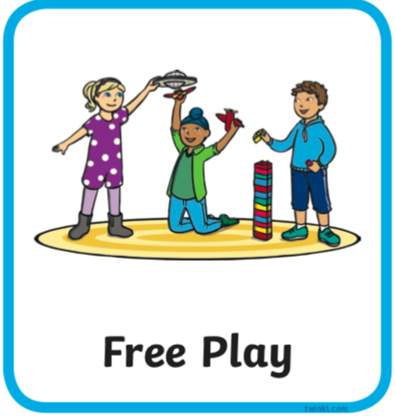 | Resource idea- If you have plastic cups see if you can make plastic cup towers! If not see what you can create with bowls or even plates. Do they always need to overlap? Can you make a long wall as well as a tall tower? Does a wide base help you to go higher, or not?
11:00- 11:30 | Snack and Chill | 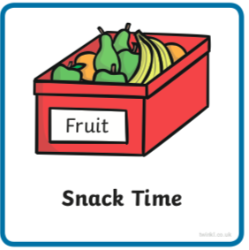 | Snack and chill
11:30- 12:00 | Maths-  Adult Led | 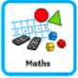 | Numbers beyond 20  Watch this https://www.bbc.co.uk/iplayer/episode/m0007lkw/numberblocks-series-4-28-one-hundred  You may like to watch for a second time with an adult pausing a few times throughout this time to explain a little further or reiterate what Is being shown.  If you haven’t got them, can you make some more groups of 10 but today make sure you have ten groups of ten. Can you practice counting in tens forwards and backwards with them.  Extension- Make a 100 square writing numbers from 0-9 then the next row 10- 19 and so on. Each column should have the same units eg 11, 21, 31, 41, 51, 61, 71, 81, 91 should all be in the same column below each other.
12:00- 12:30 | Prepare For Lunch | 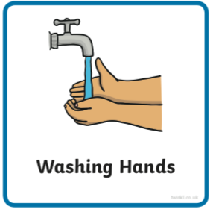 | You could help your grown up by setting the table, getting things from the fridge, chopping or pouring the drinks.
12:30 – 13:30 | Lunch and Chill | 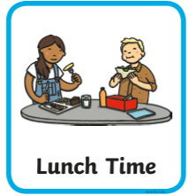 | Lunch and chill
13:30- 14:00 | Explore-  Adult Led | 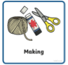 | Have a go at drawing today try following this video step by step https://vimeo.com/205109268 if this link doesn’t work try this and scroll down to the video ‘Draw Jet Bug’ https://www.theartabet.com/what-should-you-teach-a-young-child-to-draw-ages-3-to-7/  Before you do practice these movements on paper  - Move your arm in a round and round motion.  - Move your arm up and down.  - Move your arm back and forth.  - Move your arm in a zig zag motion.  - Move your arm in a wiggle motion.  - Move your arm with a jabbing or dot dot dot motion.
14:00- 15:00 | Inside and Outside Play-  Child Led |  | Refresh the resource from this morning.
15:00- 15:15 | Tidy Up Time | 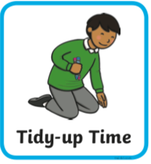 | Playing a song on may help keep things positive.
15:15- 15:30  or Bedtime | Story Time- | 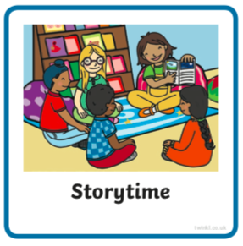 | We are focusing on poetry this week, listen with Michael Rosen and learn about repetition https://www.bbc.co.uk/cbeebies/radio/poetry-playtime-repetition you might recognise the ‘Ram Sam Sam’ song children, we have sung it in school before. Have a go at some rain sound repetition yourself.  Now it’s your turn to share a story with your grown up. Choose a story from this website, remember to read the same book at least 3 times to improve your comprehension skills.  First you need to register on the website for free here- https://www.oxfordowl.co.uk/user/sign_up.html  Once you are logged in this link will take you to the children's e reading books. Look for a blob of colour on the virtual front cover of the book, you should choose the colour book your child is currently reading-  https://www.oxfordowl.co.uk/for-home/find-a-book/library-page/?view=image&query=&type=book&age_group=Age+4-5&level=&level_select=&book_type=&series=#
Links for more stories if you’d like a few new ones |  |  | https://www.freechildrenstories.com/age-3-5  https://www.freechildrenstories.com/age-5-8-1https://www.bbc.co.uk/cbeebies/stories  https://www.booktrust.org.uk/books-and-reading/have-some-fun/storybooks-and-games/  https://www.storyberries.com/category/5-min-stories/

Key Skills
These key skills are important in giving children a good foundation for year one.
These are the key skills covered in today’s timetable. You may like to cover them in a different way to suggested in the timetable or do some further exploration of them in addition to the timetable.

Prime Key Skills | Literacy Key Skills | Maths Key Skills
Use pencils effectively for writing by forming most letters correctly. | Write words in a way that match children’s spoken sounds. | Create and describe patterns
Understand what they have read by talking with others about what they have just read. | Understand the use of a finger space to separate words. Use finger spaces appropriately. | Add and subtract using objects or equipment
 | Write a simple sentence.
 | Use phonic knowledge to decode regular words and read them aloud accurately.
 | Read simple sentences.
 | Read some common irregular words.

