09:00- 09:30 | Joe Wicks Workout | 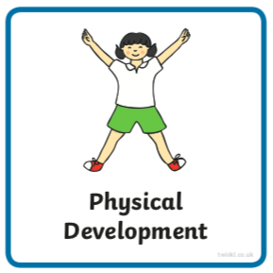 | Find Joe Wick’s live daily workouts via YouTube
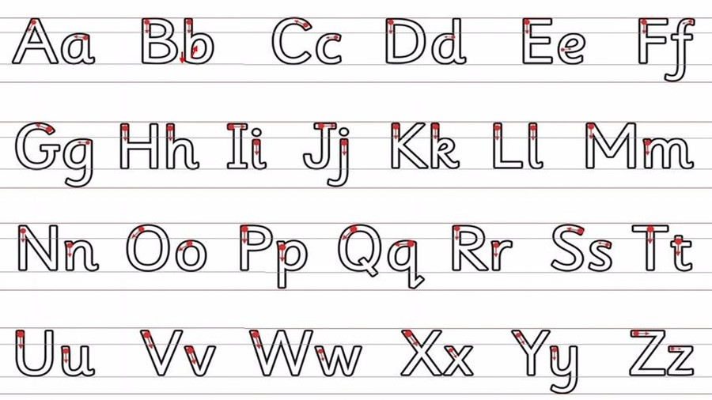  09:30- 10:00 | Literacy-  Adult Led | 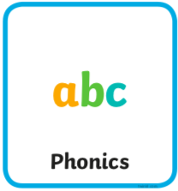 | Segment and Blend- Can you read the sentence and then substitute in one of the words to change the sentence?  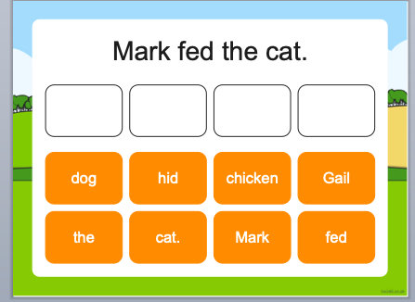  Write- Can you write what you have changed the sentence to?  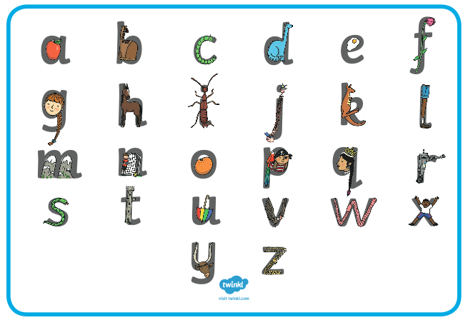  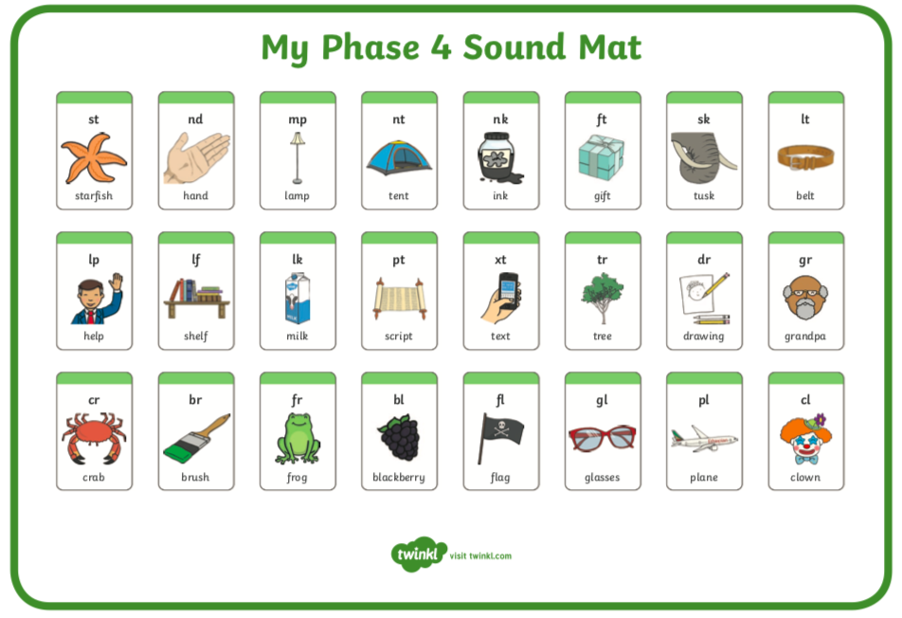  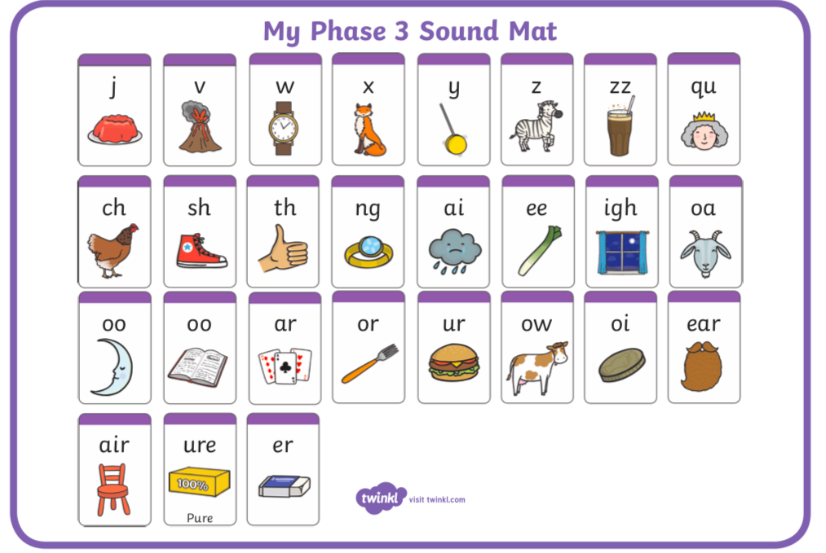
10:00- 11:00 | Inside and Outside Play-  Child Led | 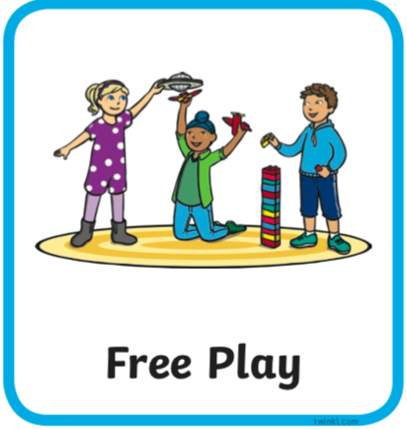 | Resource idea- Make a cutting tray with safe things to cut such as natural things like leaves, grass, dandelions, daisies, feather if you’re lucky. Maybe you have some things safe to experiment cutting with scissors indoors like wool, string, tape, food, toilet roll. Remember to be extra careful if you are using adult scissors.
11:00- 11:30 | Snack and Chill | 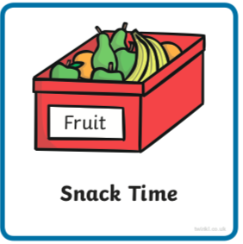 | Snack and chill
11:30- 12:00 | Maths-  Adult Led | 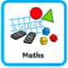 | Numbers beyond 20  Watch this https://www.bbc.co.uk/iplayer/episode/m0007jym/numberblocks-series-4-25-fifty  You may like to watch for a second time with an adult pausing a few times throughout this time to explain a little further or reiterate what Is being shown.  You may or may not still have the groups of 10 you made a couple of weeks ago. If you don’t could you make them again? See how many different number sentences you can make using them e.g. 10 + 20 =… or 40 - 10 =… Can you record two of them on paper?
12:00- 12:30 | Prepare For Lunch | 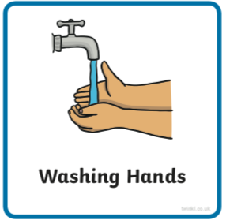 | You could help your grown up by setting the table, getting things from the fridge, chopping or pouring the drinks.
12:30 – 13:30 | Lunch and Chill | 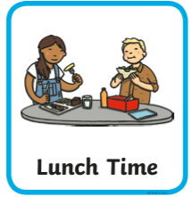 | Lunch and chill
13:30- 14:00 | Explore-  Adult Led | 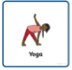 | Can you get changed into something sporty for your yoga session (key skill)?  Do ‘Cosmic Kids Yoga’ session, today it’s all about dogs https://uk.video.search.yahoo.com/yhs/search;_ylt=AwrExwjDe7heJWgANx6c3olQ?fr=yhs-sz-002&hsimp=yhs-002&hspart=sz&gdpr=1&ei=UTF-8&p=cosmic+kids+yoga&fr2=p%3As%2Cv%3Av%2Cm%3Asp-qrw-corr-top&norw=1#id=1&vid=c868780183090bd932f6bcc15db4b94f&action=view
14:00- 15:00 | Inside and Outside Play-  Child Led |  | Refresh the resource from this morning.
15:00- 15:15 | Tidy Up Time | 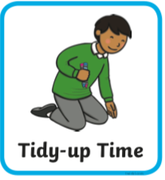 | Playing a song on may help keep things positive.
15:15- 15:30  or Bedtime | Story Time- | 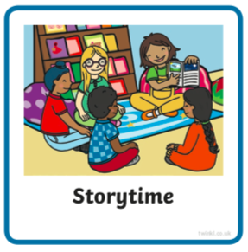 | We are focusing on poetry this week, listen with Michael Rosen and learn about riddles https://www.bbc.co.uk/cbeebies/radio/poetry-playtime-riddles  Did you guess any of the riddles in the podcast? They can be tricky cant they? Mrs Griffiths loves to try and work out a riddle.  Now it’s your turn to share a story with your grown up. Choose a story from this website, remember to read the same book at least 3 times to improve your comprehension skills.  First you need to register on the website for free here- https://www.oxfordowl.co.uk/user/sign_up.html  Once you are logged in this link will take you to the children's e reading books. Look for a blob of colour on the virtual front cover of the book, you should choose the colour book your child is currently reading-  https://www.oxfordowl.co.uk/for-home/find-a-book/library-page/?view=image&query=&type=book&age_group=Age+4-5&level=&level_select=&book_type=&series=#
Links for more stories if you’d like a few new ones |  |  | https://www.freechildrenstories.com/age-3-5  https://www.freechildrenstories.com/age-5-8-1https://www.bbc.co.uk/cbeebies/stories  https://www.booktrust.org.uk/books-and-reading/have-some-fun/storybooks-and-games/  https://www.storyberries.com/category/5-min-stories/

Key Skills
These key skills are important in giving children a good foundation for year one.
These are the key skills covered in today’s timetable. You may like to cover them in a different way to suggested in the timetable or do some further exploration of them in addition to the timetable.

Prime Key Skills | Literacy Key Skills | Maths Key Skills
Use pencils effectively for writing by forming most letters correctly. | Write words in a way that match children’s spoken sounds. | Create and describe patterns
Understand what they have read by talking with others about what they have just read. | Understand the use of a finger space to separate words. Use finger spaces appropriately. | Add and subtract using objects or equipment
Dress themselves independently | Write a simple sentence.
Can show sensitivity towards other’s needs some of the time | Use phonic knowledge to decode regular words and read them aloud accurately.
Respond to stories after listening to them with comments and questions or anticipating what’s coming next. | Read simple sentences.

