09:00- 09:30 | Joe Wicks Workout | 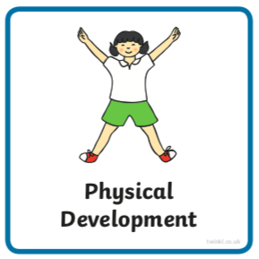 | Joe Wick’s live daily workouts via YouTube
09:30- 10:00 | Literacy-  Adult Led | 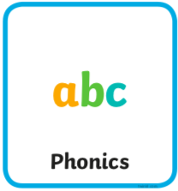 | Segment and Blend- Can you read the sentences and match it to the picture?  Write- Choose of the sentence you have read to write. Try not to look at it whilst writing if you can.  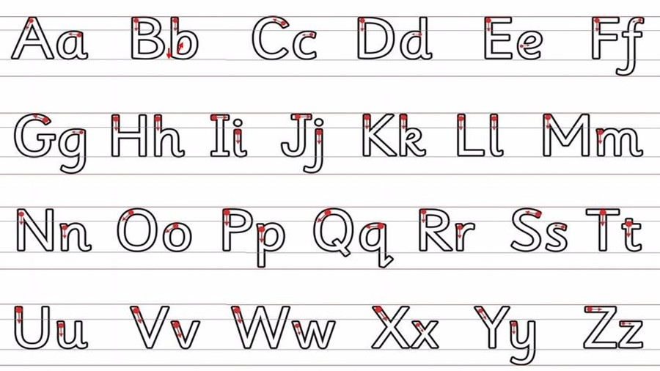  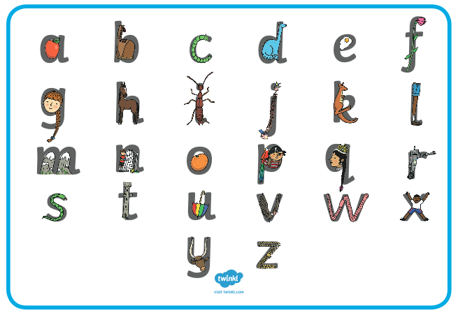  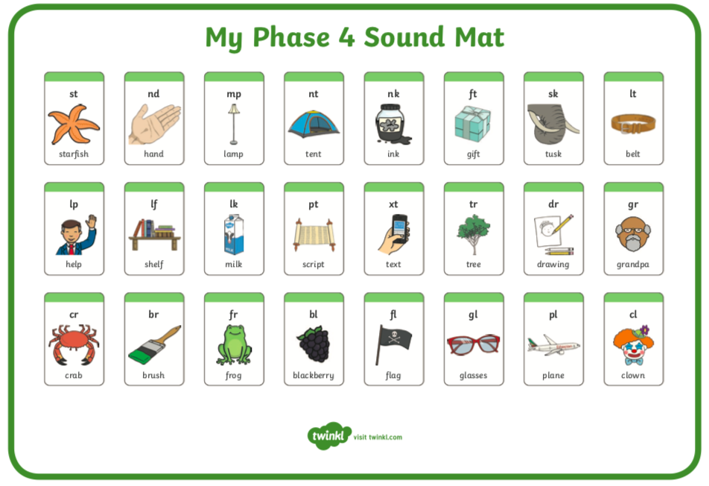  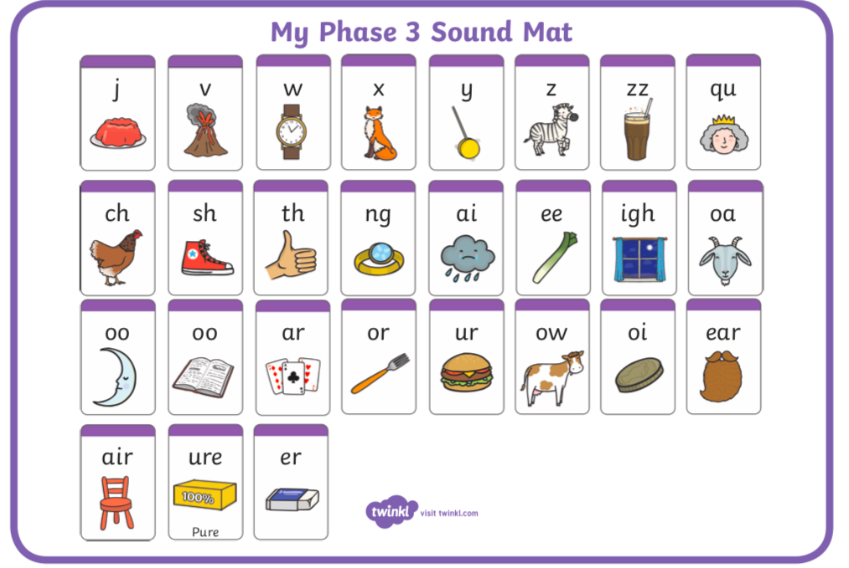
10:00- 11:00 | Inside and Outside Play-  Child Led | 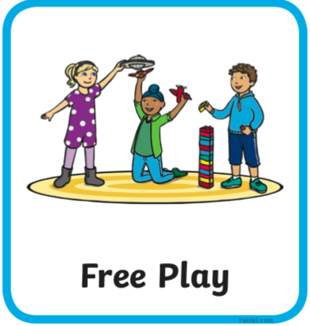 | Resource idea- Set up a little station outside as a ‘café’ or ‘lemonade stop’ all you need is a jug with a drink of your choice in and some cups (maybe various sizes). Your family may come along and ask for one at various times, if not, play with your toys. Your pouring skills may get better and better!
11:00- 11:30 | Snack and Chill | 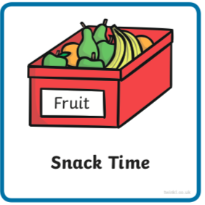 | Snack and chill
11:30- 12:00 | Maths-  Adult Led | 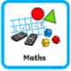 | We are revisiting halving but with shapes this time. Use pieces of paper you have already or if you’d like more of a challenge trace or draw some shapes. Once you’ve drawn them you’re gong to cut or fold them in exactly half. Here is some inspiration below. Remember the two halves must be exactly the same. You may struggle a little with cutting exactly the same but try your best!  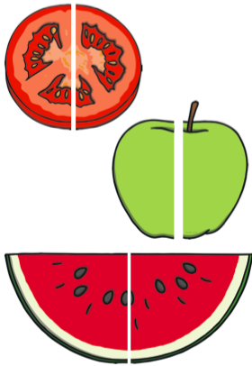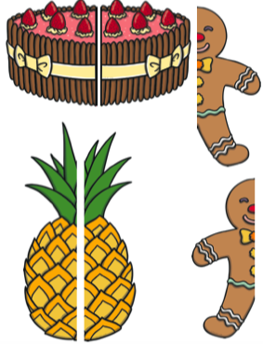
12:00- 12:30 | Prepare For Lunch | 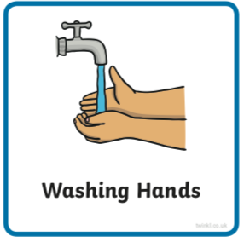 | You could help your grown up by setting the table, getting things from the fridge, chopping or pouring the drinks.
12:30 – 13:30 | Lunch and Chill | 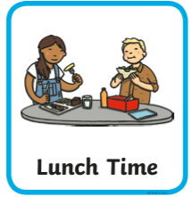 | Lunch and chill
13:30- 14:00 | Explore-  Adult Led | 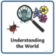 | How many of these things can you find on this scavenger hunt?  Can you answer a why question asked by an adult about something you find?
14:00- 15:00 | Inside and Outside Play-  Child Led |  | Refresh the resource from this morning.
15:00- 15:15 | Tidy Up Time | 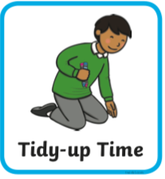 | Playing a song on may help keep things positive.
15:15- 15:30  or Bedtime | Story Time- | 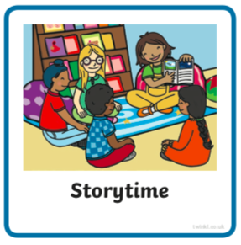 | We are focusing on poetry this week, listen with Michael Rosen and learn about word play https://www.bbc.co.uk/cbeebies/radio/poetry-playtime-wordplay can you think of any word plays using ‘Ashton Vale’?  Now it’s your turn to share a story with your grown up. Choose a story from this website, remember to read the same book at least 3 times to improve your comprehension skills.  First you need to register on the website for free here- https://www.oxfordowl.co.uk/user/sign_up.html  Once you are logged in this link will take you to the children's e reading books. Look for a blob of colour on the virtual front cover of the book, you should choose the colour book your child is currently reading-  https://www.oxfordowl.co.uk/for-home/find-a-book/library-page/?view=image&query=&type=book&age_group=Age+4-5&level=&level_select=&book_type=&series=#
Links for more stories if you’d like a few new ones |  |  | https://www.freechildrenstories.com/age-3-5  https://www.freechildrenstories.com/age-5-8-1https://www.bbc.co.uk/cbeebies/stories  https://www.booktrust.org.uk/books-and-reading/have-some-fun/storybooks-and-games/  https://www.storyberries.com/category/5-min-stories/

Key Skills
These key skills are important in giving children a good foundation for year one.
These are the key skills covered in today’s timetable. You may like to cover them in a different way to suggested in the timetable or do some further exploration of them in addition to the timetable.

Prime Key Skills | Literacy Key Skills | Maths Key Skills
Use pencils effectively for writing by forming most letters correctly. | Write words in a way that match children’s spoken sounds. | Understand the concept of doubling and halving using objects or concrete equipment.
Understand what they have read by talking with others about what they have just read. | Understand the use of a finger space to separate words. Use finger spaces appropriately.
Respond to stories after listening to them with comments and questions or anticipating what’s coming next. | Write a simple sentence.
Understand what they have read by talking with others about what they have just read. | Use phonic knowledge to decode regular words and read them aloud accurately.
 | Read simple sentences.

