09:00- 09:30 | Joe Wicks Workout | 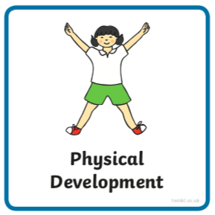 | Joe Wick’s live daily workouts via YouTube
09:30- 10:00 | Literacy-  Adult Led | 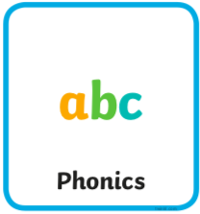 | Segment and Blend- Can you read the sentences and match them to the picture?  Write- Choose of the sentence you have read to write. Try not to look at it whilst writing if you can.  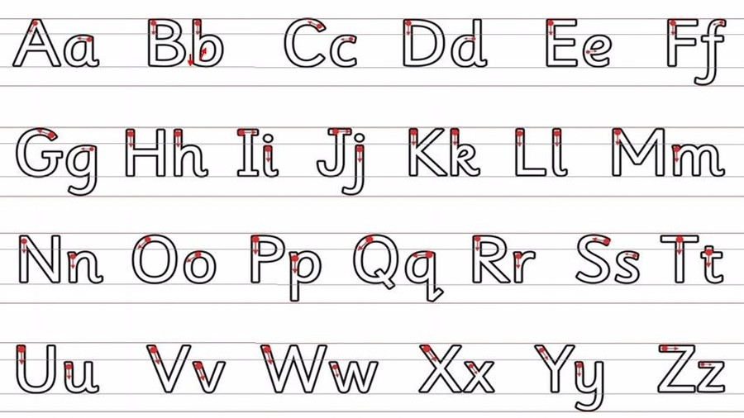  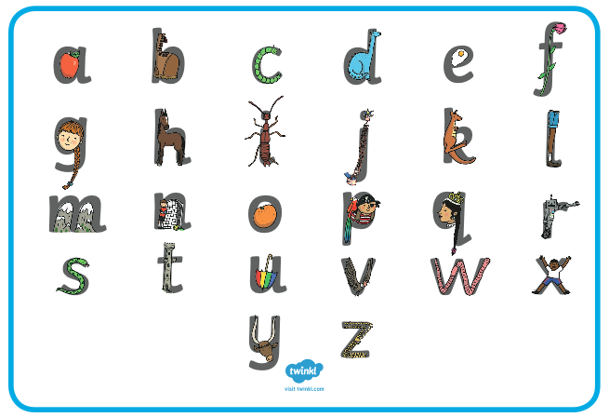  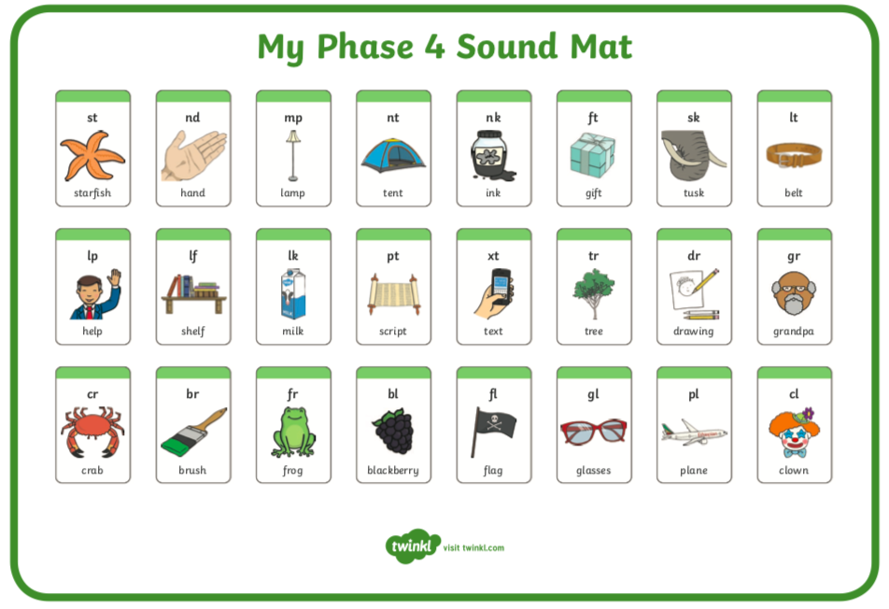  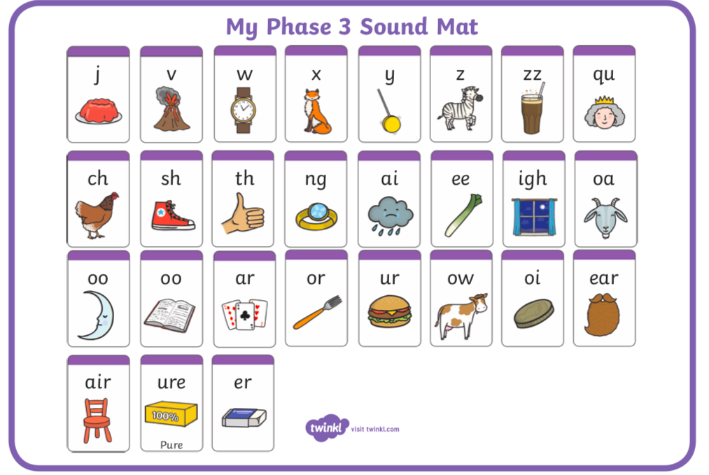
10:00- 11:00 | Inside and Outside Play-  Child Led | 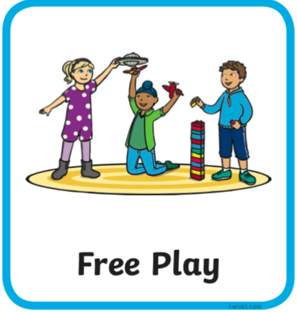 | Resource idea- Collect rocks, stone or grit… can you find a way or different ways to sort and order them? Is there anything special or unique about any you find?
11:00- 11:30 | Snack and Chill | 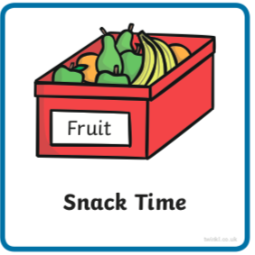 | Snack and chill
11:30- 12:00 | Maths-  Adult Led | 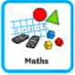 | We’re revisiting doubles; remind your child “doubling means we add the same again”. If we are adding does that mean there will be more or less?  Play this game (you may need to make it full screen to play) use the apples below to help you if you need to. Try level 1 or more if you’d like. https://www.ictgames.com/mobilePage/archeryDoubles/index.html  Try doing quick double challenges (to 10) with your fingers. Could you show your choice of amount of fingers to hold up, your adult has to double it with theirs and say the total? Then reverse the roles.
12:00- 12:30 | Prepare For Lunch | 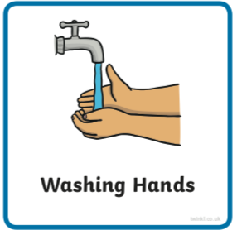 | You could help your grown up by setting the table, getting things from the fridge, chopping or pouring the drinks.
12:30 – 13:30 | Lunch and Chill | 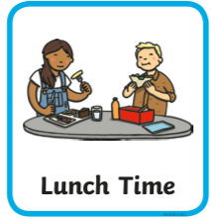 | Lunch and chill
13:30- 14:00 | Explore-  Adult Led | 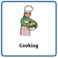 | Can you make a simple 3-ingredient cereal bar? Hopefully you already have these in the cupboard…  Melt equal parts of peanut butter (or normal butter) with honey or syrup on the hob or in the microwave.  Mix with cheerios (or any cereal) in another bowl.  Pour into a lined baking tin.  Best kept in the fridge or I like to keep them in the freezer!  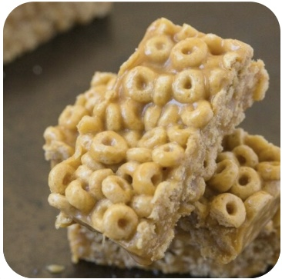
14:00- 15:00 | Inside and Outside Play-  Child Led |  | Refresh the resource from this morning.
15:00- 15:15 | Tidy Up Time | 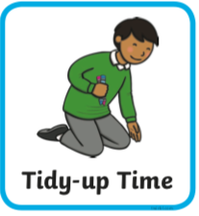 | Playing a song on may help keep things positive.
15:15- 15:30  or Bedtime | Story Time- | 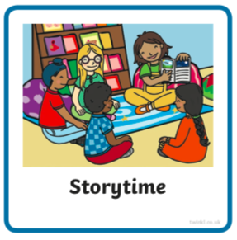 | We are focusing on poetry this week, listen with Michael Rosen and learn about rhyme https://www.bbc.co.uk/cbeebies/radio/poetry-playtime-rhyme  Maybe you could think of two words of things you can buy from the shop that do rhyme and two things that don’t.  Now it’s your turn to share a story with your grown up. Choose a story from this website, remember to read the same book at least 3 times to improve your comprehension skills.  First you need to register on the website for free here- https://www.oxfordowl.co.uk/user/sign_up.html  Once you are logged in this link will take you to the children's e reading books. Look for a blob of colour on the virtual front cover of the book, you should choose the colour book your child is currently reading-  https://www.oxfordowl.co.uk/for-home/find-a-book/library-page/?view=image&query=&type=book&age_group=Age+4-5&level=&level_select=&book_type=&series=#
Links for more stories if you’d like a few new ones |  |  | https://www.freechildrenstories.com/age-3-5  https://www.freechildrenstories.com/age-5-8-1https://www.bbc.co.uk/cbeebies/stories  https://www.booktrust.org.uk/books-and-reading/have-some-fun/storybooks-and-games/  https://www.storyberries.com/category/5-min-stories/

Key Skills
These key skills are important in giving children a good foundation for year one.
These are the key skills covered in today’s timetable. You may like to cover them in a different way to suggested in the timetable or do some further exploration of them in addition to the timetable.

Prime Key Skills | Literacy Key Skills | Maths Key Skills
Use pencils effectively for writing by forming most letters correctly. | Write words in a way that match children’s spoken sounds. | Understand the concept of doubling and halving using objects or concrete equipment
Understand what they have read by talking with others about what they have just read. | Understand the use of a finger space to separate words. Use finger spaces appropriately.
Respond to stories after listening to them with comments and questions or anticipating what’s coming next. | Write a simple sentence.
Understand what they have read by talking with others | Use phonic knowledge to decode regular words and read them aloud accurately.
 | Read simple sentences.

