09:00- 09:30 | Joe Wicks Workout | 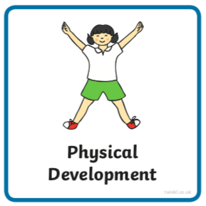 | Joe Wick’s live daily workouts via YouTube
09:30- 10:00 | Literacy-  Adult Led | 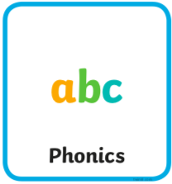 | Segment and Blend- Can you read the sentences and match it to the picture? (you should be able to enlarge the image)  Write- Choose of the sentence you have read to write. Try not to look at it whilst writing if you can.  - Draw lines to write onto. Use paper or boards landscape.  - Ask your child to remember the things we need to use when writing a sentence. If they don’t remember tell them: a capital letter at the beginning, finger spaces between words and a full stop or question mark at the end.  - Ask your child to say the sentence a couple of times first with help, then independently. They should try and ‘hold the sentence’ in their head.  - Without looking at the above (if possible), begin to work on the first word. Show them the capital letter chart below to help. They should aim to sound the word before or as they are writing it. They can look at the charts below to help as they write.  - If they miss out a sound try not to correct them as they write. Let them know once they have completed the whole sentence (focus on just one correction).  - If your child finds this tricky, write two words separated by a finger space.  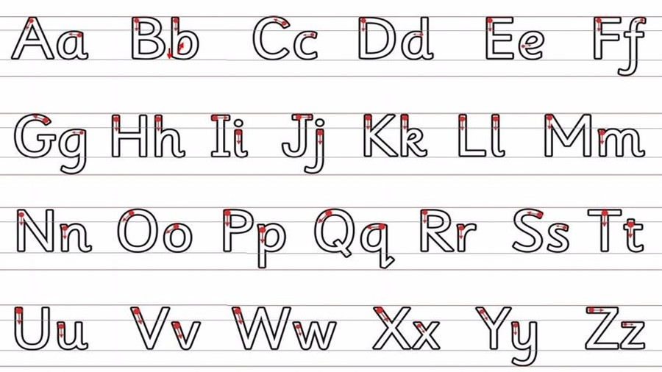  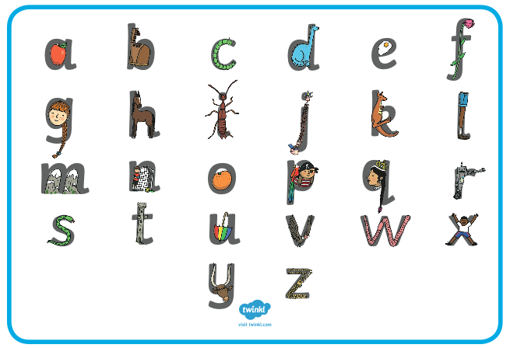  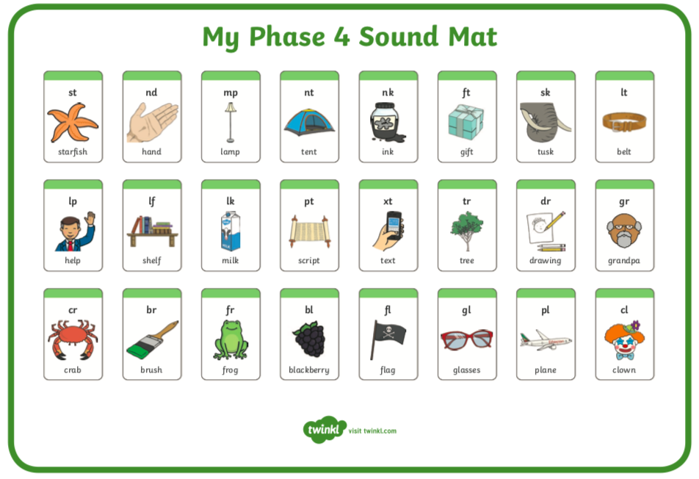  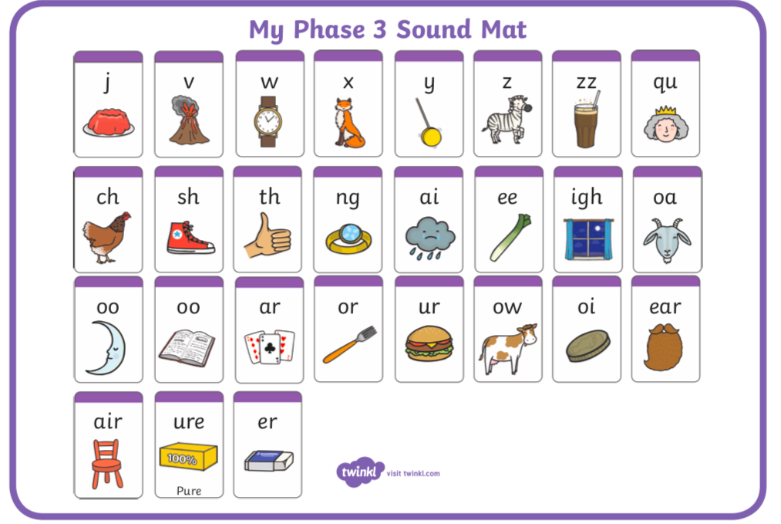
10:00- 11:00 | Inside and Outside Play-  Child Led | 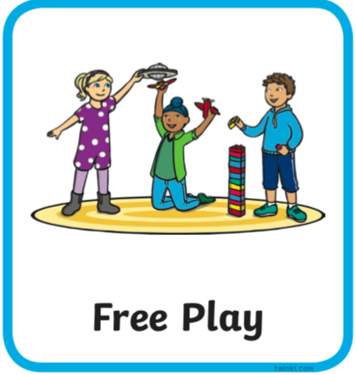 | Resource idea- Can you make a toy zipline? Find some string or similar and attach it to an upstairs window if you have one, with an adult. Secure the other end in the garden or get someone to hold the other end. Find a hanger and attach a toy. Send your toy down the zip line!
11:00- 11:30 | Snack and Chill | 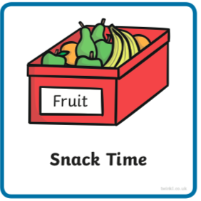 | Snack and chill
11:30- 12:00 | Maths-  Adult Led | 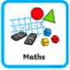 | We’re looking at ordering teen numbers, watch this https://www.bbc.co.uk/cbeebies/watch/the-numtums-the-mysterious-land-beyond-ten  Then have a go at ordering yourself here https://www.ictgames.com/rangeArranger/index.html set the level from 1 to 20 or beyond but watch out there are some numbers missing.
12:00- 12:30 | Prepare For Lunch | 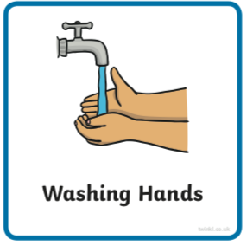 | You could help your grown up by setting the table, getting things from the fridge, chopping or pouring the drinks.
12:30 – 13:30 | Lunch and Chill | 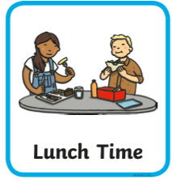 | Lunch and chill
13:30- 14:00 | Explore-  Adult Led | 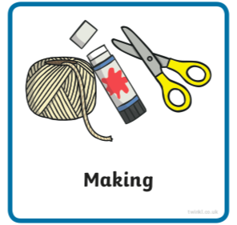 | Can you make an octopus using a toilet roll tube? How many legs do they have?  Very carefully, and with an adult helping you all of the time, can you curl the octopus’ paper legs?
14:00- 15:00 | Inside and Outside Play-  Child Led |  | Refresh the resource from this morning.
15:00- 15:15 | Tidy Up Time | 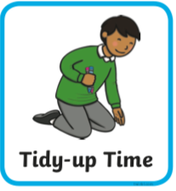 | Playing a song on may help keep things positive.
15:15- 15:30  or Bedtime | Story Time- | 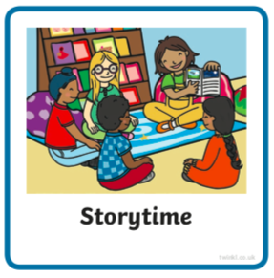 | We are focusing on poetry this week, listen with Michael Rosen and learn about question and answer https://www.bbc.co.uk/cbeebies/radio/poetry-playtime-question-and-answer  Think about a question you could ask using a question word at the beginning. Do you notice when you are asking questions at home? Can you think of any silly answers to a question that rhyme?  Now it’s your turn to share a story with your grown up. Choose a story from this website, remember to read the same book at least 3 times to improve your comprehension skills.  First you need to register on the website for free here- https://www.oxfordowl.co.uk/user/sign_up.html  Once you are logged in this link will take you to the children's e reading books. Look for a blob of colour on the virtual front cover of the book, you should choose the colour book your child is currently reading-  https://www.oxfordowl.co.uk/for-home/find-a-book/library-page/?view=image&query=&type=book&age_group=Age+4-5&level=&level_select=&book_type=&series=#
Links for more stories if you’d like a few new ones |  |  | https://www.freechildrenstories.com/age-3-5  https://www.freechildrenstories.com/age-5-8-1https://www.bbc.co.uk/cbeebies/stories  https://www.booktrust.org.uk/books-and-reading/have-some-fun/storybooks-and-games/  https://www.storyberries.com/category/5-min-stories/

Key Skills
These key skills are important in giving children a good foundation for year one.
These are the key skills covered in today’s timetable. You may like to cover them in a different way to suggested in the timetable or do some further exploration of them in addition to the timetable.

Prime Key Skills | Literacy Key Skills | Maths Key Skills
Use pencils effectively for writing by forming most letters correctly. | Write words in a way that match children’s spoken sounds. | Create and describe patterns
Understand what they have read by talking with others about what they have just read. | Understand the use of a finger space to separate words. Use finger spaces appropriately. | Count objects up to 20 reliably forwards and backwards
Respond to stories after listening to them with comments and questions or anticipating what’s coming next. | Write a simple sentence. | Place the numbers to 20 in order
 | Use phonic knowledge to decode regular words and read them aloud accurately.
 | Read simple sentences.

