09:00- 09:30 | Joe Wicks Workout | 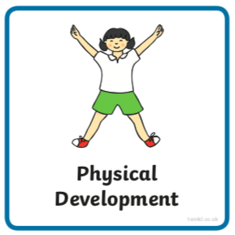 | Find Joe Wick’s live daily workouts via YouTube.
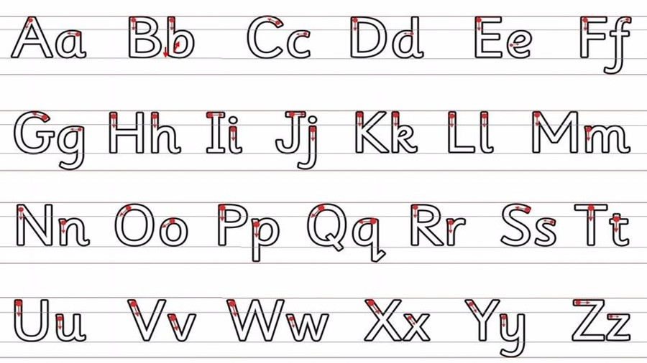  09:30- 10:00 | Literacy-  Adult Led | 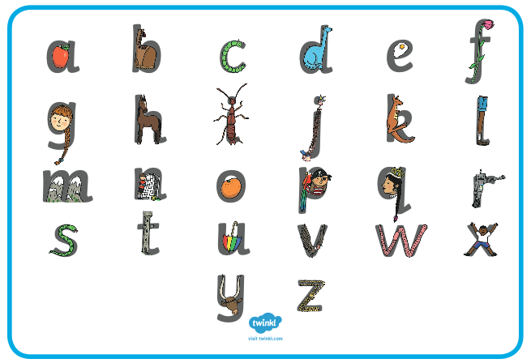  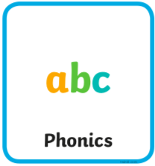 | Read- Play this tricky word game https://epicphonics.com/games/play/free-penalty-shootout-tricky-words-game  Write- Choose 3 tricky words to write. You can use the Pokémon sheet you are working on at the moment to help you.  - Draw lines for your child to write onto. Use paper or boards landscape.  - Remember to still use finger spaces between words.  - Try writing one of them without looking.  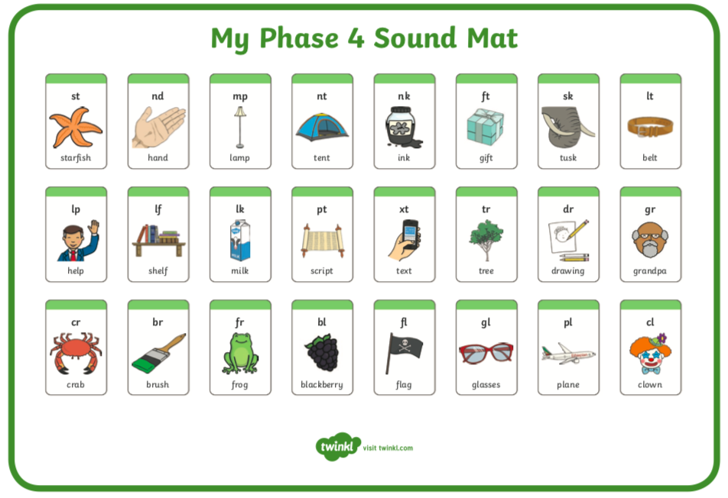  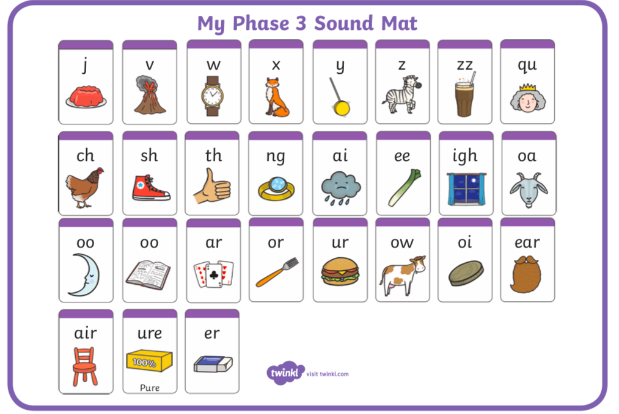
10:00- 11:00 | Inside and Outside Play-  Child Led | 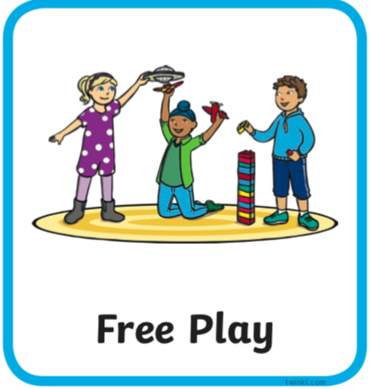 | Resource idea- A pack of cards give some prompt ideas such as sorting or stacking, or fanning.
11:00- 11:30 | Snack and Chill | 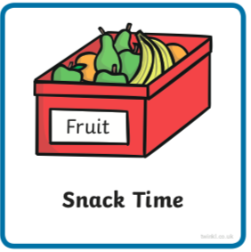 | Screen time, picnic or more playing after you’ve eaten- you choose!
11:30- 12:00 | Maths-  Adult Led | 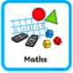 | Watch this lesson clip https://www.bbc.co.uk/bitesize/clips/zksvcdm  Do you have these coins at home to experiment with? If you don’t you could draw them and cut them out.  Are there any other coins that if added together make 10 pence altogether? Remember with a problem it’s great to get it wrong first before you find the solution.  Can you record the problem on paper?
12:00- 12:30 | Prepare For Lunch | 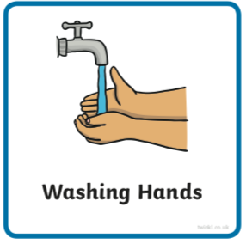 | You could help your grown up by setting the table, getting things from the fridge, chopping or pouring the drinks.
12:30 – 13:30 | Lunch and Chill | 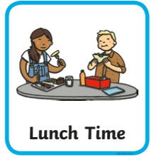 | Screen time, picnic or more playing after you’ve eaten- you choose!
13:30- 14:00 | Explore-  Adult Led | 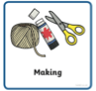 | Toilet roll craft- can you make a ninja?  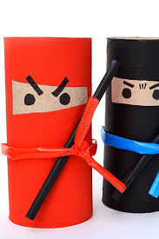
14:00- 15:00 | Inside and Outside Play-  Child Led |  | Refresh the resource from this morning.
15:00- 15:15 | Tidy Up Time | 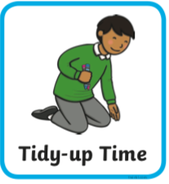 | Playing a song on may help keep things positive.
15:15- 15:30  or Bedtime | Story Time-  Adult or Child Led | 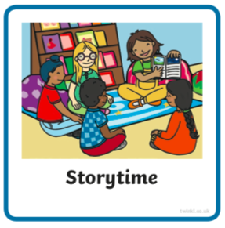 | Read ‘The Journey of the Nobel Gnarble’  https://www.freechildrenstories.com/the-journey-of-the-noble-gnarble
More links for stories if you’re getting a little fed up with the selection you have |  |  | Can you choose a story from home or from one of these websites for an adult to share with you?  https://www.freechildrenstories.com/age-3-5  https://www.freechildrenstories.com/age-5-8-1https://www.bbc.co.uk/cbeebies/stories  https://www.booktrust.org.uk/books-and-reading/have-some-fun/storybooks-and-games/  https://www.storyberries.com/category/5-min-stories/ | Can you choose a story from this website for you to share with an adult?  First you need to register on the website for free here  https://www.oxfordowl.co.uk/user/sign_up.html  Once you are logged in this link should take you to the children's e reading books. If you look closely you will see a little blob of colour on the virtual front cover of the book, you should choose the colour book your child is currently reading.  https://www.oxfordowl.co.uk/for-home/find-a-book/library-page/?view=image&query=&type=book&age_group=Age+4-5&level=&level_select=&book_type=&series=#

Key Skills
These key skills are important in giving children a good foundation for year one.
These are the key skills covered in today’s timetable. You may like to cover them in a different way to suggested in the timetable or do some further exploration of them in addition to the timetable.

Prime Key Skills | Literacy Key Skills | Maths Key Skills
Use pencils effectively for writing by forming most letters correctly. | Write some irregular common words. | Add and subtract within single digits using objects or equipment.

