Reception week 39 Home and School Learning Theme- Animals and Legs! Week Commencing: 13.07.20
This is our last week of reception I have, and will, miss you all. Thanks for being such a lovely class Enjoy your summer!

Monday |  | Tuesday |  | Wednesday |  | Thursday |  | Friday
8:50  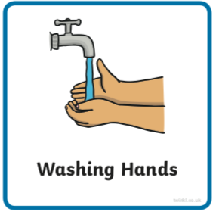 | Use the image to create a conversation  https://www.pobble365.com | 8:50 | https://www.pobble365.com | 8:50 | https://www.pobble365.com | 8:50 | https://www.pobble365.com | 8:50 | https://www.pobble365.com
9:00  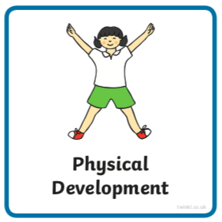  If these links don’t load find ‘Kids Get Moving’ channel on youtube | Adult led- Try this workout today  https://www.youtube.com/watch?v=sJGZoEXboRQ  (‘Get Moving Disney Family The Incredibles’ in youtube if link doesn’t work) | 9:00 | Adult led- Try this workout today  https://www.youtube.com/watch?v=fMTXq7v3G7U  (‘Get Moving Disney Family Moana in youtube) | 9:00 | Adult led- Try this workout today  https://www.youtube.com/watch?v=kKuVq48vUcw  (‘Get Moving Disney Family Lion King’ in youtube) | 9:00 | Adult led- Try this workout today  https://www.youtube.com/watch?v=coXGLWZIW00  (‘Get Moving Disney Family Mulan in youtube) | 9:00 | Adult led- Try this workout today  https://www.youtube.com/watch?v=2R_lvbiJOgc  (‘Get Moving Disney Family Jungle Book’ in youtube)
9:10- 9:30  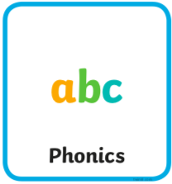 | Adult led- Phonics  See powerpoint choose a couple of slides each day | 9:30- 9:30 | Adult led- Phonics  See powerpoint choose a couple of slides each day | 9:10- 9:30 | Adult led- Phonics  See powerpoint choose a couple of slides each day | 9:10- 9:30 | Adult led- Phonics  See powerpoint choose a couple of slides each day | 9:10- 9:30 | Adult led- Phonics  See powerpoint choose a couple of slides each day
9:30- 10:30  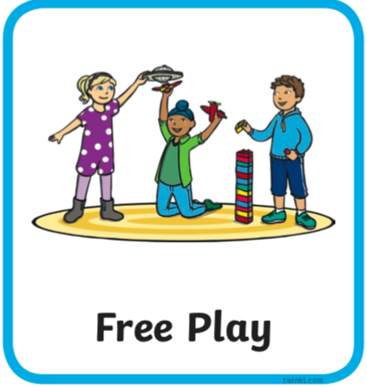 | Child led- Play in continuous provision  Resource idea- A little dried pasta, some different sized containers and a utensil or two.  Adult 1 child led- Support play (IMP*)  Adult 2 led- 1:1 reading (read your reading book at home) | 9:30- 10:30 | Child led- Play in continuous provision  Resource idea- Tip out the cutlery draw. Can the chn play with putting it back incorrectly and correctly into the sorter tray?  Adult 1 led- 1:1 reading (read your reading book at home)  Adult 2 child led- Support play (IMP*) | 9:30- 10:30 | Child led- Play in continuous provision  Resource idea- ‘Juice Pong!’ cups, ball (can be made with foil), tube (or hand)  Adult 1 child led- Support play (IMP*)  Adult 2 led- 1:1 reading (read your reading book at home) | 9:30- 10:30 | Child led- Play in continuous provision  Resource idea- Finger paint using paper of cardboard. If you don’t have paint experiment with sauces.  Adult 1 led- 1:1 reading (read your reading book at home)  Adult 2 child led- Support play (IMP*) | 9:30- 10:30 | Child led- Play in continuous provision  Resource idea- Soap and water in a bowl, sink or bath. Do any dolls, trucks or any toys need a wash?  Adult 1 child led- Support play (IMP*)  Adult 2 led- 1:1 reading (read your reading book at home)
10:30/45- 11 | Playtime | 10:30/45- 11 | Playtime | 10:30/45- 11 | Playtime | 10:30/45- 11 | Playtime | 10:30/45- 11 | Playtime
11:00  11:50 | Child led- Play in continuous provision  Adult 1 led- Writing (at home see writing document on website try writing two sentences each day this week)  Adult 2 led- Writing  Tidy up | 11:00  11:50 | Child led- Play in continuous provision  Adult 1 led- Writing (at home see writing document on website try writing two sentences each day this week)  Adult 2 led- Writing  Tidy up | 11:00  11:50 | Child led- Play in continuous provision  Adult 1 led- Writing (at home see writing document on website try writing two sentences each day this week)  Adult 2 led- Writing  Tidy up | 11:00  11:50 | Child led- Play in continuous provision  Adult 1 led- Writing (at home see writing document on website try writing two sentences each day this week)  Adult 2 led- Writing  Tidy up | 11:00  11:50 | Child led- Play in continuous provision  Adult 1 led- Writing (at home see writing document on website try writing two sentences each day this week)  Adult 2 led- Writing  Tidy up
12:00- 13:00  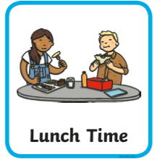 | Lunchtime | 12:00- 13:00 | Lunchtime | 12:00- 13:00 | Lunchtime | 12:00- 13:00 | Lunchtime | 12:00- 13:00 | Lunchtime
13:10- 13:30  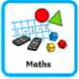 | Adult led- Maths  https://whiterosemaths.com/homelearning/early-years/ (week 12)  First read ‘How Many Legs’ on youtube  Today you will just need yourself. | 13:10- 13:30 | Adult led- Maths  https://whiterosemaths.com/homelearning/early-years/  Today you will just need yourself. | 13:10- 13:30 | Adult led- Maths  https://whiterosemaths.com/homelearning/early-years/  Today you will need your (homemade) tens frame. | 13:10- 13:30 | Adult led focus- Maths  https://whiterosemaths.com/homelearning/early-years/  Today you will need your (homemade) tens frame. | 13:10- 13:30 | Adult led-Maths  https://whiterosemaths.com/homelearning/early-years/  Today you will need some paper made into a booklet and a pencil.
13:30 | Child led- Play in continuous provision  Adult 1 child led- Support play (IMP*)  Adult 2 child led- Support play (IMP*) | 13:30 | Child led- Play in continuous provision  Adult 1 child led- Support play (IMP*)  Adult 2 child led- Support play (IMP*) | 13:30 | Child led- Play in continuous provision  Adult 1 child led- Support play (IMP*)  Adult 2 child led- Support play (IMP*) | 13:30 | Adult led- Physical exercise  - Daily mile  - Bikes on the field path  - Walk to the pond  - Parachute games  - Relays in the MUGA  - Track races on the field  - Roll the dice action game | 13:30 | Child led- Play in continuous provision  Adult 1 child led- Support play (IMP*)  Adult 2- Book changes and restocks
14:30  14:45 | Adult 1 Tidy out  Adult 2 Tidy in | 14:30  14:45 | Adult 1 Tidy out  Adult 2 Tidy in | 14:30  14:45 | Adult 1 Tidy out  Adult 2 Tidy in | 13:30- 14:45 |  | 14:30  14:45 | Adult 1 Tidy out  Adult 2 Tidy in
14:45  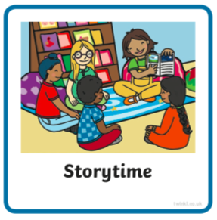 | Adult led- Communication and language  Find ‘One is a snail, ten is a crab’ on youtube. Before you watch talk to chn about the front of the book.  What can they see that is different about the crab and snail?  How many feet does the snail have?  How many feet does the crab have?  How many feet do chn have? Then read.  After reading  Discuss the similarities and differences between crabs and snails. For example they both have shells and googly eyes. | 14:45 | Adult led- Communication and language  Go on a snail hunt. Use black card (or a dark surface) in a box if possible to very carefully place the snails on. Watch and discuss the silvery trails they leave behind. | 14:45 | Adult led- Communication and language  How many legs does a crab have? How many on each side? Are there other ways 10 can be ‘split up’?  Design your own imaginary creature with ten legs but split in a different way to the crab’s. You could draw or use junk modeling. | 14:45 | Adult led- Communication and language  Choose twigs or leaves to collect and create groups of ten.  Can you make ten groups of ten? How many do you have altogether? | 14:45 | Adult led- Communication and language  Reflection- think back to something you couldn’t do but can do now…  (holding a pencil, climbing the tree, riding your bike, using a tens frame, playing with lots of different children, reading my reading book, doing my zip up)  You have all learned A LOT whether you can remember it or not! I am very proud of you.  Is there something you cant do now but you’d like to get better at next year?
15:05 | Collect belongings for home time  Reflection of the day/ singing | 15:05 | Collect belongings for home time  Reflection of the day/ singing | 15:05 | Collect belongings for home time  Reflection of the day/ singing | 15:05 | Collect belongings for home time  Reflection of the day/ singing | 15:05 | Collect belongings for home time  Reflection of the day/ singing

