Reception week 38 Home and School Learning Theme- Dinosaurs Week Commencing: 06.07.20
If you would like a new reading book don’t forget you can access them online via Oxford Owl or contact the school to arrange picking up of new ones

Monday |  | Tuesday |  | Wednesday |  | Thursday |  | Friday
8:50  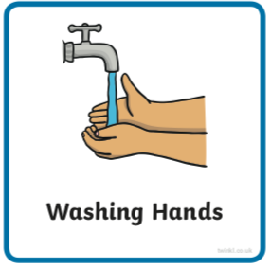 | Use the image to create a conversation  https://www.pobble365.com | 8:50 | https://www.pobble365.com | 8:50 | https://www.pobble365.com | 8:50 | https://www.pobble365.com | 8:50 | https://www.pobble365.com
9:00  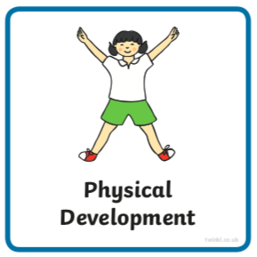  If these links don’t load find ‘Kids Get Moving’ channel on youtube | Adult led- Try this workout today  https://www.youtube.com/watch?v=snh8aWjWRYQ  (‘Kids Get Moving Star Wars SITH Dark Side HIIT workout’ in youtube if link doesn’t work) | 9:00 | Adult led- Try this workout today  https://www.youtube.com/watch?v=kAUMHws2ap0&t=6s  (‘Kids Get Moving Star Wars Jedi Light Side HIIT workout’ in youtube) | 9:00 | Adult led- Try this workout today  https://www.youtube.com/watch?v=myvBF2_JaIY  (‘Kids Get Moving Star Wars Hans Solo HIIT workout’ in youtube) | 9:00 | Adult led- Try this workout today  https://www.youtube.com/watch?v=aNTTMeduOw0  (‘Kids Get Moving Star Wars Use the Force Tabata Workout’ in youtube) | 9:00 | Adult led- Try this workout today  https://www.youtube.com/watch?v=TBGOZlZ2-DY  (‘Kids Get Moving Harry Potter Hogwart’s School Workout’ in youtube)
9:10- 9:30  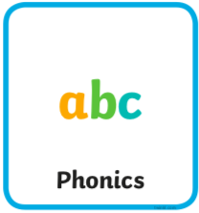 | Adult led- Phonics  See powerpoint | 9:30- 9:30 | Adult led- Phonics  See powerpoint | 9:10- 9:30 | Adult led- Phonics  See powerpoint | 9:10- 9:30 | Adult led- Phonics  See powerpoint | 9:10- 9:30 | Adult led- Phonics  See powerpoint
9:30- 10:30  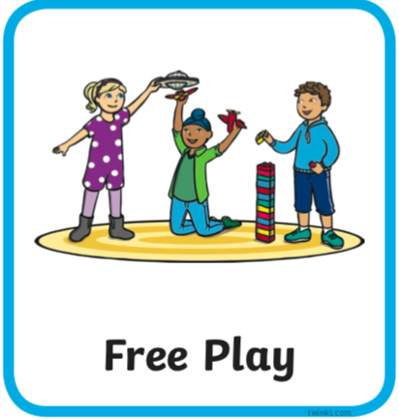 | Child led- Play in continuous provision  Resource idea- Make wool or string hair over a chair, use child scissors and ties.  Adult 1 child led- Support play (IMP*)  Adult 2 led- 1:1 reading (read your reading book at home) | 9:30- 10:30 | Child led- Play in continuous provision  Resource idea- Use an electric whisk to make foam with some washing up liquid and a little water, just whisk it up!  Adult 1 led- 1:1 reading (read your reading book at home)  Adult 2 child led- Support play (IMP*) | 9:30- 10:30 | Child led- Play in continuous provision  Resource idea- Do you know how to use the hoover? If you have carpet can you make any shapes or patterns on it with the hoover?  Adult 1 child led- Support play (IMP*)  Adult 2 led- 1:1 reading (read your reading book at home) | 9:30- 10:30 | Child led- Play in continuous provision  Resource idea- Use some soft balls or scrunched up paper to experiment with rolling down the stairs.  Adult 1 led- 1:1 reading (read your reading book at home)  Adult 2 child led- Support play (IMP*) | 9:30- 10:30 | Child led- Play in continuous provision  Resource idea- A pack of cards. Can you sort by suit, number, stack or fan them?  Adult 1 child led- Support play (IMP*)  Adult 2 led- 1:1 reading (read your reading book at home)
10:30/45- 11 | Playtime | 10:30/45- 11 | Playtime | 10:30/45- 11 | Playtime | 10:30/45- 11 | Playtime | 10:30/45- 11 | Playtime
11:00  11:50 | Child led- Play in continuous provision  Adult 1 led- Writing (at home see writing document on website try writing two sentences each day this week)  Adult 2 led- Writing  Tidy up | 11:00  11:50 | Child led- Play in continuous provision  Adult 1 led- Writing (at home see writing document on website try writing two sentences each day this week)  Adult 2 led- Writing  Tidy up | 11:00  11:50 | Child led- Play in continuous provision  Adult 1 led- Writing (at home see writing document on website try writing two sentences each day this week)  Adult 2 led- Writing  Tidy up | 11:00  11:50 | Child led- Play in continuous provision  Adult 1 led- Writing (at home see writing document on website try writing two sentences each day this week)  Adult 2 led- Writing  Tidy up | 11:00  11:50 | Child led- Play in continuous provision  Adult 1 led- Writing (at home see writing document on website try writing two sentences each day this week)  Adult 2 led- Writing  Tidy up
12:00- 13:00  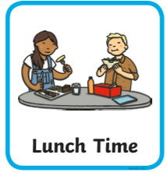 | Lunchtime | 12:00- 13:00 | Lunchtime | 12:00- 13:00 | Lunchtime | 12:00- 13:00 | Lunchtime | 12:00- 13:00 | Lunchtime
13:10- 13:30  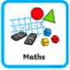 | Adult led- Maths  https://whiterosemaths.com/homelearning/early-years/ (week 11)  First read ‘The Dinosaur That Pooped a Planet’ on youtube  Today you will need some empty recycling. | 13:10- 13:30 | Adult led- Maths  https://whiterosemaths.com/homelearning/early-years/  Today you will need 3 different coloured square pieces of paper or blocks if you have them.  Optional paint and paper. | 13:10- 13:30 | Adult led- Maths  https://whiterosemaths.com/homelearning/early-years/  Today you will just need yourself. | 13:10- 13:30 | Adult led focus- Maths  https://whiterosemaths.com/homelearning/early-years/  Today you will need 2 dice (or an online dice roller if you don’t have one) pencil and paper. | 13:10- 13:30 | Adult led-Maths  https://whiterosemaths.com/homelearning/early-years/  Today you will need glue, vinegar, paper, cardboard, tape, small plastic container, food colouring, paint, baking soda, flour,
13:30 | Child led- Play in continuous provision  Adult 1 child led- Support play (IMP*)  Adult 2 child led- Support play (IMP*) | 13:30 | Child led- Play in continuous provision  Adult 1 child led- Support play (IMP*)  Adult 2 child led- Support play (IMP*) | 13:30 | Child led- Play in continuous provision  Adult 1 child led- Support play (IMP*)  Adult 2 child led- Support play (IMP*) | 13:30 | Adult led- Physical exercise  - Daily mile  - Bikes on the field path  - Walk to the pond  - Parachute games  - Relays in the MUGA  - Track races on the field  - Roll the dice action game | 13:30 | Child led- Play in continuous provision  Adult 1 child led- Support play (IMP*)  Adult 2- Book changes and restocks
14:30  14:45 | Adult 1 Tidy out  Adult 2 Tidy in | 14:30  14:45 | Adult 1 Tidy out  Adult 2 Tidy in | 14:30  14:45 | Adult 1 Tidy out  Adult 2 Tidy in | 13:30- 14:45 |  | 14:30  14:45 | Adult 1 Tidy out  Adult 2 Tidy in
14:45  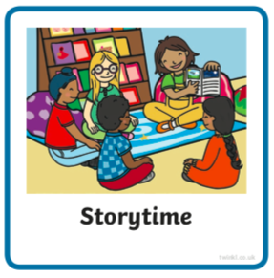 | Adult led- Communication and language  Find and watch ‘Harry and His Bucketful of Dinosaurs’ on youtube.  Then look through the ‘Dinosaur Names’ powerpoint document on website trying to learn some names and talking about similarities and differences. | 14:45 | Adult led- Communication and language  Look at  ‘What is a Dinosaur?’ powerpoint document on website | 14:45 | Adult led- Communication and language  Look at  ‘Omnivore, Carnivore, Herbivore?’ powerpoint document on website | 14:45 | Adult led- Communication and language  Look at  ‘Herbivore, Omnivore or Carnivore’ pdf document on website, can you remember from yesterday? Or use yesterdays document to help you. | 14:45 | Adult led- Communication and language  Look at  ‘Label The Dinosaur’ pdf document on website, can you label the parts correctly?
15:05 | Collect belongings for home time  Reflection of the day/ singing | 15:05 | Collect belongings for home time  Reflection of the day/ singing | 15:05 | Collect belongings for home time  Reflection of the day/ singing | 15:05 | Collect belongings for home time  Reflection of the day/ singing | 15:05 | Collect belongings for home time  Reflection of the day/ singing

*IMP
- Observe and wait for a suitable moment where you feel you can extend the child in some way (interact not interfere)  - Teach the next step to the child when appropriate (this could be by providing a suitable environment or resources, or by using the following teaching methods encouraging, explaining, questioning, facilitating, modeling, showing, setting challenge)  - Note the outcome  Cycle:  Observe (and possibly assess), wait for a moment where you can make a difference and  Teach the appropriate next step,  Record the outcome (evidence that learning has happened) | 