Reception week 37 Home and School Learning Theme- Fruit and Vegetables Week Commencing: 29.06.20
If you would like a new reading book don’t forget you can access them online via Oxford Owl or contact the school to arrange picking up of new ones

Monday |  | Tuesday |  | Wednesday |  | Thursday |  | Friday
8:50  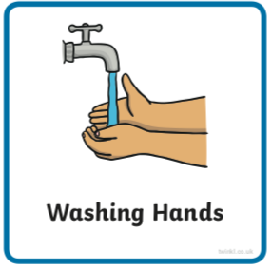 | Use the image to create a conversation  https://www.pobble365.com | 8:50 | https://www.pobble365.com | 8:50 | https://www.pobble365.com | 8:50 | https://www.pobble365.com | 8:50 | https://www.pobble365.com
9:00  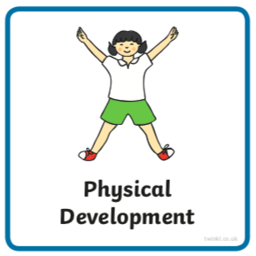  If these links don’t load find ‘Kids Get Moving’ channel on youtube | Adult led- Try this workout today  https://www.youtube.com/watch?v=c3oeoVsM95s&t=1s  (‘Kids Get Moving Train Like Thor’ in youtube if link doesn’t work) | 9:00 | Adult led- Try this workout today  https://www.youtube.com/watch?v=y2nURl5xOWU  (‘Kids Get Moving Guardians of the Galaxy’ in youtube) | 9:00 | Adult led- Try this workout today  https://www.youtube.com/watch?v=15BWn39QYY0  (‘Kids Get Moving Spider-Verse Workout’ in youtube) | 9:00 | Adult led- Try this workout today  https://www.youtube.com/watch?v=9SDWArXm4mA  (‘Kids Get Moving Black Panther Workout’ in youtube) | 9:00 | Adult led- Try this workout today  https://www.youtube.com/watch?v=jyWyBern6q4  (‘Kids Get Moving Avengers Kids Tabata’)
9:10- 9:30  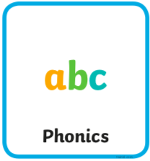 | Adult led- Phonics  See powerpoint | 9:30- 9:30 | Adult led- Phonics  See powerpoint | 9:10- 9:30 | Adult led- Phonics  See powerpoint | 9:10- 9:30 | Adult led- Phonics  See powerpoint | 9:10- 9:30 | Adult led- Phonics  See powerpoint
9:30- 10:30  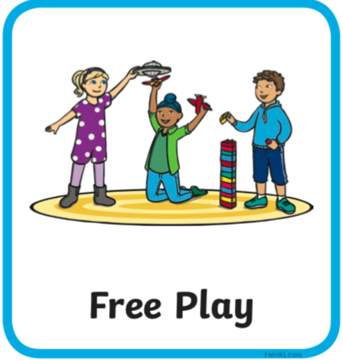 | Child led- Play in continuous provision  Resource idea- Could you make a bubble mixture with washing up liquid?  Adult 1 child led- Support play (IMP*)  Adult 2 led- 1:1 reading (read your reading book at home) | 9:30- 10:30 | Child led- Play in continuous provision  Resource idea- Collect some soft toys together, would they like a tea party?  Adult 1 led- 1:1 reading (read your reading book at home)  Adult 2 child led- Support play (IMP*) | 9:30- 10:30 | Child led- Play in continuous provision  Resource idea- Find some chairs to put together, could they be a bus or a train?  Adult 1 child led- Support play (IMP*)  Adult 2 led- 1:1 reading (read your reading book at home) | 9:30- 10:30 | Child led- Play in continuous provision  Resource idea- Pens and paper to draw a picture for a neighbour.  Adult 1 led- 1:1 reading (read your reading book at home)  Adult 2 child led- Support play (IMP*) | 9:30- 10:30 | Child led- Play in continuous provision  Resource idea- Make a water table with a plastic box outside and add some containers.  Adult 1 child led- Support play (IMP*)  Adult 2 led- 1:1 reading (read your reading book at home)
10:30/45- 11 | Playtime | 10:30/45- 11 | Playtime | 10:30/45- 11 | Playtime | 10:30/45- 11 | Playtime | 10:30/45- 11 | Playtime
11:00  11:50 | Child led- Play in continuous provision  Adult 1 led- Writing (at home see writing document on website)  Adult 2 led- Writing  Tidy up | 11:00  11:50 | Child led- Play in continuous provision  Adult 1 led- Writing (at home see writing document on website)  Adult 2 led- Writing  Tidy up | 11:00  11:50 | Child led- Play in continuous provision  Adult 1 led- Writing (at home see writing document on website)  Adult 2 led- Writing  Tidy up | 11:00  11:50 | Child led- Play in continuous provision  Adult 1 led- Writing (at home see writing document on website)  Adult 2 led- Writing  Tidy up | 11:00  11:50 | Child led- Play in continuous provision  Adult 1 led- Writing (at home see writing document on website)  Adult 2 led- Writing  Tidy up
12:00- 13:00  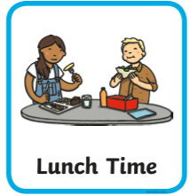 | Lunchtime | 12:00- 13:00 | Lunchtime | 12:00- 13:00 | Lunchtime | 12:00- 13:00 | Lunchtime | 12:00- 13:00 | Lunchtime
13:10- 13:30  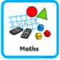 | Adult led- Maths  https://whiterosemaths.com/homelearning/early-years/ (week 10)  First read ‘Oliver’s Vegetables’ on youtube  Today you will need some vegetables or paper and coloured pens/pencils. | 13:10- 13:30 | Adult led- Maths  https://whiterosemaths.com/homelearning/early-years/  First read ‘Oliver’s Fruit Salad’ on youtube.  Today you will need one or two others to play some games with and ask and answer questions. | 13:10- 13:30 | Adult led- Maths  https://whiterosemaths.com/homelearning/early-years/  You will need 2 tens frames drawn. | 13:10- 13:30 | Adult led focus- Maths  https://whiterosemaths.com/homelearning/early-years/  Pen and paper/ whiteboard (if in class print outs of the pictures to count) | 13:10- 13:30 | Adult led-Maths  https://whiterosemaths.com/homelearning/early-years/  ‘Units of measure’ carrots if you have them or pencils or unifix in school
13:30 | Child led- Play in continuous provision  Adult 1 child led- Support play (IMP*)  Adult 2 child led- Support play (IMP*) | 13:30 | Child led- Play in continuous provision  Adult 1 child led- Support play (IMP*)  Adult 2 child led- Support play (IMP*) | 13:30 | Child led- Play in continuous provision  Adult 1 child led- Support play (IMP*)  Adult 2 child led- Support play (IMP*) | 13:30 | Adult led- Physical exercise  - Daily mile  - Bikes on the field path  - Walk to the pond  - Parachute games  - Relays in the MUGA  - Track races on the field  - Roll the dice action game | 13:30 | Child led- Play in continuous provision  Adult 1 child led- Support play (IMP*)  Adult 2- Book changes and restocks
14:30  14:45 | Adult 1 Tidy out  Adult 2 Tidy in | 14:30  14:45 | Adult 1 Tidy out  Adult 2 Tidy in | 14:30  14:45 | Adult 1 Tidy out  Adult 2 Tidy in | 13:30- 14:45 |  | 14:30  14:45 | Adult 1 Tidy out  Adult 2 Tidy in
14:45  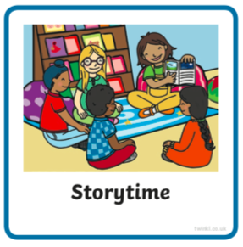 | Adult led- Communication and language  Find and watch ‘Kitchen Disco’ story on youtube. Talk about the rhyming words you spot.  Optional- create your own fruity designs by cutting different fruits in half, dipping them in paint and printing on paper. | 14:45 | Adult led- Communication and language  ‘Where do fruits and vegetables grow?’ powerpoint document on website.  Use to form a discussion about what interests the child. | 14:45 | Adult led- Communication and language  ‘What am I?’ powerpoint document on website.  A fruit and vegetable guessing game. | 14:45 | Adult led- Communication and language  ‘Fruit, vegetable, farm or zoo animal?’  Use the resource as a discussion point. A printer isn’t necessary you can discuss instead or create and draw your own if you wish. | 14:45 | Adult led- Communication and language  Watch this song version of the book (turn the lights down and the music up!)  https://www.youtube.com/watch?v=aeg0cNyaj7w  Create a dance move to do for each of the fruits as you hear the song!
15:05 | Collect belongings for home time  Reflection of the day/ singing | 15:05 | Collect belongings for home time  Reflection of the day/ singing | 15:05 | Collect belongings for home time  Reflection of the day/ singing | 15:05 | Collect belongings for home time  Reflection of the day/ singing | 15:05 | Collect belongings for home time  Reflection of the day/ singing

*IMP
- Observe and wait for a suitable moment where you feel you can extend the child in some way (interact not interfere)  - Teach the next step to the child when appropriate (this could be by providing a suitable environment or resources, or by using the following teaching methods encouraging, explaining, questioning, facilitating, modeling, showing, setting challenge)  - Note the outcome  Cycle:  Observe (and possibly assess), wait for a moment where you can make a difference and  Teach the appropriate next step,  Record the outcome (evidence that learning has happened) | 