Reception week 36 Home and School Learning Theme- Dragons- ‘Zog’ and ‘Have You Seen My Dragon?’ Week Commencing: 22.06.20

If you would like a new reading book don’t forget you can access them online via Oxford Owl or contact the school to arrange picking up of new ones

Monday |  | Tuesday |  | Wednesday |  | Thursday |  | Friday
8:50  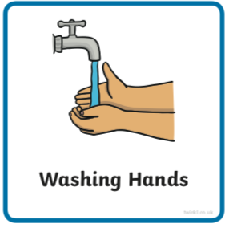 | Use the image to create a conversation  https://www.pobble365.com | 8:50 | https://www.pobble365.com | 8:50 | https://www.pobble365.com | 8:50 | https://www.pobble365.com | 8:50 | https://www.pobble365.com
9:00  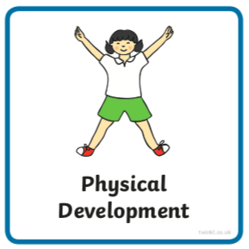  If these links don’t load find ‘Kids Get Moving’ channel on youtube | Adult led- Try this workout today  https://www.youtube.com/watch?v=QL2C0X3Gx1U  (‘Kids Get Moving Avengers Training Academy Captain America Workout’ in youtube if link doesn’t work) | 9:00 | Adult led- Try this workout today  https://www.youtube.com/watch?v=YC_V8hnU2PY  (‘Kids Get Moving Avengers Training Academy Spiderman HIIT’ in youtube) | 9:00 | Adult led- Try this workout today  https://www.youtube.com/watch?v=H186QQvWXKw  (‘Avengers Training Academy Star Lord HIIT’ in youtube) | 9:00 | Adult led- Try this super hero workout today  https://www.youtube.com/watch?v=udK_PRSeVPI  (‘Kids Get Moving Avengers Infinity War Training Academy’ in youtube) | 9:00 | Adult led- Try this workout today  https://www.youtube.com/watch?v=c3oeoVsM95s  (‘Kids Get Moving Train Like Thor Workout)
9:10- 9:30  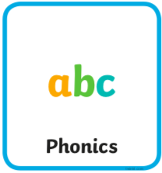 | Adult led- Phonics  See powerpoint | 9:30- 9:30 | Adult led- Phonics  See powerpoint | 9:10- 9:30 | Adult led- Phonics  See powerpoint | 9:10- 9:30 | Adult led- Phonics  See powerpoint | 9:10- 9:30 | Adult led- Phonics  See powerpoint
9:30- 10:30  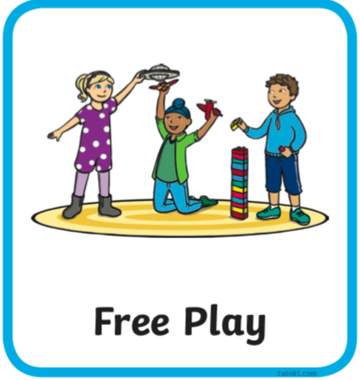 | Child led- Play in continuous provision  Resource idea- a concertina paper caterpillar and a straw  Adult 1 child led- Support play (IMP*)  Adult 2 led- 1:1 reading (read your reading book at home) | 9:30- 10:30 | Child led- Play in continuous provision  Resource idea- fill up the sink/ bowl outside with water  Adult 1 led- 1:1 reading (read your reading book at home)  Adult 2 child led- Support play (IMP*) | 9:30- 10:30 | Child led- Play in continuous provision  Resource idea- line up pairs of socks  Adult 1 child led- Support play (IMP*)  Adult 2 led- 1:1 reading (read your reading book at home) | 9:30- 10:30 | Child led- Play in continuous provision  Resource idea- blankets to make a den in your house/ garden  Adult 1 led- 1:1 reading (read your reading book at home)  Adult 2 child led- Support play (IMP*) | 9:30- 10:30 | Child led- Play in continuous provision  Resource idea- Could you use some scrunched up paper from recycling to throw at targets?  Adult 1 child led- Support play (IMP*)  Adult 2 led- 1:1 reading (read your reading book at home)
10:30/45- 11 | Playtime | 10:30/45- 11 | Playtime | 10:30/45- 11 | Playtime | 10:30/45- 11 | Playtime | 10:30/45- 11 | Playtime
11:00  11:50 | Child led- Play in continuous provision  Adult 1 led- Writing books (at home write a sentence using one of the pictures in the writing document on website)  Adult 2 led- Writing books  Tidy up | 11:00  11:50 | Child led- Play in continuous provision  Adult 1 led- Writing books (at home write a sentence using one of the pictures in the writing document on website)  Adult 2 led- Writing books  Tidy up | 11:00  11:50 | Child led- Play in continuous provision  Adult 1 led- Writing books (at home write a sentence using one of the pictures in the writing document on website)  Adult 2 led- Writing books  Tidy up | 11:00  11:50 | Child led- Play in continuous provision  Adult 1 led- Writing books (at home write a sentence using one of the pictures in the writing document on website)  Adult 2 led- Writing books  Tidy up | 11:00  11:50 | Child led- Play in continuous provision  Adult 1 led- Writing books (at home write a sentence using one of the pictures in the writing document on website)  Adult 2 led- Writing books  Tidy up
12:00- 13:00  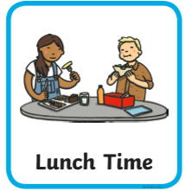 | Lunchtime | 12:00- 13:00 | Lunchtime | 12:00- 13:00 | Lunchtime | 12:00- 13:00 | Lunchtime | 12:00- 13:00 | Lunchtime
13:10- 13:30  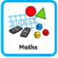 | Adult led- Maths  https://whiterosemaths.com/homelearning/early-years/ (week 9)  First read ‘Zog’ on youtube  https://www.youtube.com/watch?v=9_LmS3q4E6k  Today you will need 7 coloured pencils or crayons. | 13:10- 13:30 | Adult led- Maths  https://whiterosemaths.com/homelearning/early-years/  You might need some tens frames drawn. Optional- something to make a rosette. | 13:10- 13:30 | Adult led- Maths  https://whiterosemaths.com/homelearning/early-years/  2 tens frames drawn | 13:10- 13:30 | Adult led focus- Maths  https://whiterosemaths.com/homelearning/early-years/  Optional- something to make a dragon mask with (remember you could just attach it to a stick if you don’t have any elastic). Some music to dance to. | 13:10- 13:30 | Adult led-Maths  https://whiterosemaths.com/homelearning/early-years/  Timer/ phone/ stopwatch. Optional- baking ingredients
13:30 | Child led- Play in continuous provision  Adult 1 child led- Support play (IMP*)  Adult 2 child led- Support play (IMP*) | 13:30 | Child led- Play in continuous provision  Adult 1 child led- Support play (IMP*)  Adult 2 child led- Support play (IMP*) | 13:30 | Child led- Play in continuous provision  Adult 1 child led- Support play (IMP*)  Adult 2 child led- Support play (IMP*) | 13:30 | Adult led- Physical exercise  - Daily mile  - Bikes on the field path  - Walk to the pond  - Parachute games  - Relays in the MUGA  - Track races on the field  - Roll the dice action game | 13:30 | Child led- Play in continuous provision  Adult 1 child led- Support play (IMP*)  Adult 2- Book changes and restocks
14:30  14:45 | Adult 1 Tidy out  Adult 2 Tidy in | 14:30  14:45 | Adult 1 Tidy out  Adult 2 Tidy in | 14:30  14:45 | Adult 1 Tidy out  Adult 2 Tidy in | 13:30- 14:45 |  | 14:30  14:45 | Adult 1 Tidy out  Adult 2 Tidy in
14:45  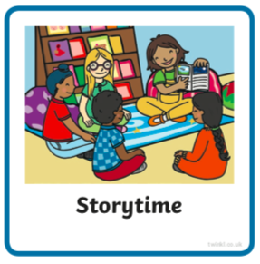 | Adult led- Communication and language  Before reading- The boy in the story has lost his dragon. ASK: Have you ever lost something? How did you find it? Have you ever found something you weren’t expecting while you were searching for something else? Where would you look for a dragon?  Find ‘Have You Seen My Dragon’ story on youtube https://www.youtube.com/watch?v=6OFBI1KM8Bs | 14:45 | Adult led- Communication and language  Introduction  There are so many things to count in this story! ASK: How do you think counting helped the boy find the dragon? When do you count (in life)?  Share a time in your life when it was important to know exactly how many of something there were, instead of just knowing there were ‘few’ or ‘some’  Remind yourself of ‘positional language’ when looking at the final page (next tp.. upside down, to the right of, to the left of, by the side, bigger, smaller, closer, further) | 14:45 | Adult led- Communication and language  What’s in the room?  The story shows there are patterns and amounts of things all around us.  Invite chn to list types of things they see in the room they are in. Draw/record them on the board/sheet of paper. Sort the objects together by different categories, such as ‘things on the walls” or “things that are green.” | 14:45 | Adult led- Communication and language  Dragon Hunt  Make 20 dragon circles – you can use this template, or chn can draw their own.  Number the dragon circles 1 through 20 (one number on each circle)  Hide the dragon circles in your space. Think about hiding them in some sort of pattern, such as: Low numbers close to the ground, larger numbers higher up or all on things that are red.  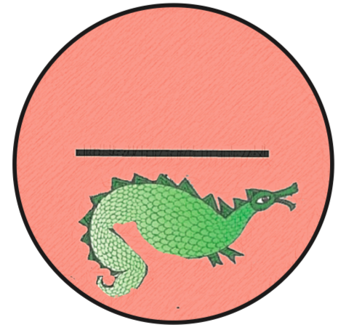 | 14:45 | Adult led- Communication and language  The dragon is found in ‘China Town’ where they celebrate chinese culture. Lets see what culture is like in the country of China. Can you remember anything from when we learned about Chinese New Year earlier in the year?  https://www.youtube.com/watch?v=WQK4tAKNllo  Can you practice a Chinese word you heard in the video?
15:05 | Collect belongings for home time  Reflection of the day/ singing | 15:05 | Collect belongings for home time  Reflection of the day/ singing | 15:05 | Collect belongings for home time  Reflection of the day/ singing | 15:05 | Collect belongings for home time  Reflection of the day/ singing | 15:05 | Collect belongings for home time  Reflection of the day/ singing

*IMP
- Observe and wait for a suitable moment where you feel you can extend the child in some way (interact not interfere)  - Teach the next step to the child when appropriate (this could be by providing a suitable environment or resources, or by using the following teaching methods encouraging, explaining, questioning, facilitating, modeling, showing, setting challenge)  - Note the outcome  Cycle:  Observe (and possibly assess), wait for a moment where you can make a difference and  Teach the appropriate next step,  Record the outcome (evidence that learning has happened) | 