Reception week 35 Home and School Learning Theme- ‘Arrgghhh Spider’ and ‘Princess Mirror-Belle and the Dragon Pox’ Week Commencing: 08.06.20
Staff | Info
Mrs Griffiths and Mrs Batchelor bubble 1  Miss Andow and Mrs Derby bubble 2 | Lunch in classrooms

Monday |  | Tuesday |  | Wednesday |  | Thursday |  | Friday
8:50  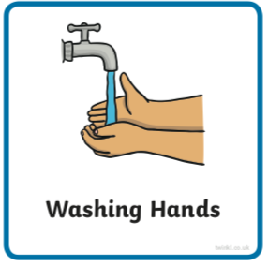 | Use the image to create a conversation  https://www.pobble365.com  Can you talk in full sentences? Can you make sure your sentence has a ‘who’ and a ‘what’ in it? Use your imagination as much as you like- there is no wrong or right! | 8:50 | https://www.pobble365.com | 8:50 | https://www.pobble365.com | 8:50 | https://www.pobble365.com | 8:50 | https://www.pobble365.com
9:00  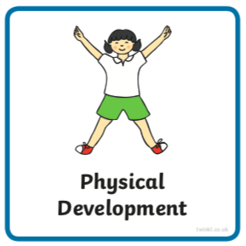  If these links don’t load find ‘Kids Get Moving’ channel on youtube | Adult led- Try this workout today  https://www.youtube.com/watch?v=fu-ZCwMrvKc&list=PLvuT1Bjs2VSF0Yqahj8VAKBwyYFnLJIDa&index=7  (‘Kids Get Moving Harry Potter Enchanted Spells’ in youtube if link doesn’t work) | 9:00 | Adult led- Try this workout today  https://www.youtube.com/watch?v=Zm9qhyh4TJk&list=PLvuT1Bjs2VSF0Yqahj8VAKBwyYFnLJIDa&index=8  (‘Kids Get Moving Captain America Avengers Kids Workout’ in youtube) | 9:00 | Adult led- Try this workout today  https://www.youtube.com/watch?v=MU7StZxAwJ0&list=PLvuT1Bjs2VSF0Yqahj8VAKBwyYFnLJIDa&index=10  (‘Kids Get Moving The Dark Knight Batman Workout’ in youtube) | 9:00 | Adult led- Try this super hero workout today  https://www.youtube.com/watch?v=2eI9BoQLTfo&list=PLvuT1Bjs2VSF0Yqahj8VAKBwyYFnLJIDa&index=11  (‘Kids Get Moving Star Wars Kylo Ren Sith Workout’) | 9:00 | Adult led- Try this workout today  https://www.youtube.com/watch?v=jyWyBern6q4&list=PLvuT1Bjs2VSF0Yqahj8VAKBwyYFnLJIDa&index=12  (‘Kids Get Moving Avengers Kids Tabata Workout’)
9:10- 9:30  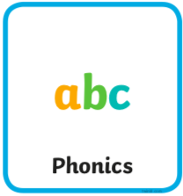 | Adult led- Phonics  See powerpoint | 9:30- 9:30 | Adult led- Phonics  See powerpoint | 9:10- 9:30 | Adult led- Phonics  See powerpoint | 9:10- 9:30 | Adult led- Phonics  See powerpoint | 9:10- 9:30 | Adult led- Phonics  See powerpoint
9:30- 10:30  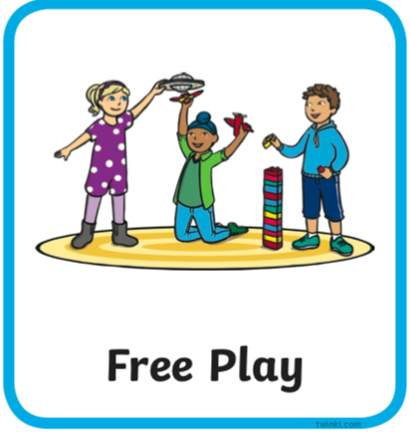 | Child led- Play in continuous provision  Resource idea- Can you go on a snail hunt, how many can you find? Can you spot their snail trail? Can you find out which plant they like eating?  Adult 1 child led- Support play (IMP*)  Adult 2 led- 1:1 reading (read your reading book at home) | 9:30- 10:30 | Child led- Play in continuous provision  Resource idea- String or wool to create spider’s webs  Adult 1 led- 1:1 reading (read your reading book at home)  Adult 2 child led- Support play (IMP*) | 9:30- 10:30 | Child led- Play in continuous provision  Resource idea- Cooked spaghetti  Adult 1 child led- Support play (IMP*)  Adult 2 led- 1:1 reading (read your reading book at home) | 9:30- 10:30 | Child led- Play in continuous provision  Resource idea- Bread painting- slices of bread and food colouring or yogurt with colouring  Adult 1 led- 1:1 reading (read your reading book at home)  Adult 2 child led- Support play (IMP*) | 9:30- 10:30 | Child led- Play in continuous provision  Resource idea- String or wool printing, can you use the spider web leftovers to dip in paint or sauce to print with?  Adult 1 child led- Support play (IMP*)  Adult 2 led- 1:1 reading (read your reading book at home)
10:30/45- 11 | Playtime | 10:30/45- 11 | Playtime | 10:30/45- 11 | Playtime | 10:30/45- 11 | Playtime | 10:30/45- 11 | Playtime
11:00  11:50 | Child led- Play in continuous provision  Adult 1 led- Writing books (at home write a sentence using one of the pictures in phonics)  Adult 2 led- Writing books  Tidy up | 11:00  11:50 | Child led- Play in continuous provision  Adult 1 led- Writing groups (at home write a sentence using one of the pictures in phonics)  Adult 2 led- Writing groups  Tidy up | 11:00  11:50 | Child led- Play in continuous provision  Adult 1 led- Writing groups  (at home write a sentence using one of the pictures in phonics)  Adult 2 led- Writing groups  Tidy up | 11:00  11:50 | Child led- Play in continuous provision  Adult 1 led- Writing groups  (at home write a sentence using one of the pictures in phonics)  Adult 2 led- Writing groups  Full tidy up inside and outside | 11:00  11:50 | Child led- Play in continuous provision  Adult 1 led- Writing groups  (at home write a sentence using one of the pictures in phonics)  Adult 2 led- Writing groups  Tidy up
12:00- 13:00  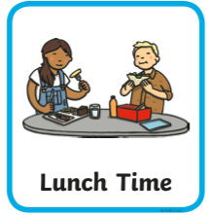 | Lunchtime | 12:00- 13:00 | Lunchtime | 12:00- 13:00 | Lunchtime | 12:00- 13:00 | Lunchtime | 12:00- 13:00 | Lunchtime
13:10- 13:30  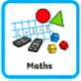 | Adult led- Maths  https://whiterosemaths.com/homelearning/early-years/ (week 8)  You will need to watch the story ‘Princess Mirror-Belle and The Dragon Pox’ on youtube first  https://www.youtube.com/watch?v=LAFaJfcqqt4  Today you will need some recycling cartons/ packages | 13:10- 13:30 | Adult led- Maths  https://whiterosemaths.com/homelearning/early-years/  You might need to draw a tens frame to help | 13:10- 13:30 | Adult led- Maths  https://whiterosemaths.com/homelearning/early-years/ | 13:10- 13:30 | Adult led focus- Maths  https://whiterosemaths.com/homelearning/early-years/  You will need some toilet roll | 13:10- 13:30 | Adult led-Maths  https://whiterosemaths.com/homelearning/early-years/  Various shoes.  Two different containers to fill the sink (or other container).
13:30 | Child led- Play in continuous provision  Adult 1 child led- Support play (IMP*)  Adult 2 child led- Support play (IMP*) | 13:30 | Child led- Play in continuous provision  Adult 1 child led- Support play (IMP*)  Adult 2 child led- Support play (IMP*) | 13:30 | Child led- Play in continuous provision  Adult 1 child led- Support play (IMP*)  Adult 2 child led- Support play (IMP*) | 13:30 | Adult led- Physical exercise  - Daily mile  - Bikes on the field path  - Walk to the pond  - Parachute games  - Relays in the MUGA  - Track races on the field  - Roll the dice action game | 13:30 | Child led- Play in continuous provision  Adult 1 child led- Support play (IMP*)  Adult 2- Book changes and restocks
14:30  14:45 | Adult 1 Tidy out  Adult 2 Tidy in | 14:30  14:45 | Adult 1 Tidy out  Adult 2 Tidy in | 14:30  14:45 | Adult 1 Tidy out  Adult 2 Tidy in | 13:30- 14:45 |  | 14:30  14:45 | Adult 1 Tidy out  Adult 2 Tidy in
14:45  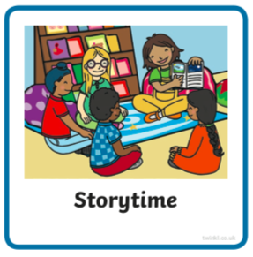 | Adult led- Communication and language  Before you read the book discuss pets. Do you have any? Are there pets that they would like to have if only parents would allow it? What reasons do their parents give them for why they aren’t allowed to have certain pets?  Ask children what they think would happen if they asked to have a spider for a pet - would their family like it? What sorts of thing do people say about spiders?  Jot these down in a list, starting with:  Spiders are...  Find ‘Arrrgghh Spider’ story on youtube https://www.youtube.com/watch?v=vQQD84blj-w  What did you think about the ending? | 14:45 | Adult led- Communication and language  Use this picture and do some research online to see if you can name some parts of a spider. You might like to draw your own diagram.  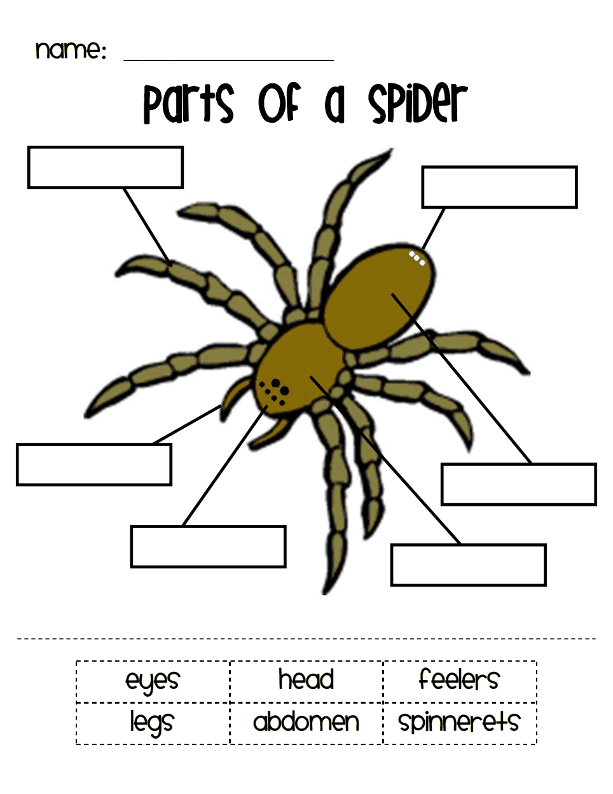 | 14:45 | Adult led- Communication and language  Are spiders good guys or bad guys?  Talk with the children about what they now know about spiders and their role in the food chain https://www.yukozimo.com/spider-fc  Should people be more willing to have them in their homes?  Collect children’s thoughts together in a comparison chart:  ‘We like spiders because’  ‘We don’t like spiders because’ | 14:45 | Adult led- Communication and language  Write a poem together using this structure:  When people see spiders they...  How do you think a spider feels?  How do you think a spider feels?  Write one final verse. Give individual children a small folded piece of paper with ‘But I think...’ on the cover and ask them to finish the sentence inside. | 14:45 | Adult led- Communication and language  Sing and explore the actions for the rhyme Incey Wincey Spider. You could make up new rhyming couplets for the things that your spider does, e.g.  Incey Wincey Spider climbs up the kitchen/classroom wall,  Be careful little spider, we don’t want you to fall!  Do you have any questions you’d still like to find out the answer to about spiders? See if you can do some research to find out. Here are some question examples.  What do spiders eat? What are baby spiders like? Do all spiders make webs?
15:05 | Collect belongings for home time  Reflection of the day/ singing | 15:05 | Collect belongings for home time  Reflection of the day/ singing | 15:05 | Collect belongings for home time  Reflection of the day/ singing | 15:05 | Collect belongings for home time  Reflection of the day/ singing | 15:05 | Collect belongings for home time  Reflection of the day/ singing

*IMP
- Focus on children of the week  - Check child’s cover sheet for focuses (areas of the curriculum or other focuses)  - Observe and wait for a suitable moment where you feel you can extend the child in some way (interact not interfere)  - Teach the next step to the child when appropriate (this could be by providing a suitable environment or resources, or by using the following teaching methods encouraging, explaining, questioning, facilitating, modeling, showing, setting challenge)  - Note the outcome- record on ILD during or after interaction (focus on interaction not the documenting)  Cycle:  Observe (and possibly assess), wait for a moment where you can make a difference and  Teach the appropriate next step,  Record the outcome (evidence that learning has happened) | 