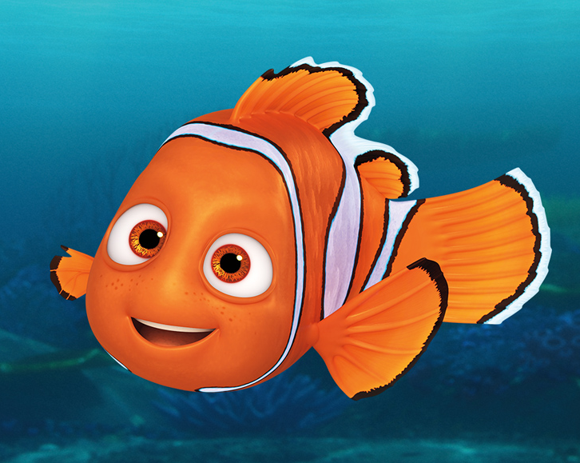KS2 MINI AQUARIUM

To make YOUR AQUARIUM YOU WILL NEED:
- water
- blue food colouring
- large clear bottle (2 litre pop bottle, shampoo bottle, glass jar etc.)
- Funnel- to help pour the liquid into the bottle
- Small stones (this could be any type of gravel or stones)
- Any plastic sea creatures, along with a small selection of plants (if you do not have any plastic creatures, you could make some- see below for ideas).
- If you want to create ocean layers just add some cooking oil (either canola or vegetable oil work well)

METHOD:
- Fill approximately 1/3 of your bottle with water.
- Then add several drops of food colouring.
- Now, add your stones to the bottom of your bottle/jar and begin filling with water again- but only to half way.
- You can now add your sea creatures and anything else you would like to add
- Finish filling your aquarium with water until you reach the top
- Place the lid on your bottle/jar
- Lastly let the fun begin, watch your mini aquarium come to life!
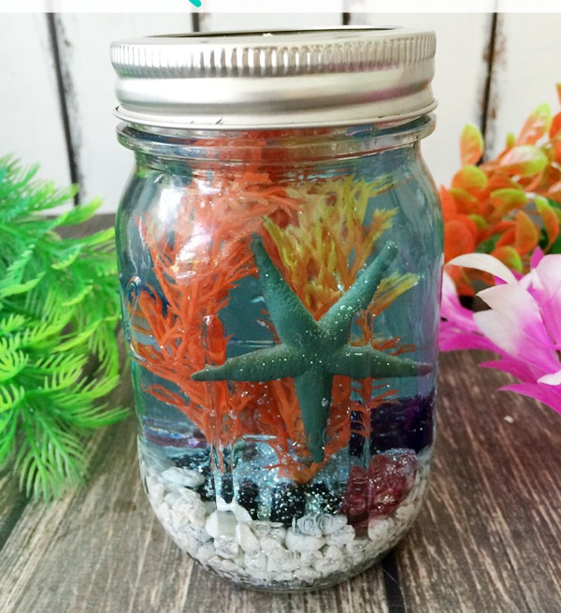

Ideas for sea creatures:

