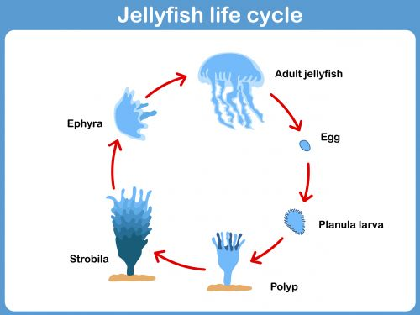

Have a go at making something like this frog
booklet but for a jellyfish life cycle.

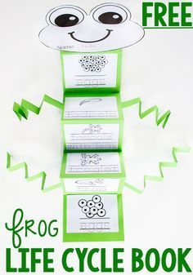

- Cut out a jelly fish shape to replace the frog head, just use this
shape.
- Now cut 6 long strips of paper for the tentacles
But make sure they are wide enough for you to
Write each stage of the life cycle on a strip.
- Write on stage of the life cycle of one tentacle strip.
- Attach the tentacles to the jellyfish head shape at the top!

Alternatively you could create this beautiful jellyfish with different strips of paper, ribbons and fabric for the tentacles.
