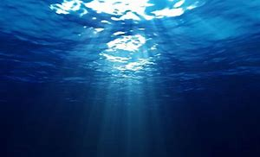 |

**Under the Sea Animation**

Watch [this video](https://www.bbc.co.uk/bitesize/clips/z27y2p3) to see how you can make a picture cell and how you can turn this into a short animation.

**Killer Question!**

Why is the ocean salty?

Can you answer this question?

How do you know?

How can you prove your answer?

How would you present this to other people, an experiment, a poster, a science report or a presentation?

Useful websites:

[NHM](https://www.nhm.ac.uk/discover/quick-questions/why-is-the-sea-salty.html)

[Density experiment](https://sciencekiddo.com/salt-water-experiment-ocean-science/)

***On this page there are some curriculum based activities and projects. The pieces on here vary in how long they take and their difficulty. Some activities might be better spread over a number of days and you should find they are easily adaptable to a range of age groups. As always these activities are a guide and are there to help you. Please choose as many of these as you feel right for your family. Underlined items are links to take you to useful resources. Any pictures on this page can be downloaded from the Home Learning blog. If you have any questions about the tasks please email Mrs Frampton. Don’t forget to share your ideas on the blog or email photographs to Mrs Frampton (***[*kayleighframpton@ashtonvale.bristol.sch.uk*](mailto:kayleighframpton@ashtonvale.bristol.sch.uk)***) so she can upload them to the blog.***

***Have a great week, you are all doing brilliantly!***

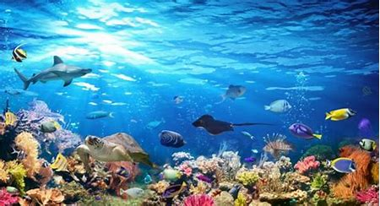

**Oceans**

**15th June 2020**

**Ocean Foil Painting**

Try to recreate an ocean foil painting

like these! Make lots of shades of

blue before you begin and even add

some green and white.

The trick here is to put the paint on

and then carefully scrape away the

ocean ripples and currents.

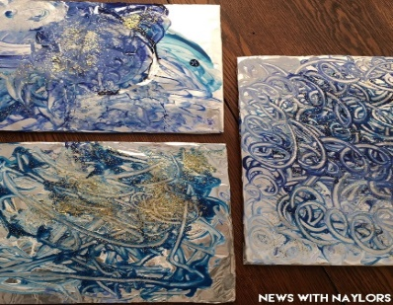

**Recreate a famous piece of music**

# Listen to [‘Aquarium’ from Carnival of the Animals’](https://safeYouTube.net/w/cc0K) by Saint Saens.

How would you describe the music?

How could you represent it with pictures or

words?

What could you use as instruments from

around your house to recreate this piece?

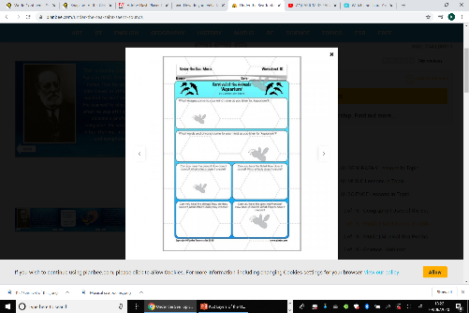

**Oceans around the world**

[Click here for web link](https://encounteredu.com/teacher-resources/our-ocean-planet-science-geography-7-11-lesson-5-our-ocean-voyage-with-prof-alex-rogers)

Prof Alex Rogers takes you on an ocean voyage to the oceans of the world and some of the **major marine features**. Work through Lesson steps 1-4. There is a powerpoint to download and lots of lovely resources to work through.

[Here](http://www.sheppardsoftware.com/World_GL.html) is a drag and drop game all

about the oceans of the world with

lots of information.

[Click here](https://www.dkfindout.com/uk/earth/oceans-and-seas/) and explore the webpage

all about Oceans of the World.

Take the quiz at the end.

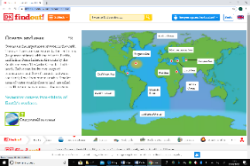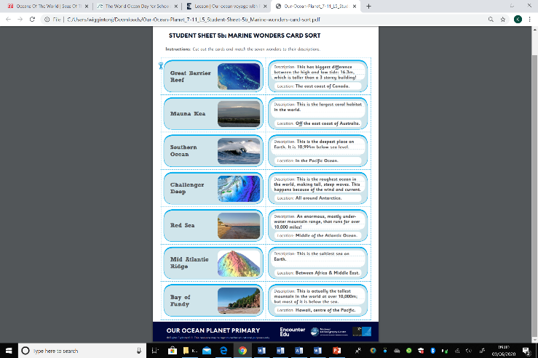

**Ocean Layers**

Can you investigate the different layers of the ocean?

Powerpoint presentation to download.

Can you create your own Ocean Zones in a Jar?

* How many ocean zones are there?
* What are the different layers of the ocean?
* Why don’t different liquids mix?

[Click here](https://littlebinsforlittlehands.com/layers-of-the-ocean/) for a step by step guide.

There is an ocean zones work sheet to download

and have a go at.

There is also a mini aquarium how to

guide to download on the blog.

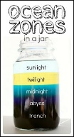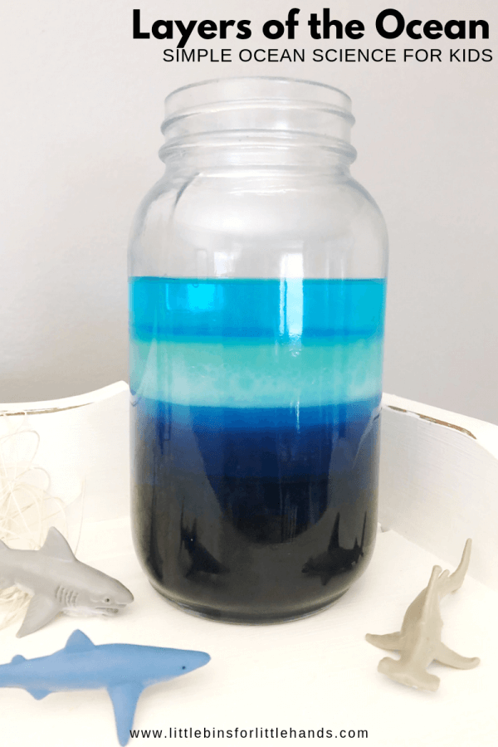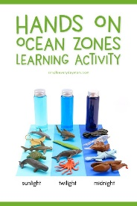

**Moving fish card**

Have a go at creating a moving fish

card (you could

choose a different

ocean animal). It

could be a pop out

card or card that

uses a slider.

Download instructions

on the Home Learning

Blog page.

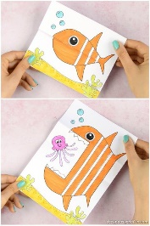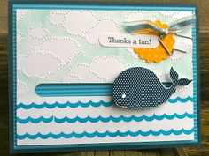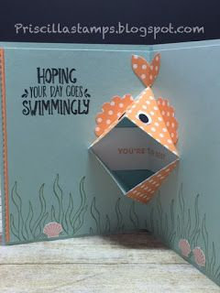

**Song of the Dolphin Boy by Elizabeth Laird**

*The dolphin saved Finn but can he save*

*them*?

Over the course of the week I will post new

chapters of the story on the blog. [Read with me here](https://www.youtube.com/watch?v=qI0or00Ye-Y).

[Watch this interview](https://www.bbc.co.uk/iplayer/episode/m000hxjt/authors-live-elizabeth-laird-and-lauren-st-john) with the author and

download the extra information from the blog

to have a look at.

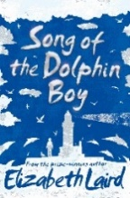

**Five Oceans of the World**

Research the five oceans of the world and make a book, pic collage or Powerpoint presentation about them. Use a new page/slide for each of the Oceans. You could work on a different ocean each day. Include fun facts and images.

[Arctic Ocean](https://encounteredu.com/teacher-resources/our-ocean-planet-science-geography-7-11-lesson-6-the-arctic-ocean-and-the-water-cycle-with-dr-mark-brandon)

[Atlantic Ocean](https://encounteredu.com/teacher-resources/our-ocean-planet-science-geography-7-11-lesson-7-the-atlantic-ocean-and-climate-with-dr-penny-holliday)

[Indian Ocean](https://encounteredu.com/teacher-resources/our-ocean-planet-science-geography-7-11-lesson-8-the-indian-ocean-and-classification-with-anjani-ganase)

[Pacific Ocean](https://encounteredu.com/teacher-resources/our-ocean-planet-science-geography-7-11-lesson-9-the-pacific-ocean-and-plastic-pollution-with-jo-royle)

[Southern Ocean](https://encounteredu.com/teacher-resources/our-ocean-planet-science-geography-7-11-lesson-10-the-southern-ocean-and-penguin-adaptation-with-dr-lucy-quinn)

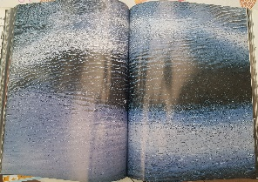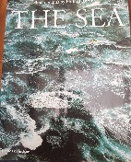

**French ‘Me Voici’ All About Me Book or ebook**

Over the next few weeks we are going to make a book all about your favourite things. Start today by designing a title and front cover for your book. You could make a contents page too. We will

include, basic information, favourite colours, pets, family

and hobbies.

