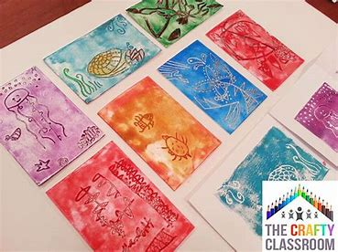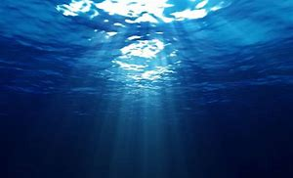

**Coral Reef Art**

Have a go at some Coral Reef inspired printing. Use [this document](Coral%20Reef%20Inspired%20Art.docx) and [the link](https://thecraftyclassroom.com/crafts/ocean-crafts-for-kids/ocean-creatures-art-prints/) provided for a step by step guide.

**Coral Reef Expert Memory Game**

Match the coral reef pictures with the names and phrases [here](http://www.coralfilm.com/games/match2.html). You might need to do some research to find out about the names first.

Make sure you

choose expert

level.

## **A Marine Wildlife Mission with Blue Plant and Live Lessons**

## [Watch this video](https://video.nationalgeographic.com/video/101-videos/0000015f-9331-d8e7-a7ff-f77d2dfb0000) about what coral reefs are. Can you explain what is happening to coral reefs around the

## world and why? Can you write a letter to explain why this is important? Have a

## look at these

## [photos](https://encounteredu.com/multimedia/images/coral-threats) for more

## examples.

**French ‘Me Voici’ All About Me Book or Ebook**

The final part of your book is to write all about your hobbies. Make a note of the different hobbies you hear as you watch [this video](https://www.bbc.co.uk/teach/class-clips-video/french-ks2-favourite-hobbies/z4hxpg8).

See if you can complete the worksheets before you put your hobbies into your books. You could even write about your families’ hobbies. I would love to see your finished books so please email them to Mrs Frampton.

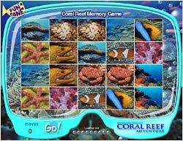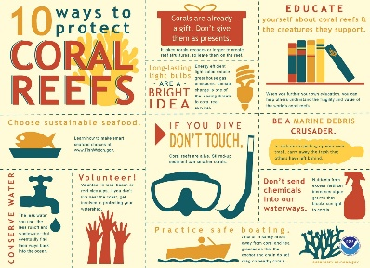Wp[;<https://worldoceanday.school/film/> |

**Lockdown Time Capsule**

Click here for an activity booklet for a range of things to include to remember your time during Lockdown.

~

## **Protect the Coral Reef**

Can you design a poster with 10 ways to protect the Coral Reef just like this one?

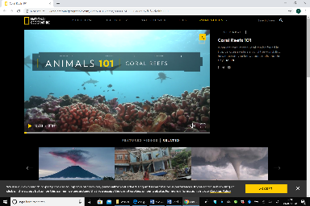

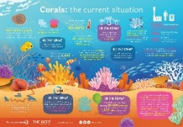

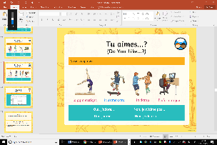

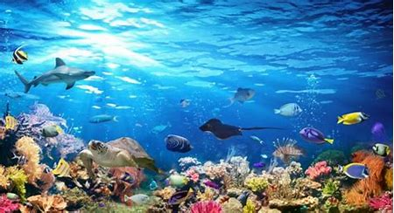

**The Coral Reef**

**13th July 2020**

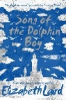

**Song of the Dolphin Boy**

**by Elizabeth Laird**

Can you make a character profile for Finn?

**Reef Research**

The Great Barrier Reef is the only living thing which is visible from space!

Take a virtual tour [here.](http://www.airpano.com/360photo/great-barrier-reef-australia/)

Create a poster of video to promote the Great Barrier Reef. Use scientific language relating to the habitats and species groups found in the reef.

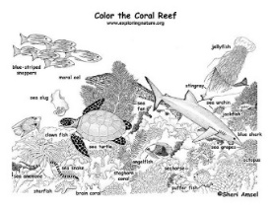

## **Labelled Coral Reef**

## Can you create your own labelled coral

## reef or complete this one? You can

## download a template on the blog.

*For our final week on oceans there is a real mixture for you. Some of the activities are all about the Coral Reef, there’s a mini history project about the Lost City of Atlantis and there are some end of year/moving on activities for you to think about that we might have been doing if we were in school. As always these activities are a guide and are there to help you. Please choose as many of these as you feel right for your family. Anything that is underlined is a hyperlink that will take you to more information to help with the tasks. If you have any questions about the tasks please email Mrs Frampton. Don’t forget to share your ideas on the blog or email photographs to Mrs Frampton (*[*kayleighframpton@ashtonvale.bristol.sch.uk*](mailto:kayleighframpton@ashtonvale.bristol.sch.uk)*) so she can upload them to the blog*

*Enjoy your final week about Oceans.*

***) so she can upload them to the blog.***

***Have a great week, you are all doing brilliantly!***

**Lockdown Positives**

Lockdown has been a completely new time for us all with good and bad points. Concentrate on the good points and think about new skills you might have learnt, talents you have found or revisited and things that you have enjoyed. Click here for a template.

***Make Lockdown certificates for members of your family for things they have done well during this time.***

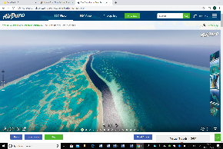

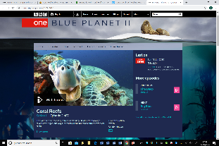

## **Blue Planet II Coral Reefs**

## Watch episode 3 [Coral Reefs of Blue Planet 11](https://www.bbc.co.uk/programmes/b09g4d98)

## where David Attenborough talks us through

## the life in undersea cities tropical reefs. Enjoy!

**Coral Reef Blow Painting**

Use [this link](https://www.woojr.com/ocean-coral-blow-painting/) to create a blow painting coral reef. Think carefully about the colours that you would find.

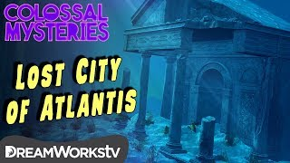

**The Lost City of Atlantis**

Can you find out about the Lost City of Atlantis?

Some people believe that it didn’t exist, what do

you think?

Can you find any evidence to support your Ideas?

There is a download sheet on the blog to help

You with some videos, different activities and

A quiz for you to take. Let us know what you

Find out on the blog or by emailing your work

to Mrs Frampton.

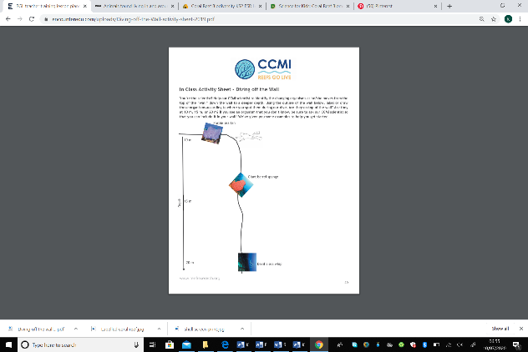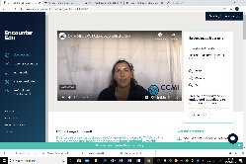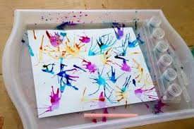

**Reef Expedition**

*.Go on a reef*

*expedition [here](https://encounteredu.com/live-lessons/reefs-go-live-2020).*

*Watch the video, it starts at*

*approximately 8:30 minutes in.*

*There is an activity sheet*

*for you to complete*

*whilst you watch this deep five.*

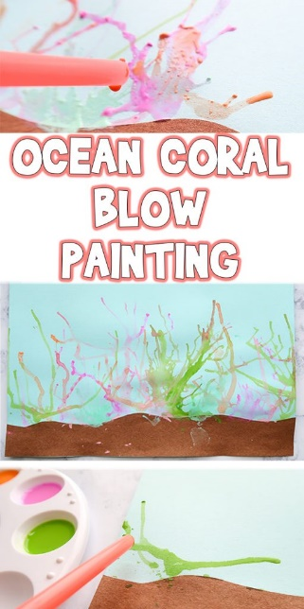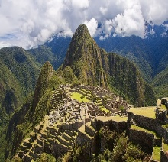

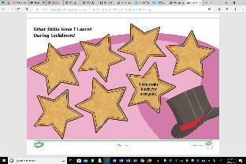

<https://thecraftyclassroom.com/crafts/ocean-crafts-for-kids/spiky-sea-urchin-craft-for-kids/>

<https://thecraftyclassroom.com/crafts/ocean-crafts-for-kids/seahorse-art-project-for-kids/>