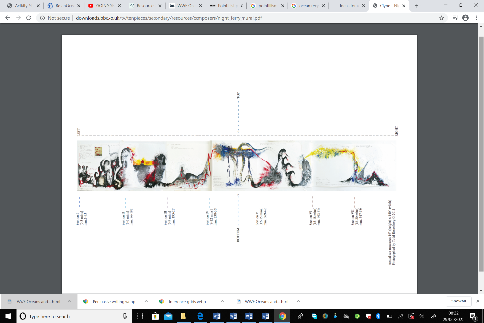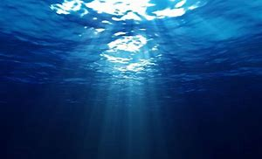

**Anna Clyne – Night Ferry**

On this page listen to Night Ferry a piece of

music all about the deep ocean. Read

all about how the piece was composed and

watch the video about it.

Can you draw your own wave listening to the

Piece?

Can you paint a musical score?

There is a powerpoint to take you through

different steps for this or be creative and just

have a go!

Don’t forget to email photographs of your art.

**Plastic Free Sandwich Wraps**

[Watch this video](https://kids.nationalgeographic.com/explore/nature/kids-vs-plastic/#/1470654531855) for how to make a sandwich wrap, you will need an adult to help for this. Scroll to the bottom of the page for the video.

**Killer Question!**

Are bioplastics more environmentally friendly than oil based plastics?

Can you answer this question? How do you know?

How can you prove your answer?

How would you present this to other people, an experiment, a

poster, a science report or a

presentation?

[Click here](https://encounteredu.com/steam-activities/plastic-degradation-test)

for more

information

and

instructions.

**French ‘Me Voici’ All About Me Book or Ebook**

It’s time to add information all about your family. Put information about their name, age and who they are to you!

You might like to remind yourselves of number and family members using these links:

[Number games](https://www.everyschool.co.uk/languages-french-numbers-2.html)

[Family members](ma_famille_Simpsons.ppt)

***Ma mère s’appelle Christine et elle a soixante-dix ans.*** Here is an example, you could draw a picture for each members or create a family tree.

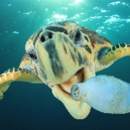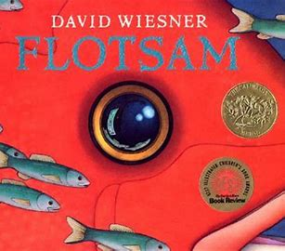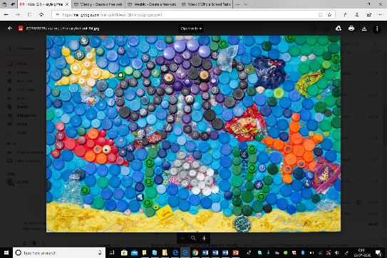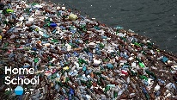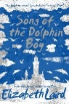[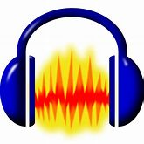](http://www.audacityteam.org/home/)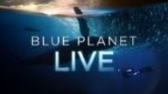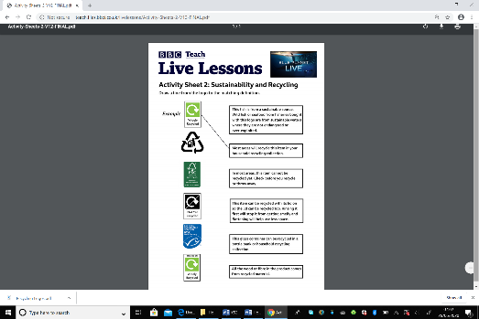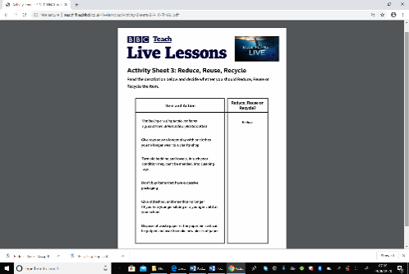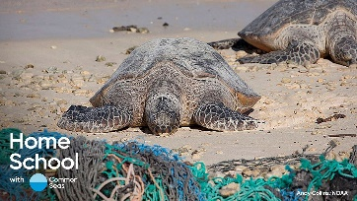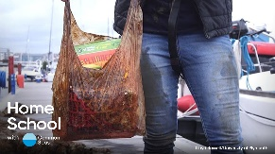Wp[;<https://worldoceanday.school/film/> |

**Plastic Plastic Plastic**

[On this page](https://encounteredu.com/teacher-resources/ocean-plastics-x-curric-ages-7-11) there are a series of lessons all about plastic and its impact on our seas. Choose from questions like:

What are plastics?

Where are plastics?

What impact can plastics have?

What can I do?

**Flotsam by David Wiesner**

[Click here](https://safeYouTube.net/w/4RSK) to see this brilliant wordless book.

Choose a page from the book and use these headings to write about the things you see: *Observe, Wonder, Infer.*

[*Watch this interview*](https://safeYouTube.net/w/smHM) *with the author*

*David Wiesner.*

*Can you create a wordless book all about*

*Saving our Oceans?*

*This week we are going to find out about what is happening to our oceans and what we can do to help. As in previous weeks the activities vary in how long they take and their difficulty. Some activities might be better spread over a number of days and you should find they are easily adaptable to a range of age groups. As always these activities are a guide and are there to help you. Please choose as many of these as you feel right for your family. Anything that is underlined is a hyperlink that will take you to more information to help with the tasks. If you have any questions about the tasks please email Mrs Frampton. Don’t forget to share your ideas on the blog or email photographs to Mrs Frampton (*[*kayleighframpton@ashtonvale.bristol.sch.uk*](mailto:kayleighframpton@ashtonvale.bristol.sch.uk)*) so she can upload them to the blog*

***How can we keep the ocean safe together?***

***) so she can upload them to the blog.***

***Have a great week, you are all doing brilliantly!***

**Recycling Collage**

This is an under the sea collage created using bottle tops by Miss Burke with Year 6 last year. Can you create a recycling collage about Oceans showing the problems with pollution?

## **The Journey of Plastic**

[Use this webpage](https://encounteredu.com/steam-activities/plastic-journey) to find out exactly what happens to

plastic. Can you create

a story board or digital

map for a plastic bottle?

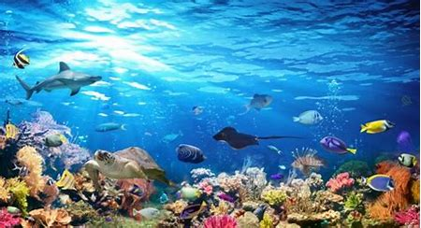

**Save our Seas**

**6th July 2020**

**Song of the Dolphin Boy**

**by Elizabeth Laird**

What problems did Finn encounter

about our theme for this week?

**How do humans affect the ocean?**

Can you write a news reports all about how humans are affecting the ocean? Maybe you have seen all of the rubbish that people are leaving on beaches and in public places recently on the news. You could write a script and then use Audacity to record this. Remember make it catchy so

people listen! Add a jingle and some music

too. There is a guide for a free Audacity download

on the blog.

Alternatively you could make a Save our Seas

Podcast!

**Oceans and Plastic Quiz**

[Take this quiz](https://encounteredu.com/steam-activities/plastic-quiz) all about plastic in our oceans. Can you make your own quiz, maybe you could use Powerpoint or an app like pic collage?

## **A Marine Wildlife Mission with Blue Plant and Live Lessons**

## **E**xplore what constitutes a healthy

## ecosystem and discuss the threats to

## our oceans such as plastics and

## overfishing. With CBBC's **Naomi Wilkinson** and

## expert wildlife biologist **Lizzie Daly**

## [here.](https://www.bbc.co.uk/teach/live-lessons/blue-planet-live-lesson/zn7tkmn)

**Balloons Out, Pom Poms In!**

[On this page](https://kids.nationalgeographic.com/explore/nature/kids-vs-plastic/pom-poms/) learn how to make pom poms to use instead of balloons to help protect ocean animals.

**The problem with straws!**

[The National Geographic Kids websites](https://kids.nationalgeographic.com/explore/nature/kids-vs-plastic/paper-straws/) tells you all about the trouble straws cause. Can you make paper straws using their guide?

**Problem Plastics**

[This webpage](https://encounteredu.com/steam-activities/plastic-threats) explains how plastic in the ocean is having a devastating effect on marine life. You could create a diorama or poster about plastic pollution.