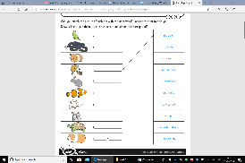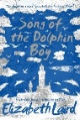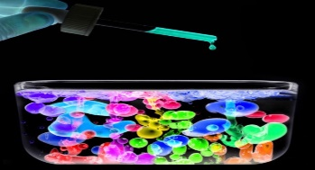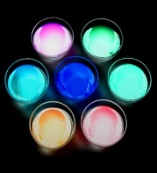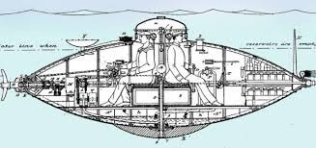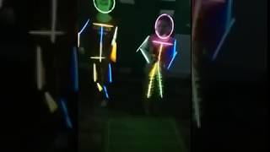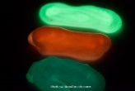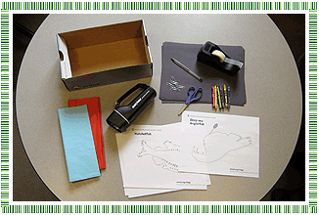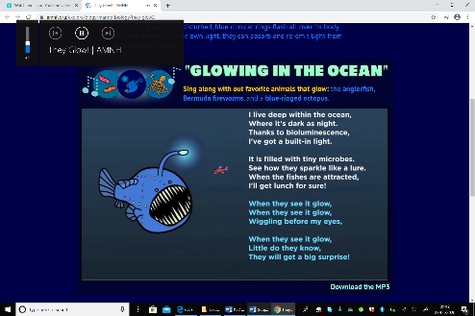 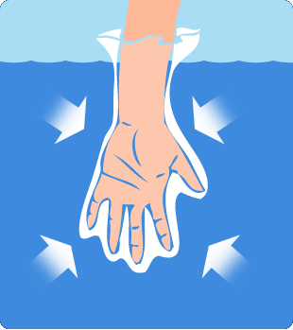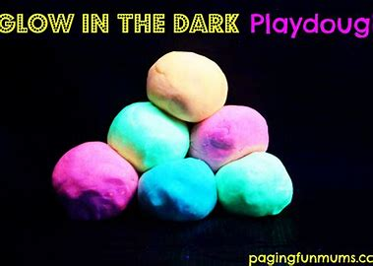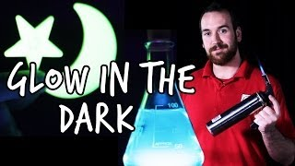A comb jelly in the genus Mnemiopsis shimmers in the dark ocean.
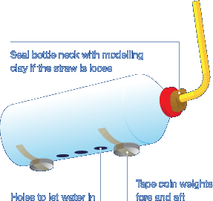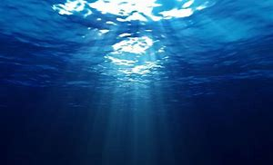 |

*I hope you enjoyed finding out about ocean habitats last week. This week we are going to be finding out about bioluminescence! As in previous weeks the activities vary in how long they take and their difficulty. Some activities might be better spread over a number of days and you should find they are easily adaptable to a range of age groups. As always these activities are a guide and are there to help you. Please choose as many of these as you feel right for your family. Anything that is underlined is a hyperlink that will take you to more information to help with the tasks. If you have any questions about the tasks please email Mrs Frampton. Don’t forget to share your ideas on the blog or email photographs to Mrs Frampton (*[*kayleighframpton@ashtonvale.bristol.sch.uk*](mailto:kayleighframpton@ashtonvale.bristol.sch.uk)*) so she can upload them to the blog*

***Let’s light up the home learning blog with your work this week!***

***) so she can upload them to the blog.***

***Have a great week, you are all doing brilliantly!***

**Song of the Dolphin Boy**

**by Elizabeth Laird**

What will happen to Finn next?

**Glowing Water Colour Experiment**

Can you use neon paint to make your water

glow?

Can you make water bubbles?

Why doesn’t it all mix together?

Don’t forget to send your photographs,

we can’t wait to see this!

How to guide on the blog.

**Submarine Safari**

Take a trip to the aphotic zone [here](https://www.submarinesafaris.com/kids_learn.php). Find out all about submarine and ocean life. Then take [this quiz](https://www.submarinesafaris.com/kids_quiz.php) to see how much you have learnt.

[This page](https://kids.britannica.com/kids/article/submarine/390261) has lots of information all about submarines and the history of them. Can you create a poster all about submarines?

Can you find out who invented the submarine? A

mini history

project for you.

**Glow in the Dark Slime!**

We all love slime, can you make your own glow in the ark slime?

[Click here for instructions](https://www.thebestideasforkids.com/glow-in-the-dark-slime/?jwsource=cl).

**Dancing Skeletons**

[Click here](https://safeYouTube.net/w/cqfM) to create your own glow in

the dark dancing skeletons!

**Can you create a spreadsheet about Ocean living things?**

There is a powerpoint on the blog to guide you. How will you categorise each living thing? What is the purpose of your spreadsheet? Microsoft excel works well for this.

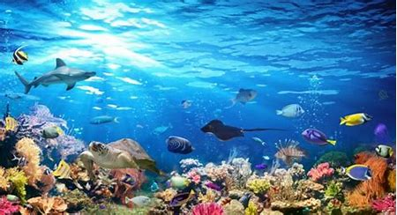

**Ocean Habitats**

**22nd June 2020**

**Make your own creatures of light!**

Have a look at the images [on this web page](https://www.nationalgeographic.org/encyclopedia/bioluminescence/) of

these bioluminescent animals. Can you create

your own creatures of light using [this guide](https://www.amnh.org/explore/ology/zoology/make-your-own-creatures-of-light/make-your-own-creatures-of-light-ocean-instructions) to help you?

**Glow in the Ocean**

[Sing along with this song](https://www.amnh.org/explore/ology/marine-biology/they-glow2) to

remember all about

animals that glow in the ocean.

**What makes things glow in the dark?**

What materials, what variables, and what other conditions are needed to make things glow?

[Watch this video](https://safeYouTube.net/w/eNmM) from We the Curious.

[Click here for a list of natural ingredients](https://www.thoughtco.com/what-glows-under-a-black-light-607615) that glow in the dark, you might just have some at home that you didn’t know about!

Can you make your own glow in the dark dough? There is a recipe on the blog to download.

**Killer Question!**

Does water apply pressure?

Can you answer this question? How do you know?

How can you prove your answer?

How would you present this to other people, an experiment, a

poster, a science report or a

presentation?

There is a handy

guide for you to

download on the

blog.

**Travel the depths of the ocean in a submarine sculpture!**

Look at pictures of real life submarines and create your own model submarine from different materials found at home. E.g. plastic bottles, paint, coloured pencils, string, paper etc. Talk about the

suitability of each material.

Don’t forget to take a photo

and email it to us.

Which materials is best for purpose?

How will you attach the pieces?

Can you use buoyancy tanks?

**Glow in the dark creatures**

Watch [this video](https://www.bbc.co.uk/bitesize/clips/ztn9p39) about making glow in

the dark art using shapes and silhouettes.

is all about an elephant but I am sure you

could create ocean creatures instead. Can

you use Wax Resist or **Sgraffito** to create

your scene? There is a guide on the blog

to help you with these techniques.

Don’t forget to email your creations to

Mrs Frampton.

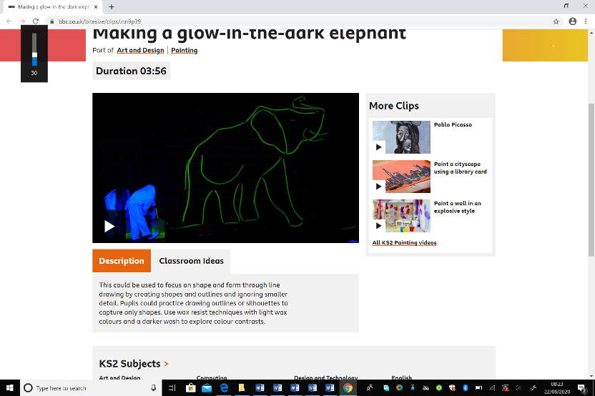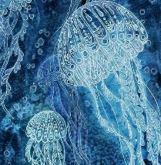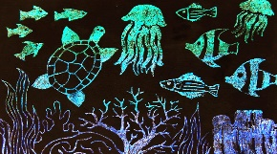

**French ‘Me Voici’ All About Me Book or Ebook**

This week we are going to write all about pets in our French books. This can be real, pretend or a wish list! Include the following information in full sentences

How many pets do you have? What is your favourite? What colour are they?

Listen to the first

radio clip [here](https://www.bbc.co.uk/teach/school-radio/french-ks2-radio-labo-1-animaux-et-les-couleurs/zhvjgwx)

about pets and

colours.

**Bioluminescence – Lighting up our Oceans**

Many sea creatures possess a fascinating light-producing ability called Bioluminescence. Some fish dangle a lighted lure in front of their mouths to attract prey, while some squid shoot out Bioluminescent liquid, instead of ink, to

confuse their predators. [Use this link](https://safeyoutube.net/w/vLB6) to find

out about Bioluminescence and how some

creatures rely on this for survival. Create a fact

file or poster all about Bioluminescence.