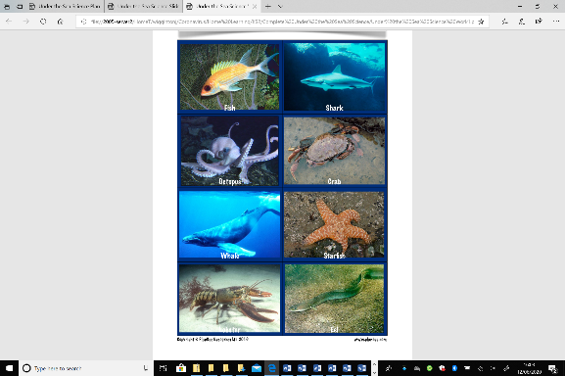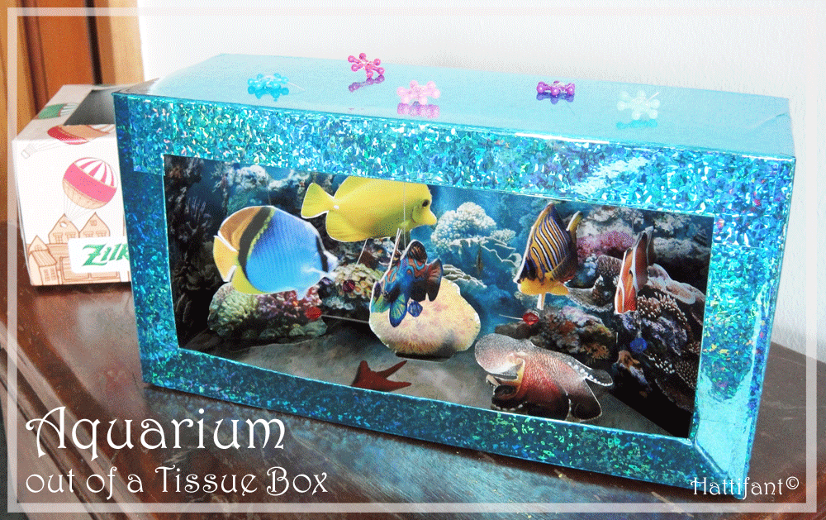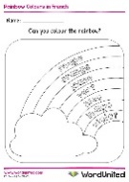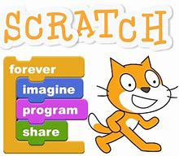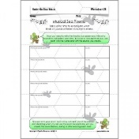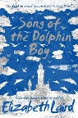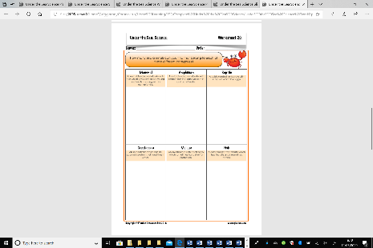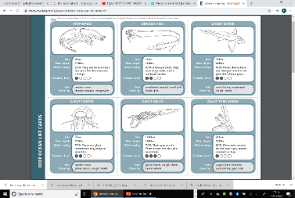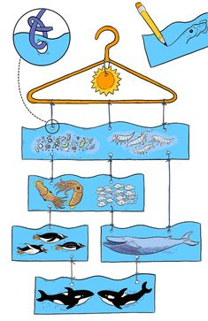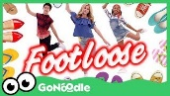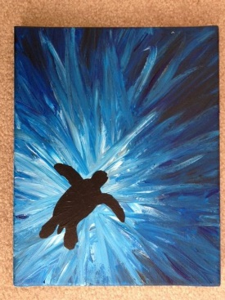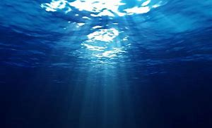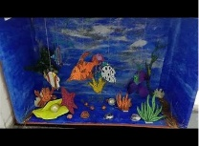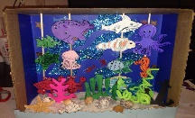 |

**French ‘Me Voici’ All About Me Book or Ebook**

This week we will start adding information all about yourselves in your book. Use these phrases to talk about your name, age, where you live and your colour preferences.

Je m’appelle …

J’ai …ans.

J’habite …

J’aime …

Je n’aime pas …

[Watch this video](https://www.youtube.com/watch?v=ARBKK0-sJGU) to remind you of French colours. Can you sing along?

**Scratch Games**

Create an ocean maze or splat game using [Scratch](https://scratch.mit.edu/projects/editor/?tutorial=getStarted). Can you change the characters and backgrounds? What ocean themed effects can you add?

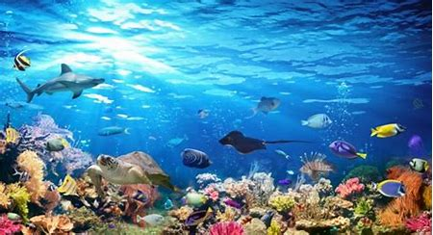

**Ocean Habitats**

**22nd June 2020**

**Musical Sea Pomes**

Can you use words and

music to describe what

the sea is like?

Listen to these ocean sounds.

[Ocean](https://safeYouTube.net/w/pRUK) [Seaside](https://safeYouTube.net/w/lSUK)

What instruments and sounds could you use to create sea sounds? What household items could you use? Waves crashing, seagulls squawking, crabs crawling, seaweed waving and fish swimming.

**Song of the Dolphin Boy by Elizabeth Laird**

I hope you enjoyed chapters 1-3. I will upload a new

chapter every few days. Can you draw an illustration

for the chapter that you have just listened to?

*I hope you enjoyed our first week of our Oceans Topic last week. This week lots of the activities on this page are all about ocean habitats and animals that you would find in the ocean. Like last week the activities vary in how long they take and their difficulty. Some activities might be better spread over a number of days and you should find they are easily adaptable to a range of age groups. As always these activities are a guide and are there to help you. Please choose as many of these as you feel right for your family. Anything that is underlined is a hyperlink that will take you to more information to help with the tasks. If you have any questions about the tasks please email Mrs Frampton. Don’t forget to share your ideas on the blog or email photographs to Mrs Frampton (*[*kayleighframpton@ashtonvale.bristol.sch.uk*](mailto:kayleighframpton@ashtonvale.bristol.sch.uk)*) so she can upload them to the blog.* ***Just keep swimming!***

***) so she can upload them to the blog.***

***Have a great week, you are all doing brilliantly!***

**Killer Question!**

How do sharks float?

Can you answer this question? How do you know?

How can you prove your answer?

How would you present this to other people, an experiment, a

poster, a science report or a

presentation?

There is a handy

guide for you to

download on the

blog.

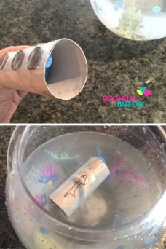

**Animal Categories**

Do you know what these terms mean and

how we use them?

*vertebrate, invertebrate, mammal,*

*crustacean, mollusc, amphibian, reptile*

Can you make a book, poster or powerpoint

presentation with examples of each of the

different animal groups? Can you think of a sea

animal for each category? Slideshow to support this on the blog.

**Marine Creatures**

Use this [NMA workshop](https://oceanconservationtrust.org/what-we-do/ocean-experiences/create-a-creature-online-workshop/) to help you create the perfect marine creature. Think about its habitat, will it need to camouflage? Think about its diet, how will it obtain food?

**Marine Biology**

Become a Marine Biologist [here](https://encounteredu.com/steam-activities/marine-biologist).

Watch the video and play the

card game to find out how deep sea

creatures are connected.

Could you make your own Top Trumps

cards. How would you rate the sea animals and plants?

**Ocean Animal Food Chains**

Watch [this video](https://www.bbc.co.uk/teach/class-clips-video/science-ks2--ks3-food-chains-and-food-webs-in-animals/zn7g92p) about food chains.

*Try making a food chain from ocean animals using the Deep Sea Life cards to help you. Or you can do your own research.*

Start with a **producer** – one of the living things that shows a 0 feeding level (four blanked circles).

Then find a **primary consumer** – they rely on the

producer for food. (I circle out of 4)

Next find a **secondary producer** and so on.

*Use a hanger to make a mobile hanging food chain.*

*What’s the longest chain that you can make?*

*Could you make it into a wind chime?*

**Go Noodle**

[Click here](https://safeYouTube.net/w/VfSL) to learn this fun dance routine. Let

us know on the blog if you enjoy it!

**Underwater Habitats**

How have these animals adapted to suit

their underwater habitat?

How do these animals breathe underwater?

How do they eat, hunt, camouflage and move?

Make a poster or a piece of art to explain

what you have found out.

How could you sort these animals into

categories? Could you create a diagram to

show this?

Slideshow to support this on the blog.

**3D Aquarium**

Have a go at making a 3D aquarium, you will need a box, some card (a cereal

box is perfect to cut down). and string or sticks to hang items from. You can

create layers by cutting different

heights of card. If you make a small

fold all along the bottom edge you

will be able to glue it down making

it stand up. Could you think about

the ocean zones and layers in your

project? Don’t forget to take a photo.

and email it to us.

**Sea Silhouettes**

Start by creating an ocean

background, thick paint works

well but you could do this with

chalks or crayons. Decide where

you will put your silhouette and

this will be the lightest section

work your way out to the darkest

section. You might find it easier to

start with the darkest colours and do the lighter colours on top when the paint is completely dry. If you don’t have black paper for the silhouette you could always paint/ colour it in black. Simple outline shapes work the best. Don’t forget to email your creations to Mrs Frampton.