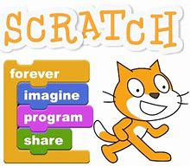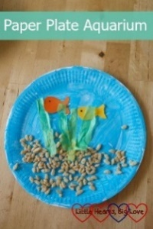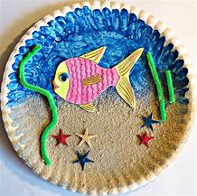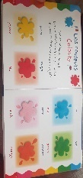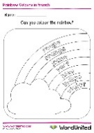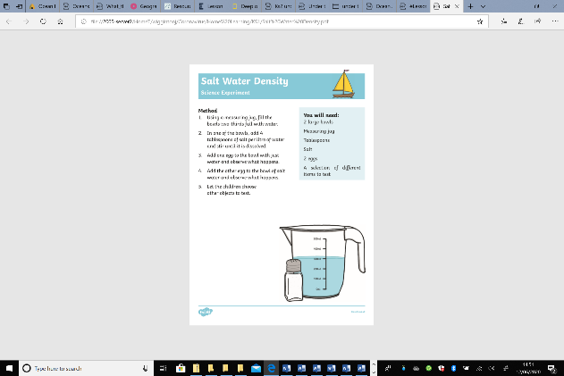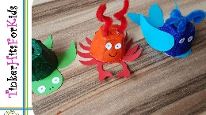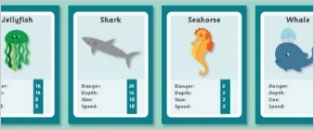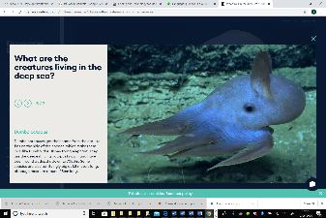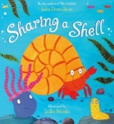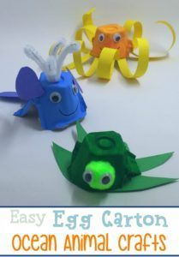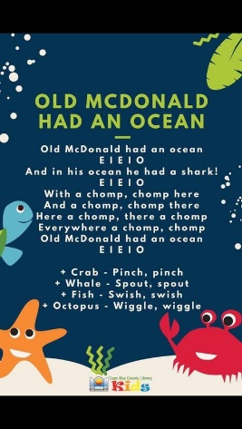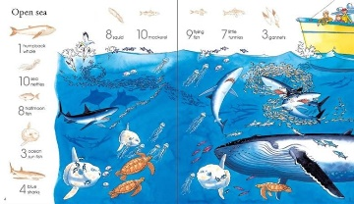 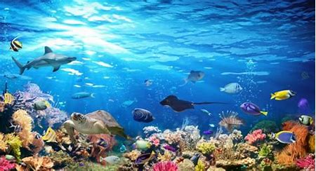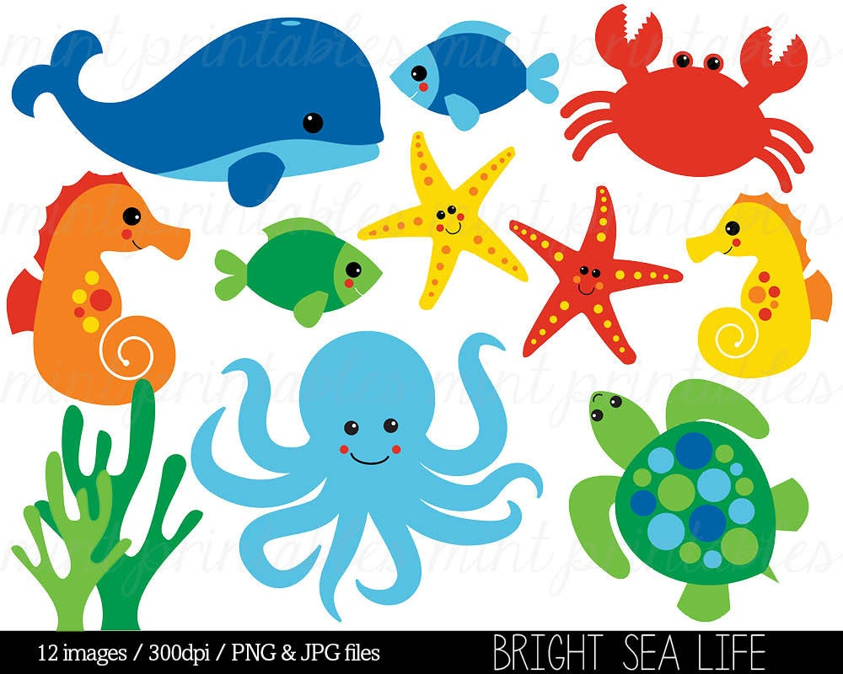

*I hope you enjoyed our first week of our Under the Sea Topic last week. This week lots of the activities on this page are all about sea animals and the creatures that you would find in the sea. Like last week the activities vary in how long they take and their difficulty. Some activities might be better spread over a number of days and you should find they are easily adaptable to a range of age groups. As always these activities are a guide and are there to help you. Please choose as many of these as you feel right for your family. Anything that is underlined is a hyperlink that will take you to more information to help with the tasks. If you have any questions about the tasks please email Mrs Frampton. Don’t forget to share your ideas on the blog or email photographs to Mrs Frampton (*[*kayleighframpton@ashtonvale.bristol.sch.uk*](mailto:kayleighframpton@ashtonvale.bristol.sch.uk)*) so she can upload them to the blog.*

***Just keep swimming!***

**Coding Cool Characters**

Download the free app ScratchJr available for tablets (such as Apple, Amazon and Android tablets) or you can use it on a laptop online. Start your under the sea project by creating a character. Use

the guides on the blog to help you. There

is a demo too.

**Ocean Animals**

[Watch this video](https://www.bbc.co.uk/bitesize/clips/zx676sg) about animals that

live in the sea.

*What do all of these animals have in common? What things are the same about them? What things are different? Can you sort the animals in groups: has legs, has fins, does not have legs, does not have legs or fins?*

Can you make ocean animal top trumps cards? Give the animals a number score based on categories such as danger, size, depth and speed.

**Junk modelling sea creatures**

How many different sea

creatures can you make

from egg boxes or

recycling?

**What is an Ocean Habitat?**

[Use this BBC Bitesize page](https://www.bbc.co.uk/bitesize/topics/zx882hv/articles/zsfkd2p) to find out what an ocean habitat is. Watch the video, complete the drag and drop activity and take the quiz.

How could you make your own Ocean Habitat?

Use [this webpage](https://encounteredu.com/teacher-resources/oceans-for-beginners-x-curric-5-7-lesson-1-our-wonderful-oceans) to help you create your own marine animal snap cards.

Can you create a fact-sheet

poster about your favourite

species, drawing and labelling

their features? This could be a pic collage, word document or done by hand. Use the Our Wonderful Oceans powerpoint to help.

**French Colours**

Listen to the [Rainbow Song](https://www.youtube.com/watch?v=ARBKK0-sJGU)

to learn the colours in French.

Have a go at this French [colour game](https://www.cartoonito.co.uk/games/cartoonito-club-french-word-fun-colours).

Complete this French rainbow, you could

colour, paint or collage it.

Create a simple book all about French colours, you could put one colour on a page with lots of pictures of all things that colour.

**[‘Sharing A Shell’ by Julia Donaldson](https://www.youtube.com/watch?v=FUt4qjc6Hj0)**

*I hope you enjoy this story, it is one of my favourites with beautiful glittery pictures!*

Is there a moral to this story? Does it teach us anything?

Who helps you right now? Does

anyone from outside of your home

help you, even though you don’t see them?

Draw a picture of all of the people and

things that help you. You could write speech bubbles to say how they help you.

**Things to spot –**

**Open Sea!**

Can you find all of

the things on the

open sea scene?

**Sea Animals**

**22nd June 2020**

**Salt water experiment**

What makes things float? Does salt water make things

float more or less?

Some pools are fresh water pools and some are salt

water pools, what is the difference?

**Aquarium**

Have a think about what you would

see in an aquarium tank. Go around

your house collecting items to make

these things, for example you could use grass or pipe cleaners for sea weed, pasta for shells, cereal for sand or maybe you have

some sand? Have a go at making an aquarium with them. Don’t forget to

take a photo and send it to us.

**Songs –** Old Macdonald Had An Ocean – can you add other sea creatures?

What sea sounds could you replace EIEIO

with?

What other under the sea creatures could

you sing?

Do you know Under the Sea from the

Little Mermaid?

Sing along [here.](https://safeYouTube.net/w/IoTK)

Let us know what you are singing about

on the Home Learning Blog comments.