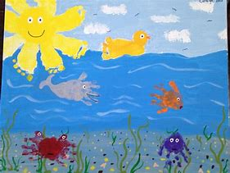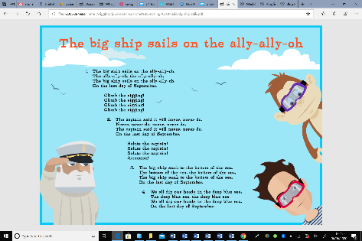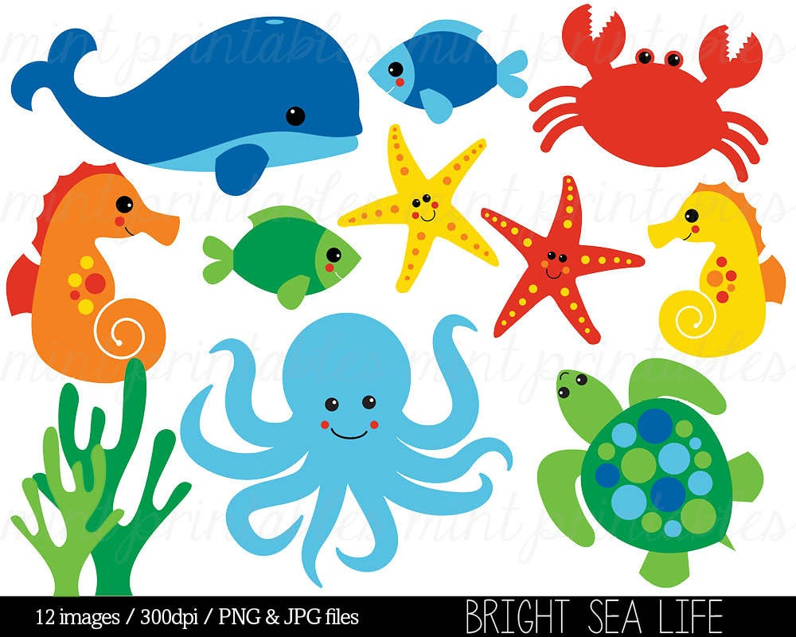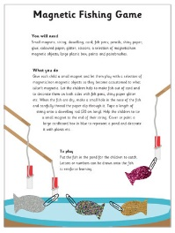 |

**‘**[**Commotion in the Ocean’ by**](https://safeYouTube.net/w/WkSJ) **Giles Andreae**

[*Click here*](https://www.youtube.com/watch?v=ItMfvwBYijs) *to read with Mrs Frampton.*

Can you create your own Commotion in the Ocean book? Choose some of your favourite

things that’d you’d find in the sea to

write about in the style of this book.

Don’t forget a picture too!

Try some Commotion in the Ocean yoga stories

[here](https://tpet.co.uk/downloads/commotion-in-the-ocean-yoga-stories/).

**What is Coding?**

Have a look [at this webpage](https://www.bbc.co.uk/bitesize/topics/z3tbwmn/articles/zykx6sg) which explains what coding is. There’s a video and game.

Now create a simple under the sea obstacle course or draw an obstacle course on a piece of paper. Children have to guide an under-water robot (Parent/sibling/toy) through the obstacles by shouting out simple instructions. E.g. forwards, right, left, backwards.

**Magnetic Fishing Game**

Make your own magnet fishing game using paper

clips. Test items around your house to find out

what materials are magnetic. Click here.

What materials are magnetic? Is that always true?

How do you know?

**Under the sea handprint cards**

Have a go at using your hands to make under the sea creatures.

Can you use your fingers to add details such as seaweed and coral?

Some of you might be making cards this week and could use your printing for a card or even wrapping paper.

**Songs – The Big Ship Sails on the Ally Ally Oh**

[Click here](https://www.bbc.co.uk/teach/school-radio/music-ks1-sun-sea-song-1-the-big-ship-sails-on-the-ally-ally-oh/zb7spg8) to sing along

with the song and some

activities all about rests

rests (pauses in music)

and whether the songs

is fast or slow.

What other under the sea songs

could you sing?

Do you know 1,2,3,4,5?

Let us know what you are singing about on the Home Learning Blog comments.

[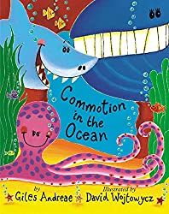](https://aax-us-east.amazon-adsystem.com/x/c/QnfJf7MhJmOp-Ov_XLSH1sAAAAFyijjAxwEAAAFKAS3xfoE/https:/assoc-redirect.amazon.com/g/r/http:/www.amazon.com/gp/product/1589253663/ref=as_li_tl?imprToken=RMVZR-AtP7w6UNzu7gAJ6A&slotNum=0&ie=UTF8&camp=1789&creative=390957&creativeASIN=1589253663&linkCode=w61&tag=groboobyboo-20&linkId=N6OG4NCPNABPDO72)

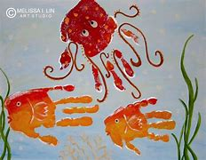

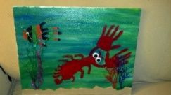

**What can you see under the sea?**

[Watch this](https://www.bbc.co.uk/teach/class-clips-video/science-ks1-ks2-wonders-of-nature-underwater-world/zh3ygwx) short video about the underwater world. Now look at the Powerpoint and see if you can guess what is hiding in the sea.

You could draw or make each of the things that you see. How could you sort what you saw?

(Animals/plants, living/non-living – you could physically put these objects on a map!)

What headings could you use on this

venn diagram?

*How do the different fish and plants all*

*live together?*

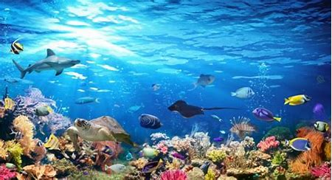

**Under the Sea**

**15th June 2020**

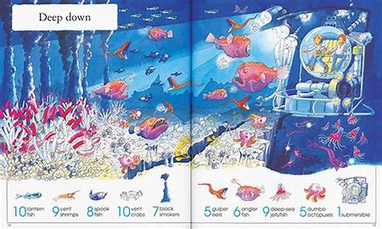

**Things to spot –**

**Deep down!**

Can you find all of the

things on the deep down

scene?

Have a go at creating you own

deep down scene.

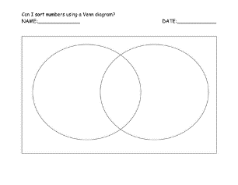

***On this page there are some curriculum based activities and projects. The pieces on here vary in how long they take and their difficulty. Some activities might be better spread over a number of days and you should find they are easily adaptable to a range of age groups. As always these activities are a guide and are there to help you. Please choose as many of these as you feel right for your family. Anything that is underlined is a hyperlink that will take you to more information to help with the tasks. Any pictures on this page can be downloaded from the Home Learning blog. If you have any questions about the tasks please email Mrs Frampton. Don’t forget to share your ideas on the blog or email photographs to Mrs Frampton (***[***kayleighframpton@ashtonvale.bristol.sch.uk***](mailto:kayleighframpton@ashtonvale.bristol.sch.uk)***) so she can upload them to the blog.***

***Have a great week, you are all doing brilliantly!***

**What is an Ocean?**

*Can you name the*

*Seven continents*

*and five oceans.of the*

*world?*

*Can you find them on*

*a map?*

Create a world map/globe to show what you have found out. You could make a paper mache globe. You could add flag markers to show where these places are. You could put photographs and place names of the types of things you might find there. There is a powerpoint to support this.

**Now try this** [**quiz**](https://www.educationquizzes.com/ks1/geography/oceans-of-the-world/)**.**

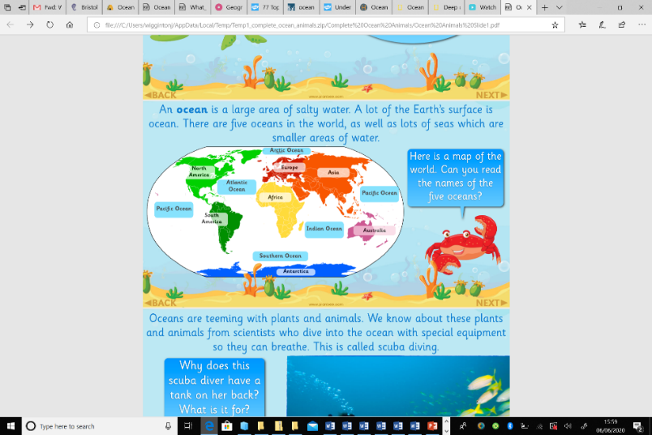0yop]h

-

**French**

Watch

[The Town Rat and The Country Rat](https://www.bbc.co.uk/bitesize/clips/zd2kjxs)

to hear some French speaking. Now let’s have a go at speaking in French. W[atch this greetings song](https://www.bbc.co.uk/teach/supermovers/ks1--ks2-mfl-french-greetings-with-ben-shires/zdpdvk7) and then have a go at joining in with the words and actions. Every day try and say hello in French at least three times. Can you say please and thank you in French too?

[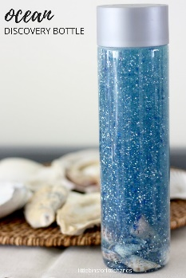](https://littlebinsforlittlehands.com/6-awesome-ocean-science-activities-kids/)

**Under the sea sensory bottle**

Make an under the sea sensory

bottle or jar. Fill your bottle half

way with water, add green/blue

glitter/glitter glue. Once it has settled

add your shells.

You could use pasta shells or real shells. What other items could you use?

[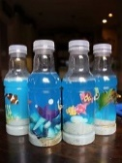](https://www.bing.com/images/search?q=under+the+sea+sensory+jar&id=AA9D4DB10770BED7B844C51018A4C7247BC30AE0&FORM=IQFRBA)

