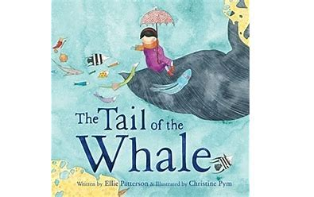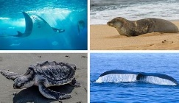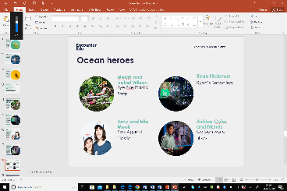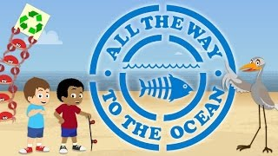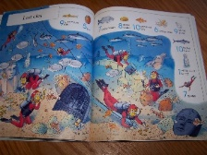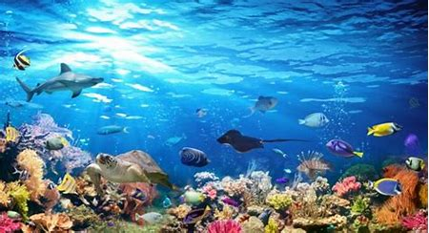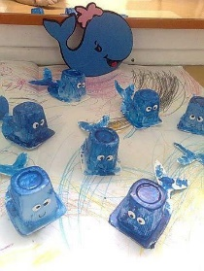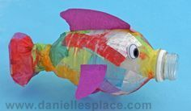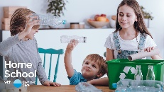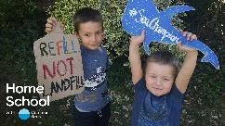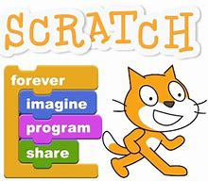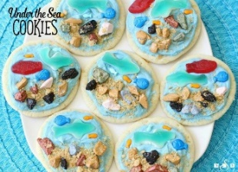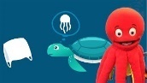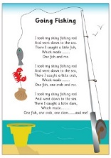Ba| https://safeYouTube.net/w/z3tM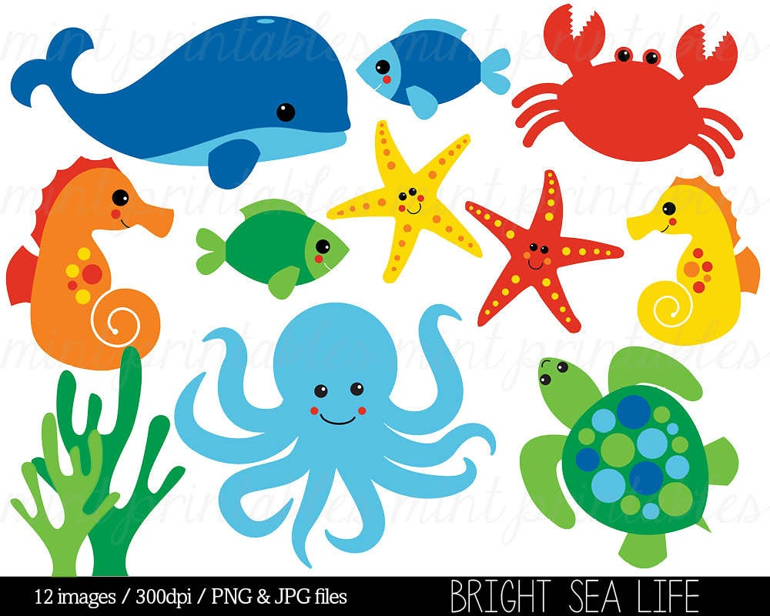gfvhvbfcdx

*This week we are going to focus on a very current issue Saving our Oceans. The activities look at what is happening to our seas and what we can all do to help As in previous weeks the activities vary in how long they take and their difficulty. Some activities might be better spread over a number of days and you should find they are easily adaptable to a range of age groups. As always these activities are a guide and are there to help you. Please choose as many of these as you feel right for your family. Anything that is underlined is a hyperlink that will take you to more information to help with the tasks. If you have any questions about the tasks please email Mrs Frampton. Don’t forget to share your ideas on the blog or email photographs to Mrs Frampton (*[*kayleighframpton@ashtonvale.bristol.sch.uk*](mailto:kayleighframpton@ashtonvale.bristol.sch.uk)*) so she can upload them to the blog.*

***#saveourseas***

**Guess Who Endangered Sea Animals**

Have a look at the powerpoint [Plastic Pollution](Plastic%20Pollution.pptx). How does plastic effect animals?

Here is a powerpoint about [Endangered Animals](Endangered%20Animals.pptx).

Can you create a game of Guess Who all about Endangered Animals? You could focus on ocean endangered animals or a mixture.

Start by drawing the pictures for the Guess Who Board. Then think about the

questions that you might ask

to identify the endangered

animals and win the game!

**Ocean Heroes**

Use the powerpoint to find out how our seas are in crisis and who are Ocean Heroes. Write a short piece all about one of the Ocean Heroes and draw a portrait of them. All of the information

is on [this webpage](https://encounteredu.com/teacher-resources/oceans-for-beginners-x-curric-5-7-lesson-3-our-ocean-in-crisis) or can

be downloaded on the blog.

**Under the Sea Dance** Join Cat Sandion for [an under the sea dance session](https://www.bbc.co.uk/programmes/p01rtm6y)

exploring creatures that live under the sea.

**The Tail of the Whale by Ellie Patterson**

Join me on a journey on the tail of a

whale as we dive down into the colourful

depths of the ocean. Link on the blog.

Watch this online story video of [‘All the Way to the Ocean’ by Brenda Canela and Katie Leigh](https://safeYouTube.net/w/z8LM). It tells a

story about two best friends, Isaac and

James and their discovery of the cause

and effect relationship between our

cities' storm drains and the world's

oceans, lakes and rivers.

**Things to spot –**

**The Lost City!**

Can you find all of

the things in the

Lost City scene?

**Save our Seas**

**29th June 2020**

**Plastic Recycling Sea Animals**

Can you reuse plastic from your

home to make these whales

and fish?

What other plastic can you find to

reuse for sea

creatures?

**Ocean Plastic Pollution**

Use this [interactive activity](https://encounteredu.com/multimedia/images/the-top-causes-of-ocean-plastic-pollution) to find out

where ocean plastics come from.

Become a plastic hero by refusing plastic[, this webpage](https://encounteredu.com/steam-activities/plastic-bin-weigh-in) can help. Keep a plastic diary of all of the plastic items you use in your home to start you off!

[Go on a plastic hunt](https://encounteredu.com/steam-activities/problem-plastic-hunt)!

Become a sea champion [here](https://encounteredu.com/steam-activities/sea-champion-pledge).

**Coding – Repeat and Sounds**

I hope you enjoyed making your character grow and shrink. This week you can add repeats into your codes and add sounds for your character.

Use the powerpoint on the blog to help

you. You could take a screenshot or

photograoh of your character and email it to us.

**Under the Sea Cookies**

Why not have a go at cooking

with your adult at home

this week? There is an

example [here](Under%20the%20Sea%20Cookies.docx) and a [video](https://butterwithasideofbread.com/under-the-sea-cookies/?jwsource=cl)

too.

**Our Ocean and Us!**

Make a diorama to show the different ways we use the ocean. There is a slideshow and various guides

on [this webpage.](https://encounteredu.com/teacher-resources/oceans-for-beginners-x-curric-5-7-lesson-2-our-ocean-and-us)

**Frozen Sea**

What happens to ice in the ocean? Is it all ice? Is there room for animals below the ice or around it?

[Use this science experiment](../Frozen%20sea%20adult%20guide.doc) to explore some of these ideas.

**The Pool Rhyme**

What under the sea creatures will you catch on

the ‘Going Fishing’ rhyme? Maybe you could

make some finger puppets to use as you sing?

[Sing along](https://safeYouTube.net/w/nALM) with Octavia Octopus all about

plastic pollution in the ocean. Do you

recognise it? Listen carefully to the lyrics.

**French Numbers**

[Sing along to this great song](https://www.youtube.com/watch?v=uTsFBOIoLxY) where you can learn to count to 10 in four different languages!

[Watch this video](https://www.bbc.co.uk/bitesize/clips/zrdg9j6) and then have a go at playing La Marelle at home. You could chalk the numbers outside or make number cards for inside.

Have a go at [this game](https://www.digitaldialects.com/French/numbers_1B.htm) where you can practise some addition and your French numbers at the same time. Remember you can use objects to help you count two groups.