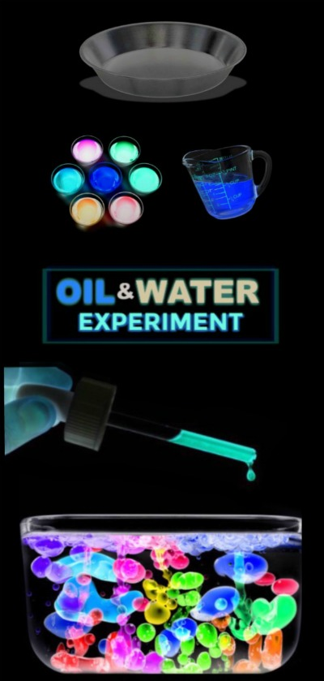
Materials
- Baby oil
- A pan or clear container
- Pipettes
- Neon Paint
- Small bowls
- . Water

Method
- Begin by filling a dish or container with baby oil. Set this aside.
Making the glowing water colours
- Add a teaspoon of glowing paint to a bowl, using one bowl for each colour of glowing water that you wish to make.
- Fill the bowls with very warm water and mix until the paints dissolve into the water.
- You will now have a variety of glowing waters to use for this experiment!
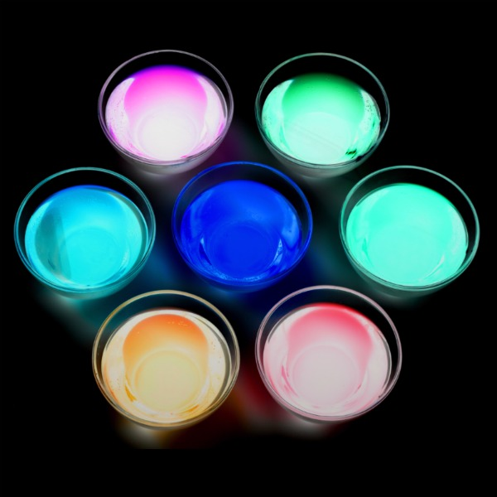
Now, the experiment can begin!

Have children use a pipette or small straw to drop the colourful waters into their container of oil.
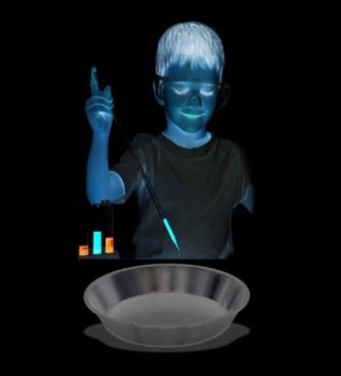
As kids drop the water into the oil the water will bead up and create beautiful effects!
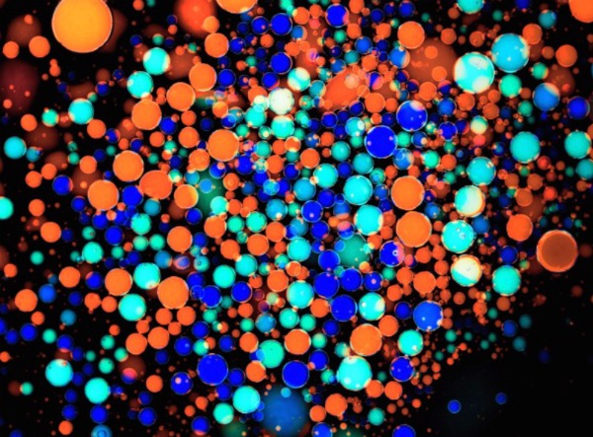
No matter how much coloured water is added the oil the oil and water will not mix! Isn't that cool science?

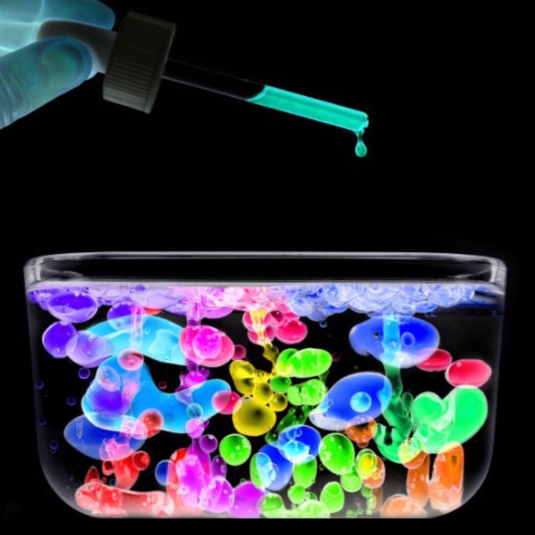

The Science Behind the Fun
For older kids you can talk in detail about the densities of the two liquids and why they do not mix.
- Why Oil & Water Don't Mix
- Oil & Water- Sick Science
- Oil & Water Science

