Watch this video all about creating animal shapes and silhouettes. How could you
recreate something in this style at home?

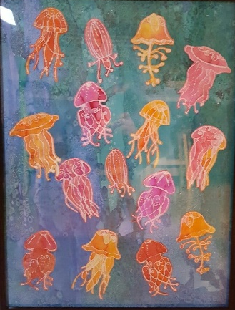
Resist Work
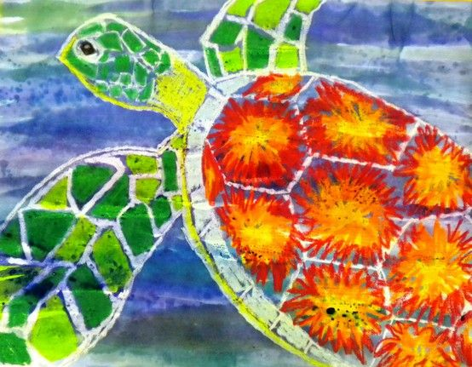
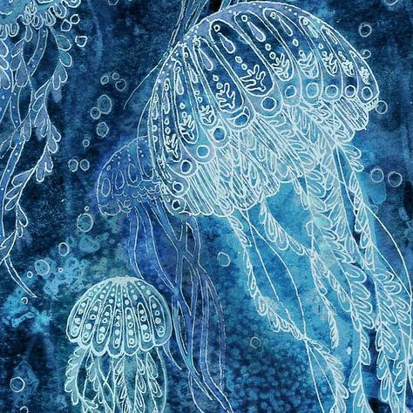
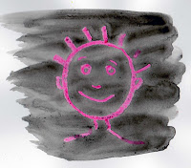

This technique exploits the water-resistant qualities of wax crayons; simple yet very effective. You create your drawing in wax crayon, and wash over it with a watery paint. You can get different effects depending upon how thick the paint is, and the colour of the drawing beneath. Used with a very watery paint and a white crayon, the effect is light and delicate, but wash over a bright wax crayon drawing with a denser black paint (not too thick or the paint will simply obliterate the drawing) and the effect is much richer and more dramatic. Alternatively, if the pictures are small you can use a felt tip marker pen over the wax crayon. To get the best effect, the wax crayon has to be applied fairly densely under pressure, which requires some strength to do. Can you use this technique to create an ocean scene?
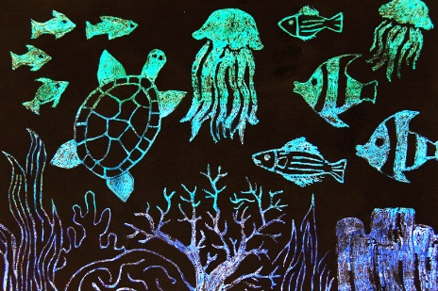
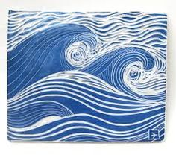
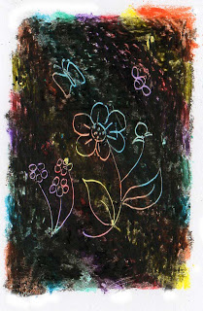
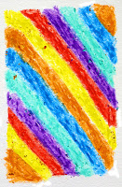
Sgraffito

This technique has 3 stages and is most suitable for older children who have more strength to apply the necessary pressure.
1. Create an bioluminescence ocean background with wax crayon, felt tips or paint.
2. Cover it densely (thickly) with black wax crayon, applying as much pressure as possible.
3. Using something like a cocktail stick, draw your picture by scraping away the black wax crayon and revealing the coloured surface below.

