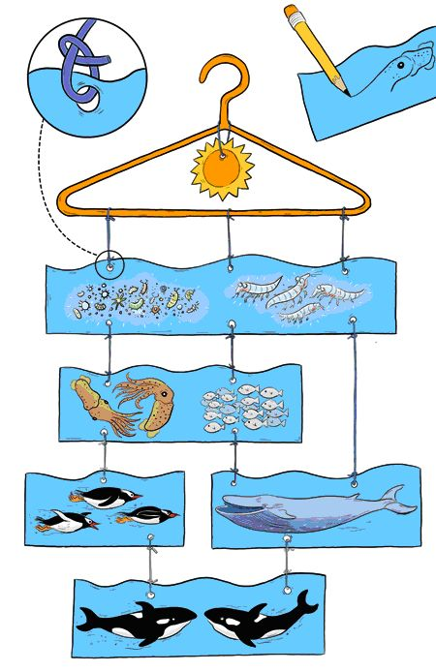
You will need:
A hanger or you could make the frame from pipe cleaners
String, ribbon or wire
Picture cards
Method:
- Start by creating your food chain picture cards with different animals from the food chain groups on each card. You could do these in different shapes or add glitter/shiny objects to make them catch your eye as they hang.
- Place your cards in the correct order of the food chain as you would like them to hang.
- Next use a hole punch to make holes at the top of your cards. Thread lengths of string through the cards tying them on.
- Tie the top cards to the hanger.
- Now make your mobile look pretty, hang some ribbons as seaweed. What other ocean features could you add?
- Make sure you give your food chain a title at the top of your mobile.

