**Downloading Audacity**

1. **Go to** <https://www.fosshub.com/Audacity.html> 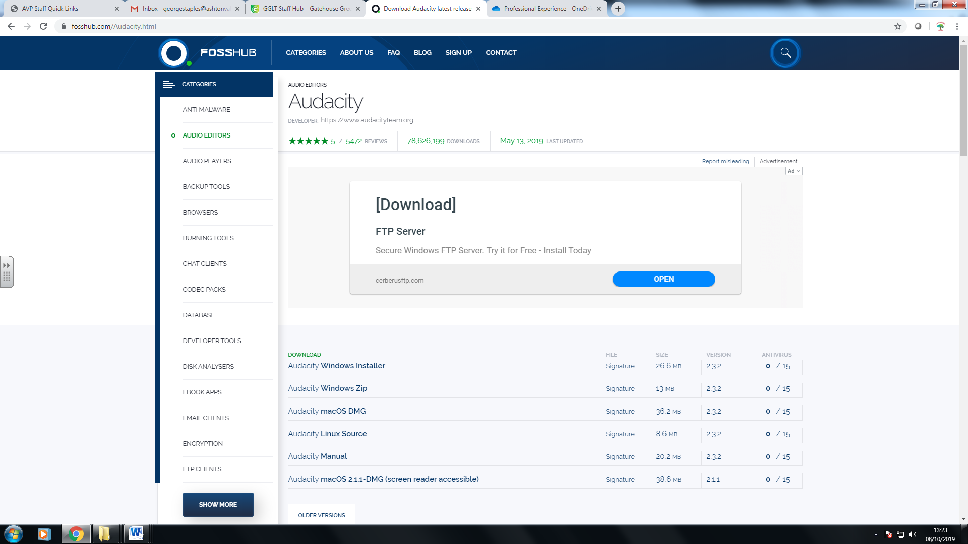
2. **Click on Audacity Windows Installer** 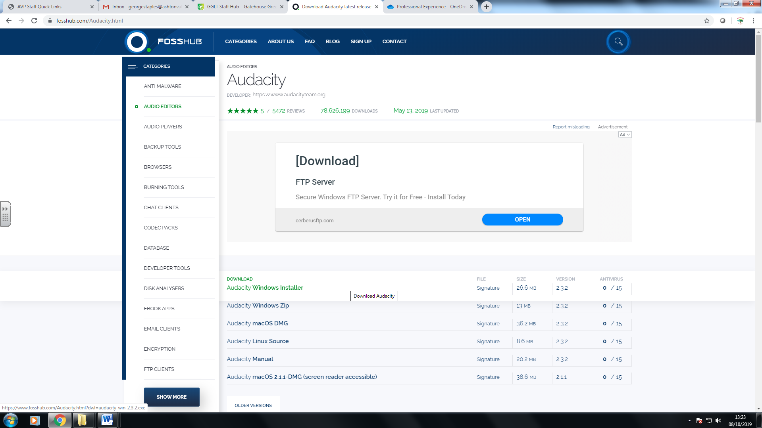
3. **Open the downloaded file in the bottom left corner**

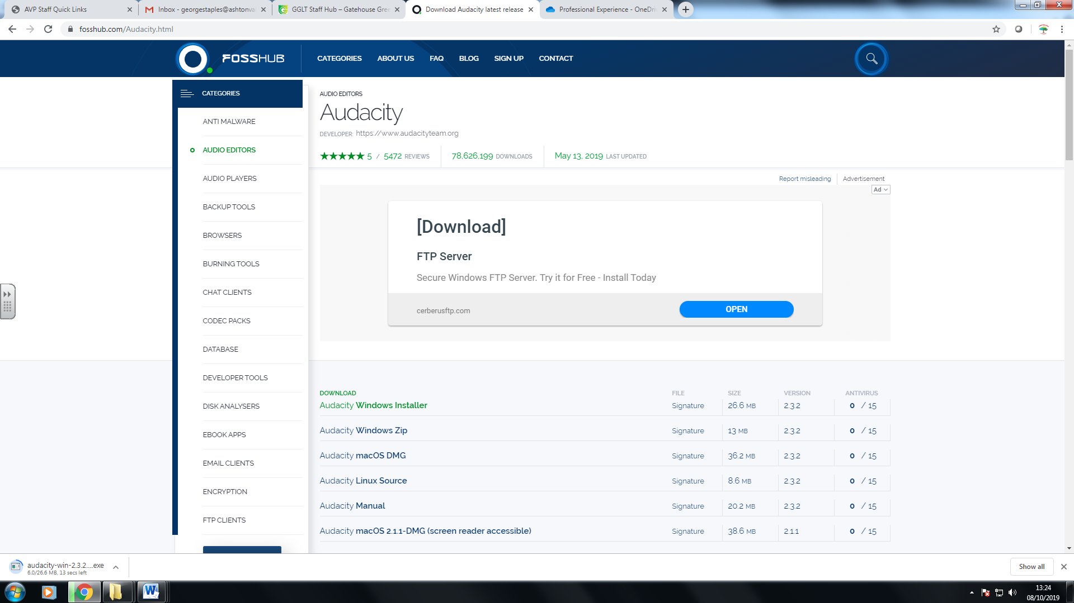

1. **Press Run, and then press YES** 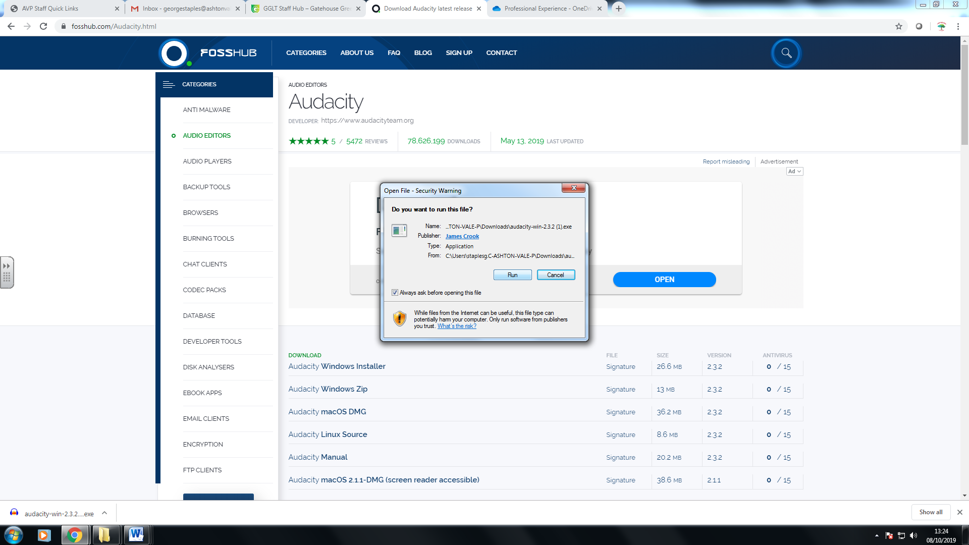
2. **Set up language as English** 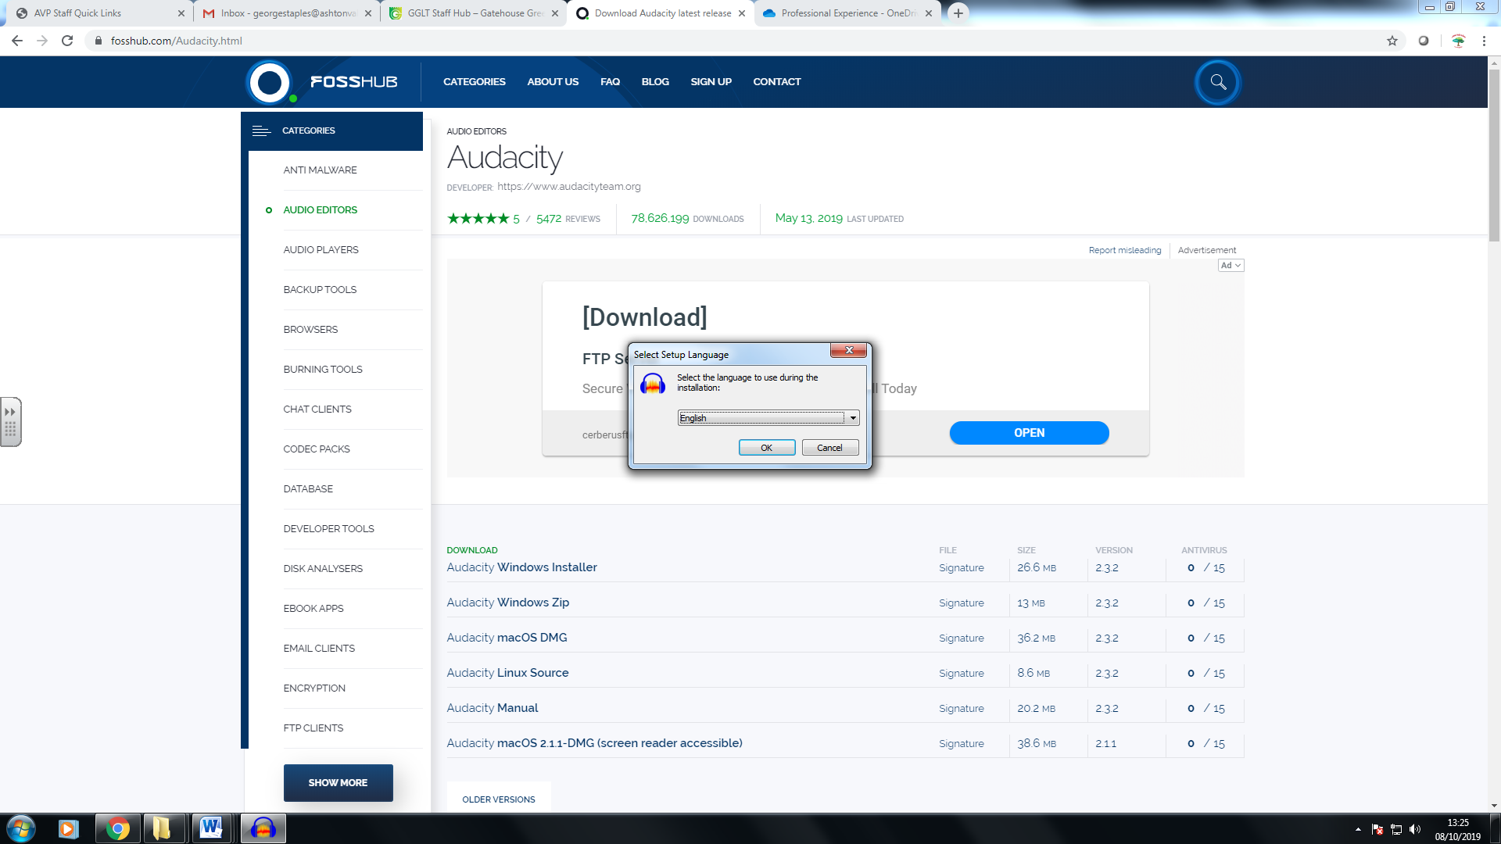
3. **Press NEXT** 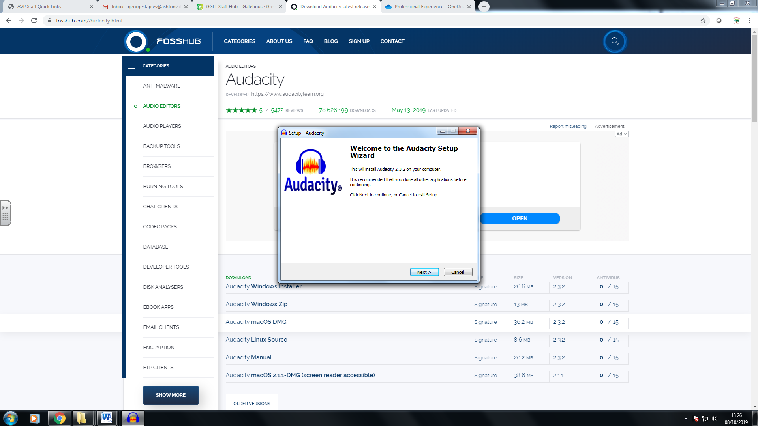
4. **Press NEXT 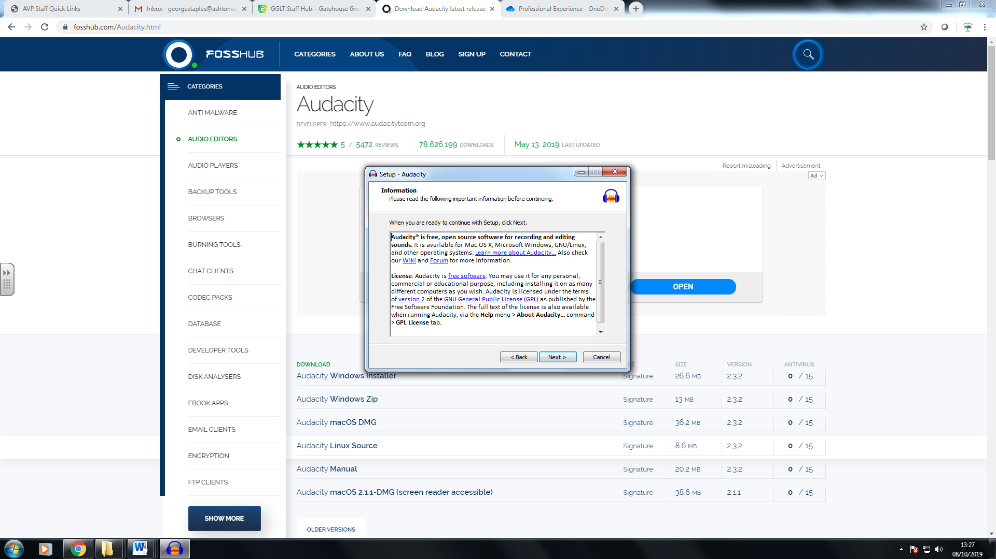.**
5. **Press NEXT** 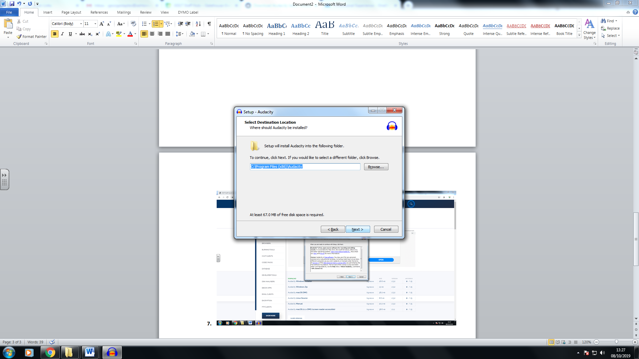
6. **Press NEXT** 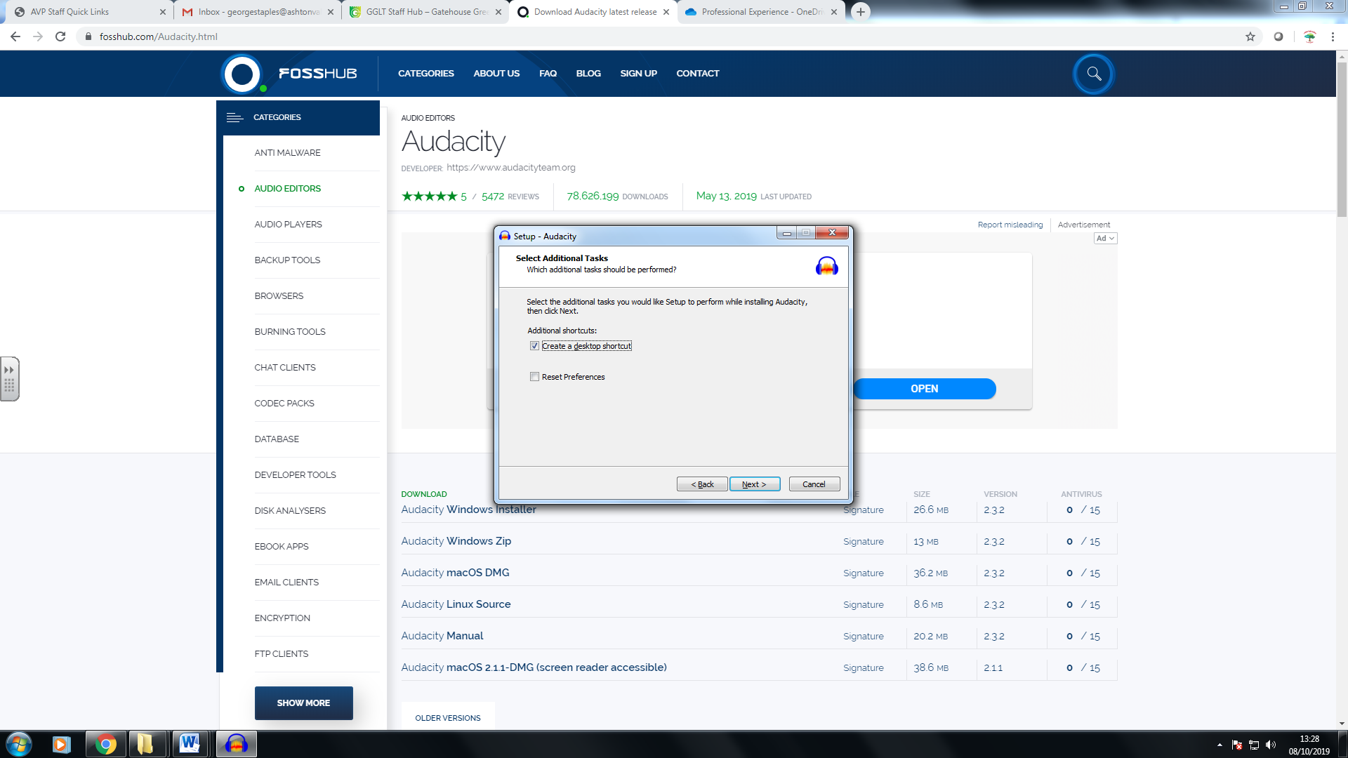
7. **Press INSTALL** 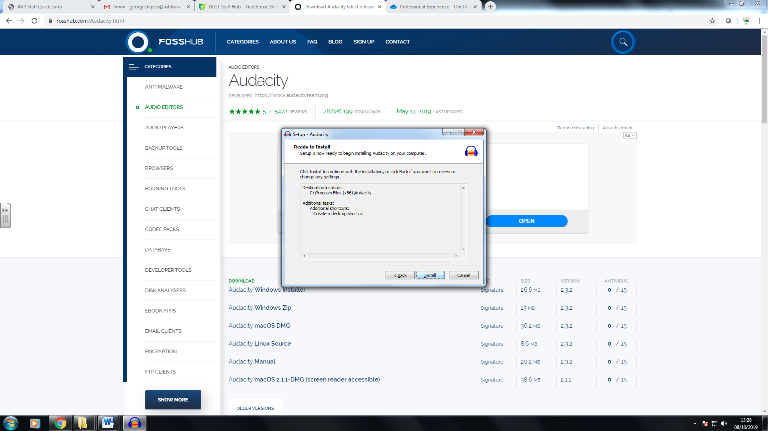
8. **Press NEXT** 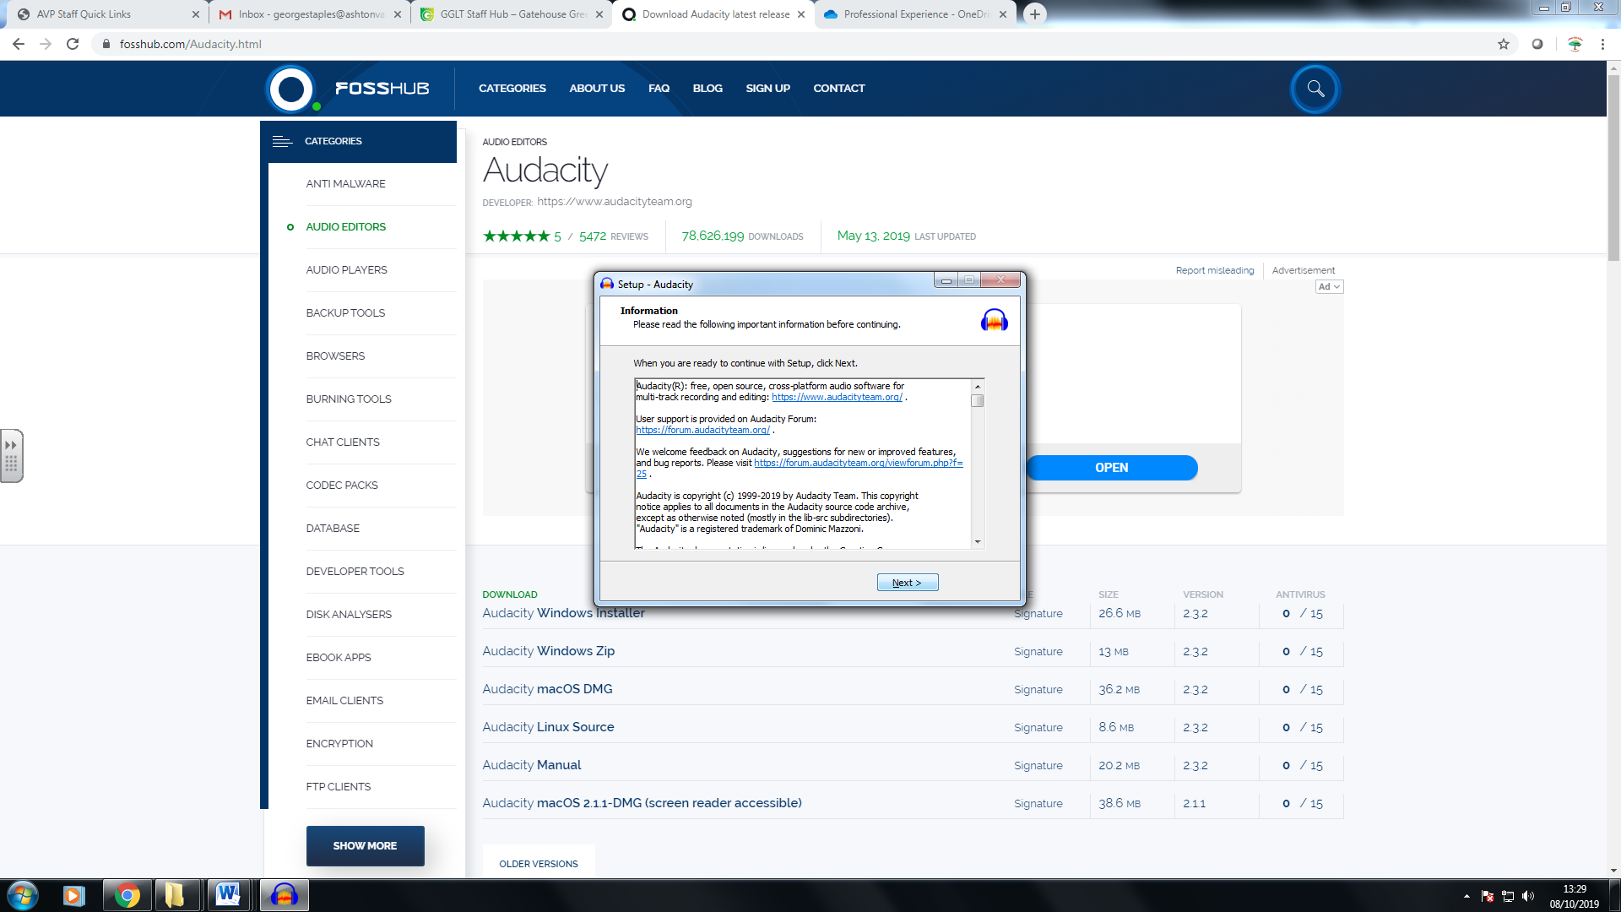
9. **Tick Launch Audacity and Press FINISH**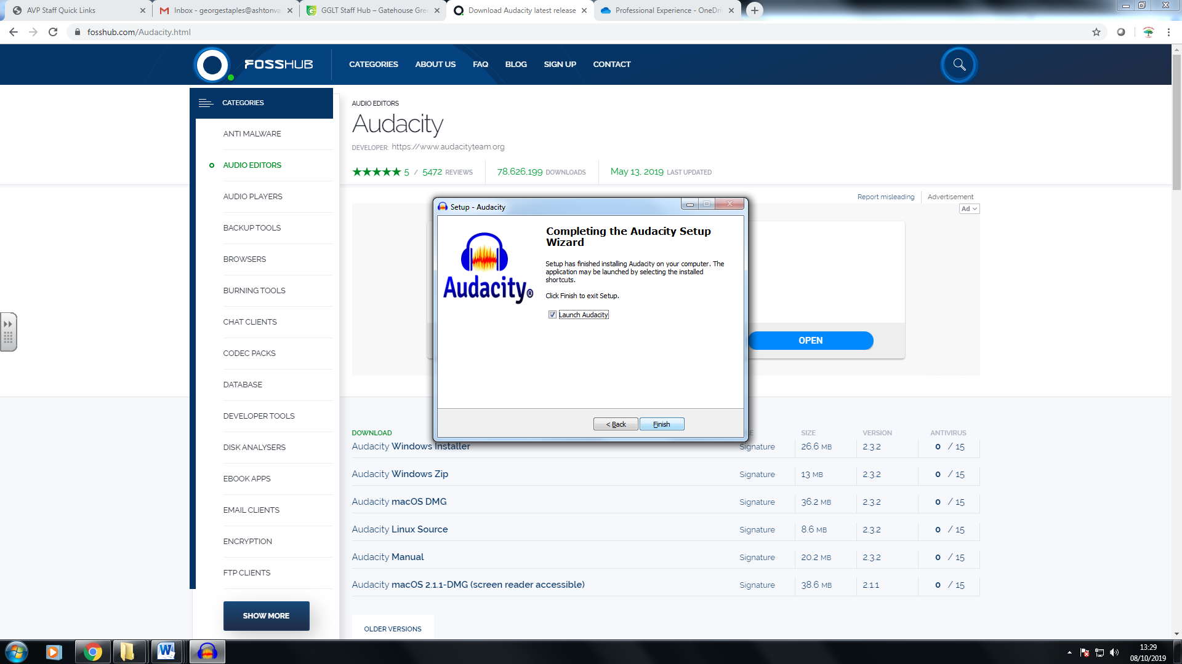
10. **Audacity will launch. Press OK to get started**