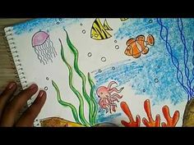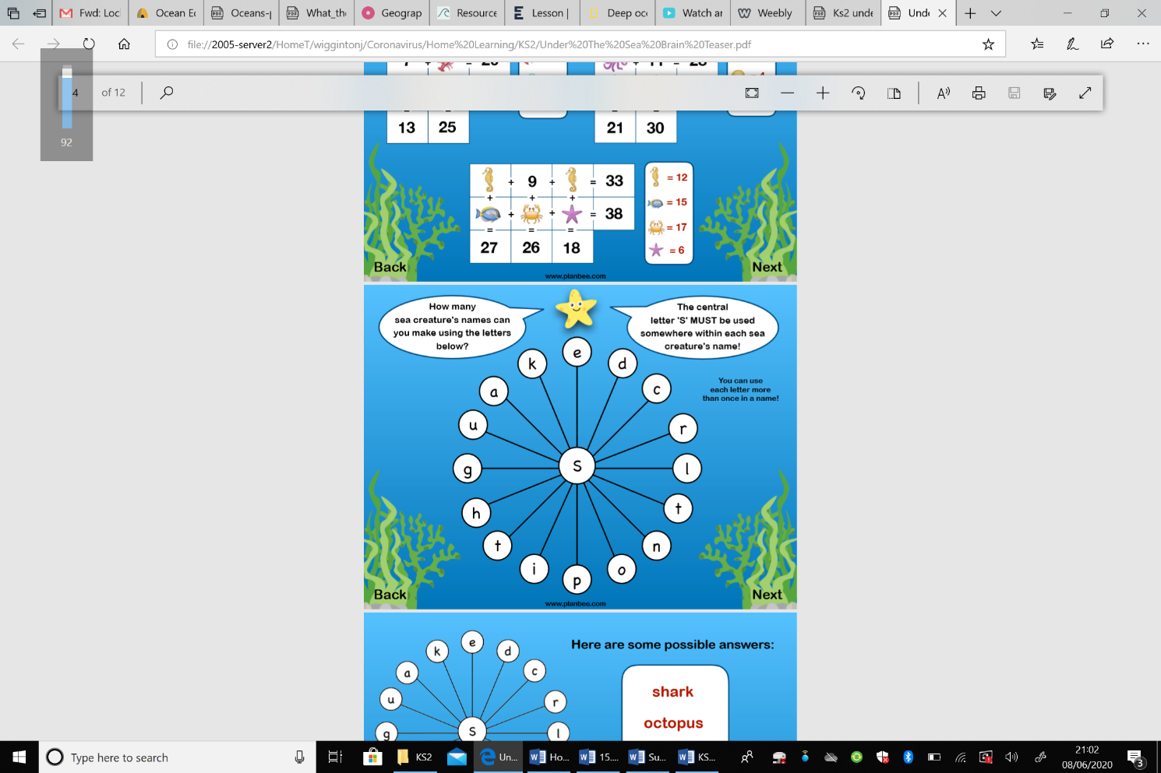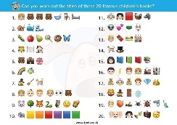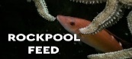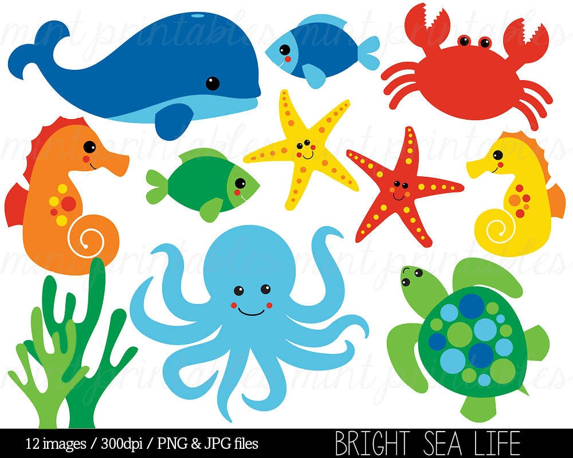 |

**Under the sea scene drawing**

*Each week we will learn how to draw something new to add to a sea scene picture.* This week we are going to learn how to draw fish. Click below for a guide to drawing fish:

[Clown fish](http://www.hellokids.com/c_16030/drawing-for-kids/drawing-lessons-for-kids/how-to-draw-animals/how-to-draw-sea-animals/clownfish)

[Pufferfish](http://www.hellokids.com/c_16031/drawing-for-kids/drawing-lessons-for-kids/how-to-draw-animals/how-to-draw-sea-animals/pufferfish)

[Fish](http://getdrawings.com/image/fish-drawing-for-kids-53.jpg)

**Brainteasers**

Can you solve this under the sea themed brain teaser?

**Mindful Colouring**

You could colour one picture each week and then put them all together to create a sea scene. If you cannot print the sheets you could have a go at drawing the outline and then using shapes to fill the inside with colour.

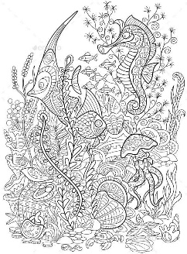

**A-Z Blog Challenge**

*Focus– things we*

*would find*

*in the sea/ocean*

Together can we think of an object for every letter of the alphabet? [Click here](https://ashtonvaleprimary.weebly.com/home-learning-blog) to share your ideas on the Home Learning Blog Page.

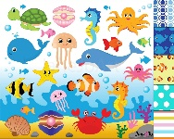

**Yoga**

Have a go at some Under the Sea themed yoga

[Moana](https://safeyoutube.net/w/Otw6)

**Disney Dance-along**

[Click here](https://safeYouTube.net/w/j4RJ) for this week’s

dance along to’ I Wanna Be Like You’ from

The Jungle Book.

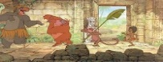

**Wellbeing Wednesday**

Meet Agent Grateful she stays happy by discovering all the things she is grateful for. Try to end each day by thinking of five things that you are grateful for and why.

**Internet Safety**

[Click here](https://www.nspcc.org.uk/globalassets/documents/fundraising/number-day/number-day-resources-2018/online-safety-quiz-ks2.pdf) to a take quiz all about staying safe online.

**Virtual Summer Games – Gymnastics**

[Click here](http://www.wesport.org.uk/active-education/school-games/2020-summer-virtual-school-games/) to download this week’s challenge card. Don’t forget to submit your scores by Sunday!

**Emoji Story Quiz**

Can you name all of the stories in this emoji quiz?

Year 5, or anyone else who has already seen this, can you make up your own question?

Can you use emojis for popular books

or stories? Make sure you share

these in the blog comments so we

can guess!

**Favourite songs**

Listen or join in with one of our

[favourite songs](https://safeYouTube.net/w/cVaL). Leave a blog

comment with your favourite

song we sing in school and

maybe yours will be next week!

**Minute of Listening**

Listen to Bristol1# 3 [here](https://www.minuteoflistening.org/resources/bristol-collection-one/)

What sound in Bristol could this be?

Could you hear the rhythmic tapping of the mechanism as it rolled around?

Was it a high or low pitched sound?

Could you hear the constant whine of the motor, and the occasional metallic sound as it moved past?

If you listen very carefully you might also be able to hear the happy shouts of children and even church bells in the distance.

**NMA Videos**

Here are two videos from

the National Marine

Aquarium.

[**Relax**](https://safeYouTube.net/w/H9RJ) in the deepest tank

in the UK

[**Live feeding time in the Rock Pools**](https://safeyoutube.net/w/pARJ)

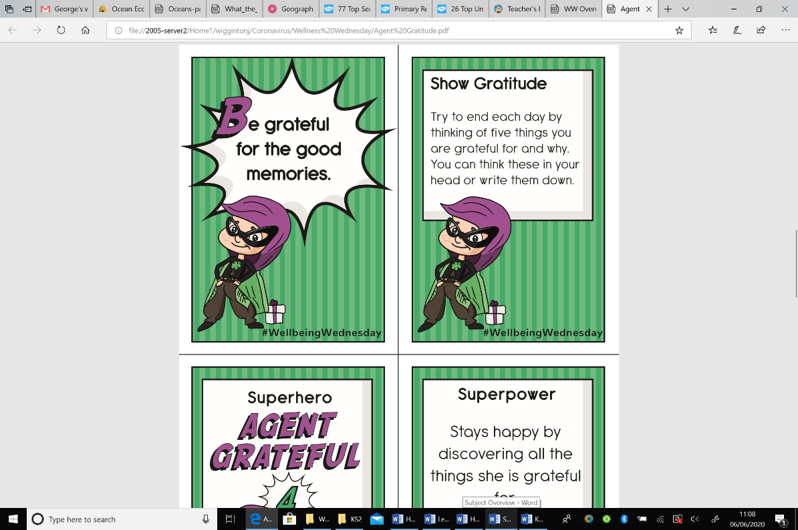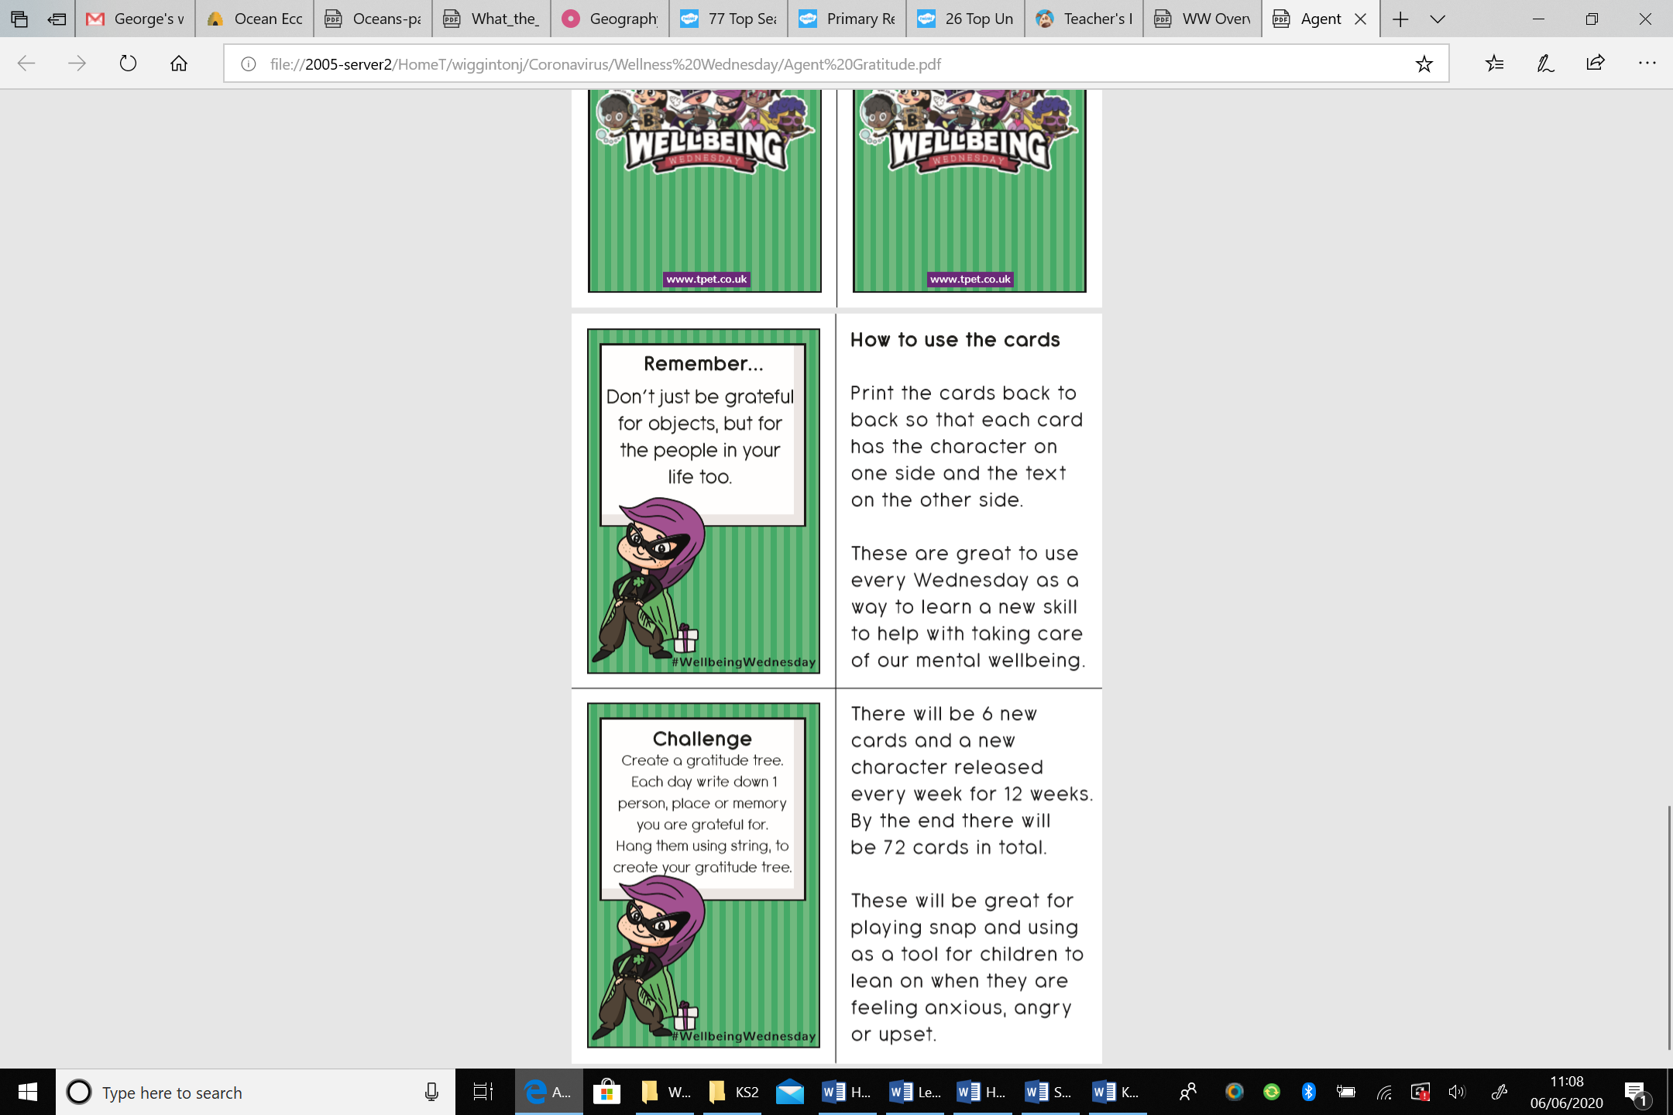

**Little Ninjas**

Below are the links for the first class in our Little Ninjas journey. You do not need any props for this you can just practise in the air. They suggest using household objects like pillows/chairs at times but your grown up can decide if you need this.

[KS1 video](https://safeYouTube.net/w/fcTK) [KS2 video](https://safeYouTube.net/w/6cTK)

***We hope you like the activities on this page, they are shorter activities helping to keep us busy and calm. You can choose as many of these as you like. Don’t forget to share your ideas on the blog or email photographs to Mrs Frampton (***[***kayleighframpton@ashtonvale.bristol.sch.uk***](mailto:kayleighframpton@ashtonvale.bristol.sch.uk)***) so she can upload them to the blog.***

***Have a great week, you are all doing brilliantly!***

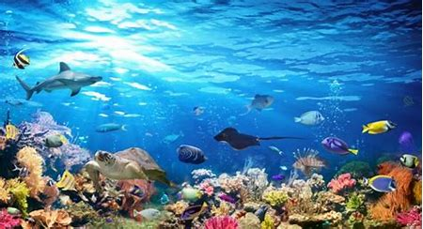

**Under the Sea and Oceans**

**15th June 2020**