Book List Years 3 and 4
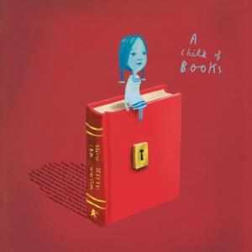
A Child of Books
By Sam Winston
A picture book which celebrates the power of stories and imagination.

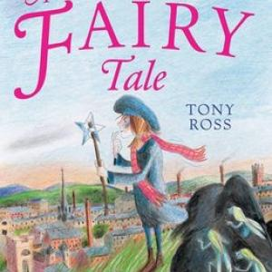
A Fairy Tale
By Tony Ross
Bess, a young girl, befriends an old lady who tries to convince her to believe in fairies. Over the years they almost imperceptibly change places until old Bess, widowed in World War 2, walks down the street with a youthful Daisy.
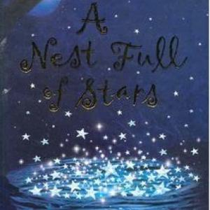
A Nest Full of Stars
By James Berry
This book is out of print

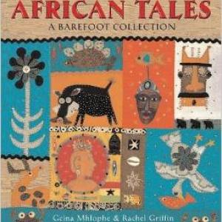
African Tales
By Gcina Mhlophe
These traditional stories from the length and breadth of Africa are retold by a renowned South African storyteller.
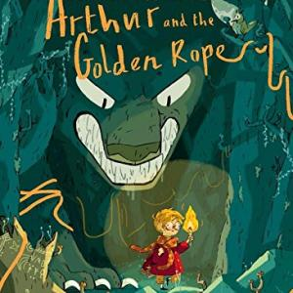
Arthur and the Golden Rope
By Joe Todd-Stanton
Arthur Brownstone often ventures from the small Icelandic town where he was born into the nearby forest where his curiosity leads him to collect objects and forge friendships that will later be use

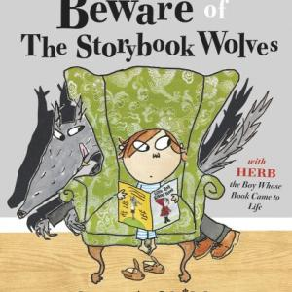
Beware of the Storybook Wolves
By Lauren Child
When it’s time to go to sleep, Herb insists that his mother removes the book containing his bedtime story because it has a wolf in it.
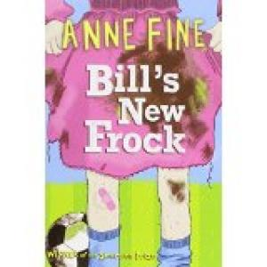
Bill's New Frock
By Anne Fine
Bill wakes up one morning and finds that he is a girl...

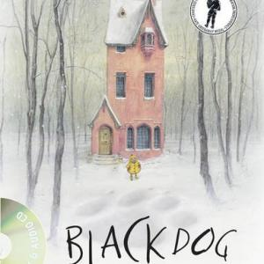
Black Dog
By Levi Pinfold
The Hope family lives in a tall narrow house in a snowy wood, the interior of which is depicted in detailed pictures full of the paraphernalia of playful & imaginative life.
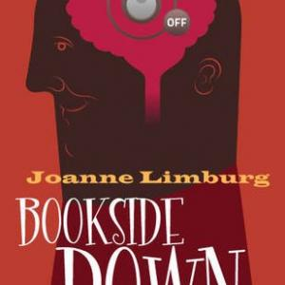
Bookside Down
By Joanne Limburg
What happens if you read a book while standing on your head?

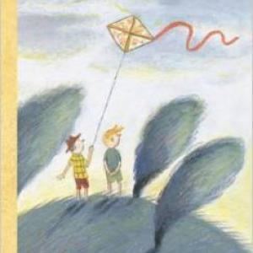
Can You Whistle, Johanna?
By Ulf Stark
Chatting with his friend, Berra realises that he is lacking a grandfather, so the pair visit the old people’s home so that he can adopt one. A delightful story dealing with friendship, loss and bereavement.

