Year 5 and 6 Book List
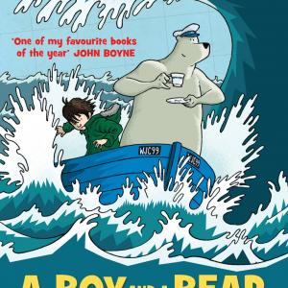
A Boy and a Bear in a Boat
By Dave Shelton
A boy and a bear go to sea, equipped with a suitcase, a comic book, and a ukulele. The bear assures the boy that they are travelling a short distance and it really shouldn't take very long....

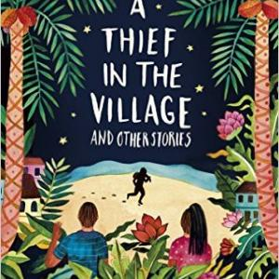
A Thief in the Village
By James Berry
These short stories are vignettes of Jamaican village life, full of the rhythms of Caribbean speech.
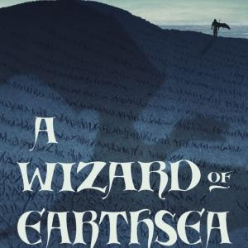
A Wizard of Earthsea
By Ursula Le Guin
Ged is a goatherd on Gont, one of many islands in the Archipelago, who discovers he has magic powers. He is sent to the school for wizards on the island of Roke.
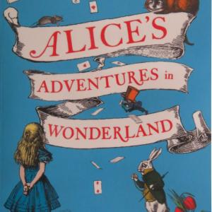
Alice's Adventures in Wonderland
By Lewis Carroll
A childhood classic which is deeply embedded in cultural consciousness. The characters, incidents, images and language of this book are familiar through many manifestations including film.
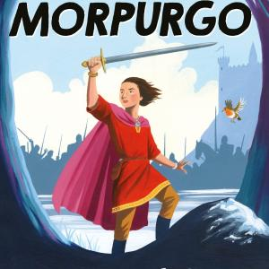
Arthur, High King of Britain
By Michael Morpurgo
In this retelling of the Arthurian legend from ‘another place, another time’ Michael Morpurgo retains the magic of the epic story with its chivalry, romance, battles and betrayals.

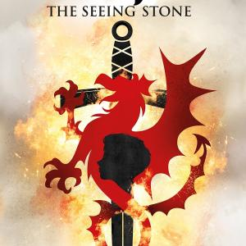
Arthur. The Seeing Stone
By Kevin Crossley-Holland
Arthur lives on the edge of manhood, on the border between England and Wales, as the twelfth century turns into the thirteenth. By means of a stone, the obsidian, given to him by Merlin, he sees into the life of that earlier, legendary, Arthur.
Artichoke Hearts
By Sita Brahmachari
Mira describes a month in her life as she turns twelve when everything is changing including her relationships with her friend Millie and her first boyfriend Jidé and she has to decide what to confide and what to conceal.

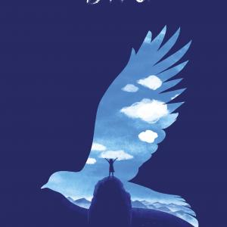
Bird
By Crystal Chan
When a tragedy happens in a family, its members often express their grief by blaming each other. From the arresting opening to this sensitive novel, the
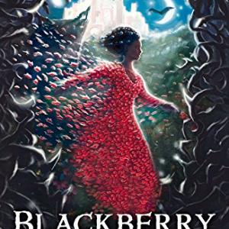
Blackberry Blue
By Jamila Gavin
Jamila Gavin has fashioned her own set of fairy tales, drawing principally on the European traditions with which she grew up.

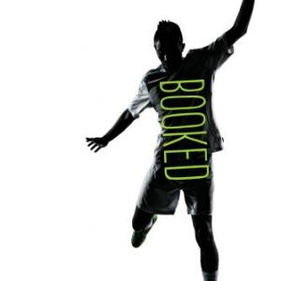
Booked
By Kwame Alexander
In this free verse novel, written in the voice of a twelve year old soccer-loving boy, African American author Kwame Alexander weaves an emotive narrative through poetry and wordplay.

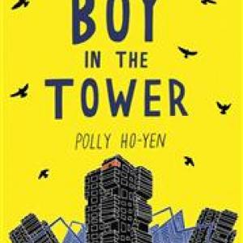
Boy in the Tower
A dramatic story which holds sadness for some but centres on courage and friendship in adversity.

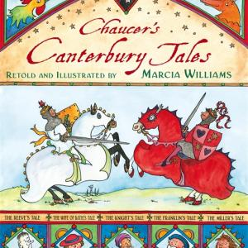
Chaucer's Canterbury Tales
By Marcia Williams
Marcia Williams’ cheerful comic strip style is well-suited to the retelling of the tales told by Chaucer’s pilgrims. This book makes Chaucer accessible to a younger audience than would usually get to meet him, and connections can be made with other known stories.
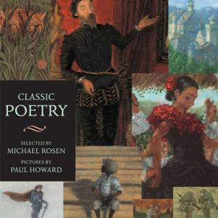
Classic Poetry
By Michael Rosen
A selection of poems from British, American and Australian poets including William Wordsworth, Langston Hughes and Judith Wright.

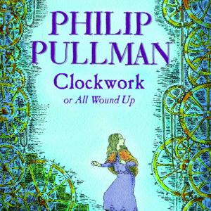
Clockwork or All Wound Up
By Philip Pullman
A chilling tale of mechanical beings which has human warmth at its heart.
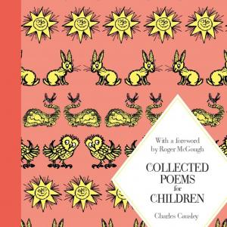
Collected Poems for Children
By Charles Causley
A beautifully produced new edition of the collected poetry of one of Britain's major poets for children, published over a period of fifty years, with a foreword by Roger McGough.

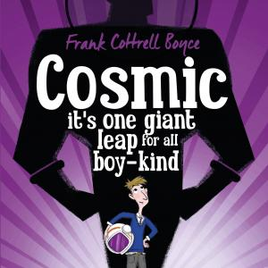
Cosmic
By Frank Cottrell Boyce
This humorous adventure is seen through the eyes of twelve year old Liam Digby a ‘gifted and talented’ child whose physical appearance ages him beyond his years.
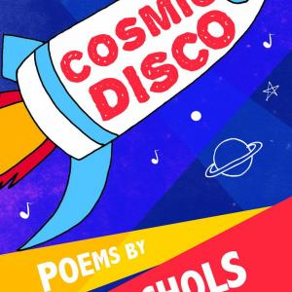
Cosmic Disco
By Grace Nichols
This poetry collection whirls us out into the cosmos to dance ‘in the endless El Dorado of stars stars stars’ and back again to ‘that little old blue ball spinning in the corner over yonder’.

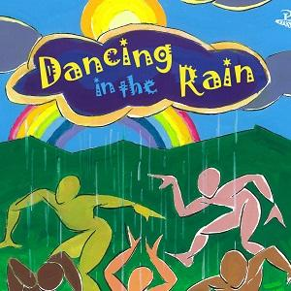
Dancing in the Rain
By John Lyons
John Lyons provides an insight into his Trinidadian childhood in this collection.
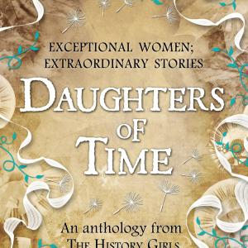
Daughters of Time
By Mary Hoffman
Thirteen enthralling short stories which highlight the lives of women across a huge swathe of time, from Boudica, Queen of the Iceni to the women who occupied Greenham Common.

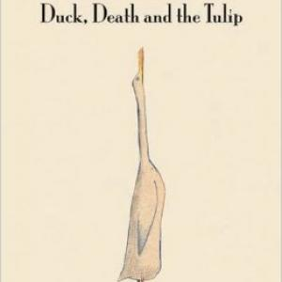
Duck, Death and the Tulip
By Wolf Erlbruch
In this stark and macabre picture book, Duck is visited by Death, in the shape of a skeleton.

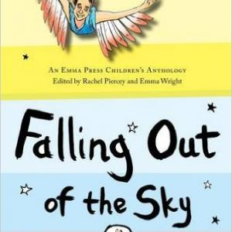
Falling Out of the Sky. Poems about Myths and Monsters
By Piercey, Rachel and Wright, Emma
This anthology brings together new poems inspired by myths, legends and folk tales.

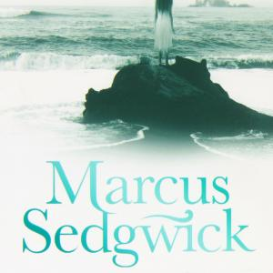
Floodland
By Marcus Sedgwick
Set in an all too believable near future when many parts of England are submerged in water and people drift into gangs, divided due to the scarcity of resources, especially food.
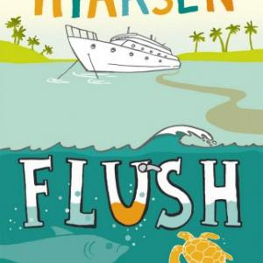
Flush
By Carl Hiaasen
Noah’s dad hates greed, injustice and cruelty to nature but he has a gungho way of putting his principles into practice which has repercussions for his family.

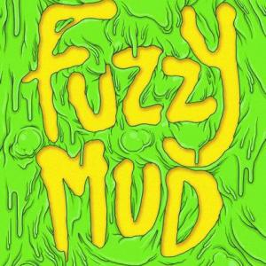
Fuzzy Mud
By Louis Sachar
This is a thrilling adventure story with peril, triumph and excitement. As with all Louis Sachar’s books this is hard to put down and his easy, engaging prose means that this is destine
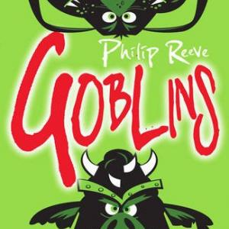
Goblins
By Philip Reeve
Skarper is different from the rest of pugnacious goblinkind. He has taught himself to read from bumwipe paper pile of burks/books and his questioning gets him bratapulted from Clovenstone Keep.

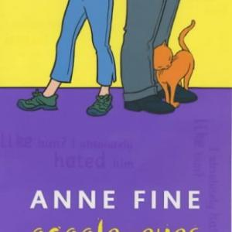
Goggle-Eyes
By Anne Fine
Witty and thought-provoking, this book demonstrates Anne Fine’s genius for dialogue and for observing the quirkiness of daily life.
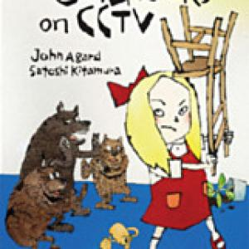
Goldilocks on CCTV
By John Agard
‘It’s no good being streetwise when you’re lost in enchanted woods.’ Goldilocks, Cinderella et al inhabit the urban jungle rather than the fairy tale forest in these poems which blend modern media with familiar tales to invite considerations of contemporary culture and modern life.

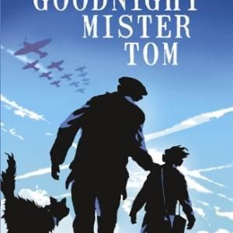
Goodnight Mister Tom
By Michelle Magorian
A substantial and involving novel about the experiences of a Second World War evacuee and his growing relationship with the old man with whom he is billeted.
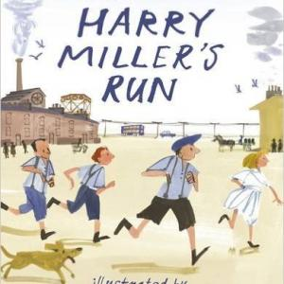
Harry Miller's Run
By David Almond
This story centres around Liam, a young boy taking part in the Junior Great North Run who just wants to train with his friends.

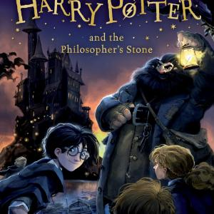
Harry Potter and the Philosopher's Stone
By J K Rowling
One of a seven book series which has had an exceptional impact on readers of all ages.

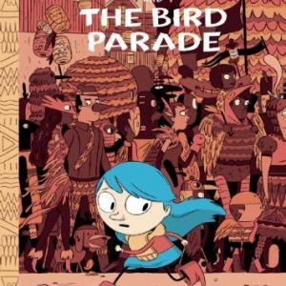
Hilda and the Bird Parade
By Luke Pearson
The third book in a series of graphic novels about a small independent girl with blue hair.

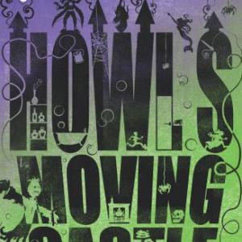
Howl's Moving Castle
By Diana Wynne Jones
Sophie Hatter is the eldest of three sisters and, in true fairytale tradition, believes that she will be the least successful in life. After being turned into an old
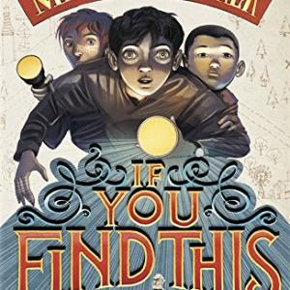
If You Find This
By Matthew Baker
There is sadness and laughter in this exciting, twisting adventure about three boys, two grandpas, a map and some hidden treasure. The lively and believable characters defy stereotype and mai

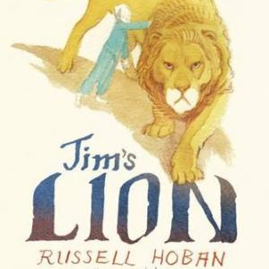
Jim's Lion
By Russell Hoban
This book portrays a child’s experience of serious illness movingly and imaginatively. It opens with a wordless comic strip,
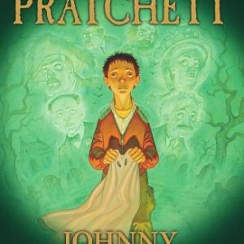
Johnny and the Dead
By Terry Pratchett
When Johnny knocks on the door of a mausoleum in the cemetery, he gets the surprise of his life when an occupant answers.

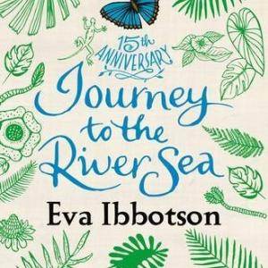
Journey to the River Sea
By Eva Ibbotson
An orphan girl, Maia, leaves her boarding school in England in 1910 to stay with distant relatives who live on a rubber plantation on the banks of the Amazon in Brazil.
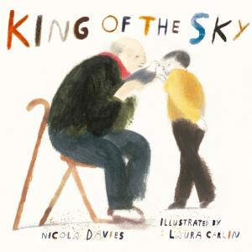
King of the Sky
By Nicola Davies
This second collaboration between author Nicola Davies and illustrator Laura Carlin, following the successful The Promise is another sensitive and subtle picture book.

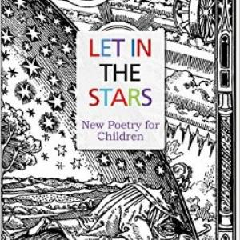
Let in the Stars
By Mandy Coe
Download the FREE teaching sequence here
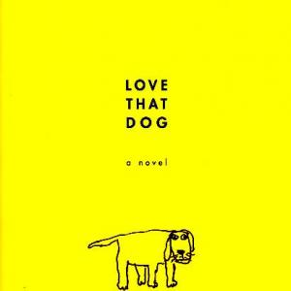
Love That Dog
By Sharon Creech
Jack keeps a diary for his teacher. It is set out as verse which reflects Jack's growing understanding of poetry.

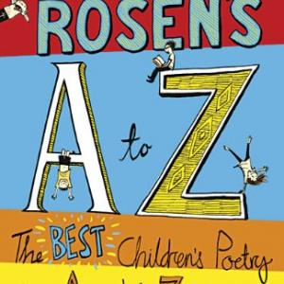
Michael Rosen's A to Z. The Best Children's Poetry from Agard to Zephaniah
By Michael Rosen
The arrangement and organising principle of this poetry anthology is based on the alphabetical sequence of poets’ surnames, resulting in interesting random juxtapositions of subject matter and forms.

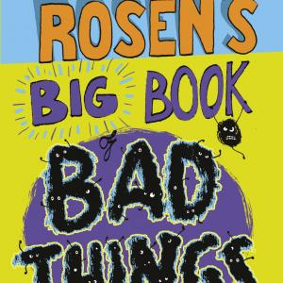
Michael Rosen's Big Book of Bad Things
By Michael Rosen
Childhood memories of the poet’s parents, continuing conversations, are interspersed throughout this book.

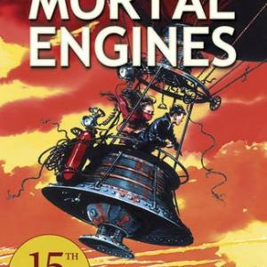
Mortal Engines
By Philip Reeve
Set in an alternative future when cities chase smaller towns and villages and devour and dismantle them. Tom is an apprentice historian in London who gets caught up in the struggles and conflicts of his time.
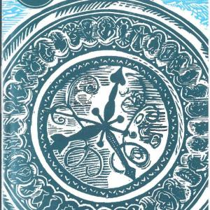
Northern Lights. His Dark Materials Book 1
By Philip Pullman
In the first book of what has become a world famous trilogy, the tough, likeable heroine, Lyra, is involved in a quest which will lead her into parallel universes

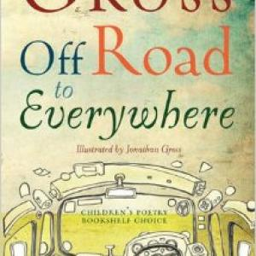
Off Road to Everywhere
By Philip Gross
Poems of exploration - all in a variety of forms from the chant of ancient people eating and dancing round a fire to the riddling wordplay of ‘Love Songs in the Key of Y’.
One Thousand and One Arabian Nights
By Geraldine McCaughrean
A retelling of a selection of tales from the Arabian Nights.

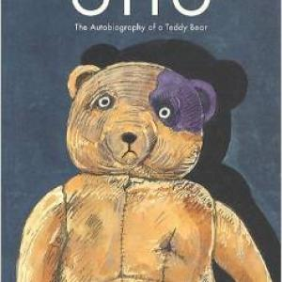
Otto: The Autobiography of a Teddy Bear
By Tomi Ungerer
Otto, a teddy bear belonging to a Jewish boy in Germany at the outbreak of World War 2, is given to his friend Oskar when David and his family are taken away in a truck.
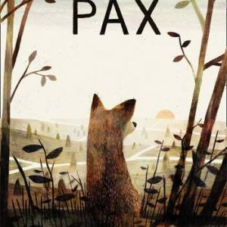
Pax
By Sara Pennypacker
Peter’s father goes away to war, taking him to stay with his grandfather before leaving. Before he does this, they drive Peter’s tame fox, Pax, many miles away and leave him to return to the wild.

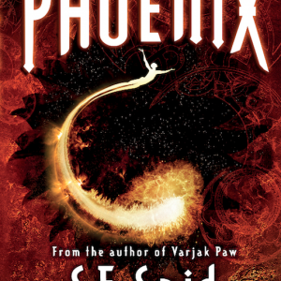
Phoenix
By S. F. Said
The story begins and ends with Lucky, a Human boy who travels through the galaxy in search of his identity, undergoing changes in both mind and body. However, it breaks the boundaries of being only Lucky’s personal story...
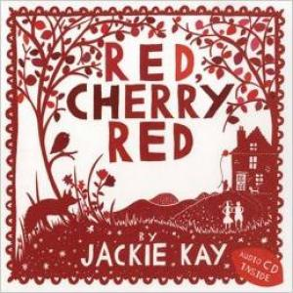
Red Cherry Red
By Jackie Kay
On the CD which accompanies this attractive square red and white book, Jackie Kay reads aloud all the poems, sometimes with added commentary.

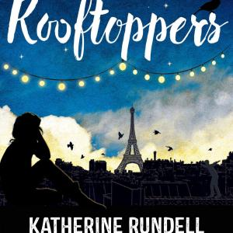
Rooftoppers
By Katherine Rundell
An intriguing statement opens this unusual novel which involves a quest for a missing mother with music playing an important part.

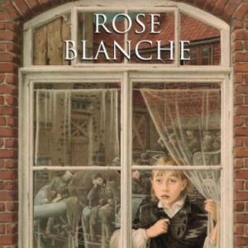
Rose Blanche
By Roberto Innocenti
An exceptionally moving picture book in which the reader views the sorrow of war through a young girl’s eyes.

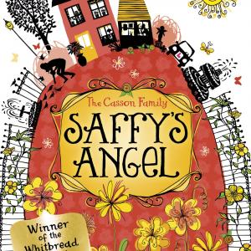
Saffy's Angel
By Hilary McKay
Saffron’s artistic family all have names that appear on the paint chart on the wall of their ramshackle kitchen. The discovery that her name is not on the chart leads to a quest for the stone angel associated with her true origins.
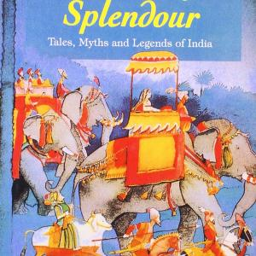
Seasons of Splendour
By Madhur Jaffrey
In this collection of Indian folk tales, Madhur Jaffrey recalls the rich storytelling traditions of her own childhood in Delhi.

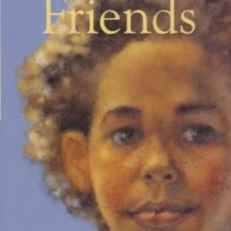
Secret Friends
By Elizabeth Laird
Tragedy strikes unexpectedly in this well-written short novel that deals sensitively with the serious subject of bullying amongst girls.
Sensational! Poems inspired by the five senses
By Roger McGough
An imaginative thematic poetry anthology featuring sections on sight, sound, touch, smell and taste.

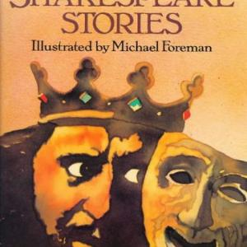
Shakespeare Stories
By Leon Garfield
Twelve of Shakespeare’s plays presented in narrative form, skilfully capturing the richness of each.
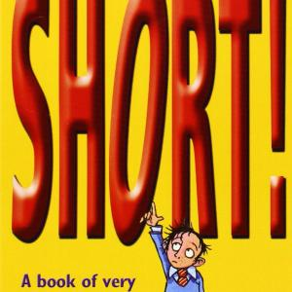
Short! A Book of Very Short Stories
By Kevin Crossley-Holland
Ghost stories, urban myths, traditional tales, funny, sad and puzzling stories - all can be found in this collection of very short stories, none more than two pages long, many much shorter.

Skellig
By David Almond
Michael and his family have just moved to a new home and his baby sister is very ill. He soon discovers a decrepit being in the dilapidated garage.
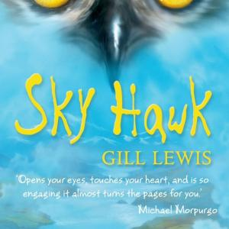
Sky Hawk
By Gill Lewis
Two children rescue an osprey in the Scottish Highlands. When tragedy strikes, one of them carries out a promise to protect the bird...

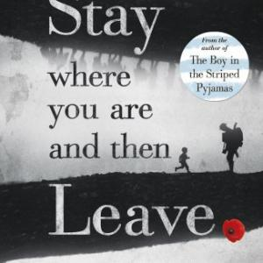
Stay Where You Are and Then Leave
By John Boyne
Alfie is five when World War 1 breaks out and his milkman father enlists in the army. Although this is a third person narrative the story is seen very much through his eyes.

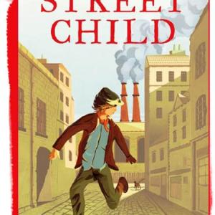
Street Child
By Berlie Doherty
This novel really does bring history to life. The reader gains insight into living and working conditions for poor children in the 1860s.

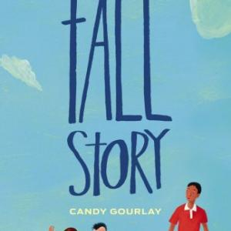
Tall Story
By Candy Gourlay
A novel in dual dialogue as Andi and Bernardo, her eight foot tall half-brother from the Philippines, tell their stories in alternate chapters.
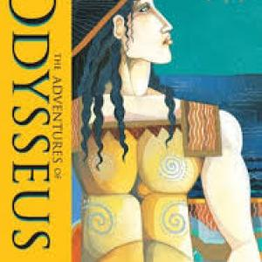
The Adventures of Odysseus
By Hugh Lupton, Daniel Morden
Adapted from an oral retelling of this epic, this version of the travels and trials of Odysseus reads aloud well.

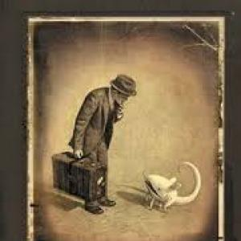
The Arrival
By Shaun Tan
This wordless graphic novel tells many stories through expressive sepia illustrations which depict a strange mix of the realistic and the surreal.
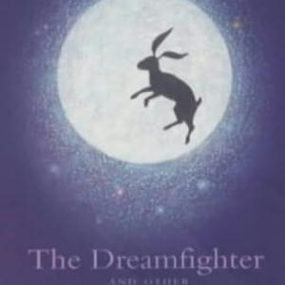
The Dreamfighter and Other Creation Tales
By Ted Hughes
A combined volume collecting together all Ted Hughes’ glorious inventions about how the earth’s creatures came to be, originally published as three separate books.

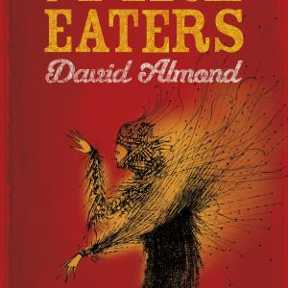
The Fire-Eaters
By David Almond
Set in 1962 with the anxieties of the Cuban missile crisis never far away, The Fire-Eaters is the sensitive story of a boy’s growing awareness of himself, his family and the wider world around him.
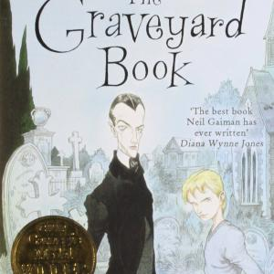
The Graveyard Book
By Neil Gaiman
A multi award winning novel with a grim and gripping opening as the man Jack murders a family, leaving only the baby who crawls away and is brought up as Nobody...

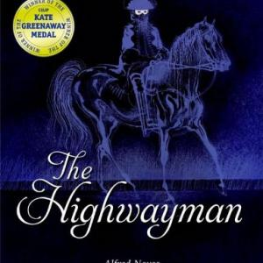
The Highwayman
By Alfred Noyes
The beauty and pathos of this poem are powerfully echoed by Charles Keeping’s ink drawings.
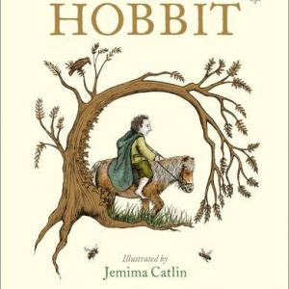
The Hobbit
By J R R Tolkien
Tolkien’s classic saga of dwarves, elves, dragons, wizards and hobbits is full of magic and excitement.

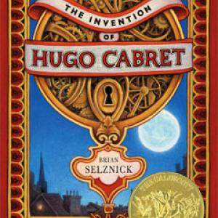
The Invention of Hugo Cabret
By Brian Selznick
On first appearance, this looks like a chunky novel. Once inside, you find that the story is told in a masterly combination of words and pictures.

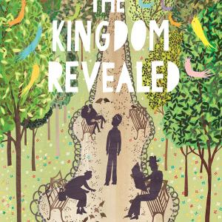
The Kingdom Revealed
By Rob Ryan
This picture book about a young boy who doesn’t want to be King is told in more extended text than is generally associated with this format.

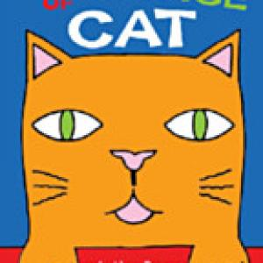
The Language of Cat and other poems
By Rachel Rooney
Rachel Rooney relishes and shares the craft of poetry and her poems have a subtle, distinctive speaking voice.
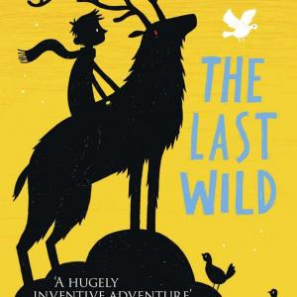
The Last Wild
By Piers Torday
Kester lives in Spectrum Hall, an academy for challenging children.

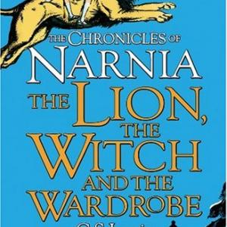
The Lion, the Witch and the Wardrobe
By C S Lewis
The most famous of the Chronicles of Narnia and the second in the sequence. Four children find a way into a magical country through the back of an old wardrobe.
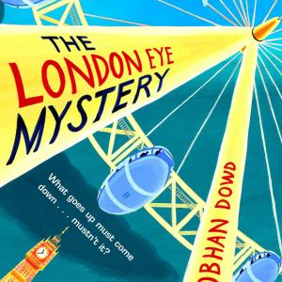
The London Eye Mystery
By Siobhan Dowd
The reader is kept in suspense throughout this humorous adventure which centres around the capital’s landmark visitor attraction.

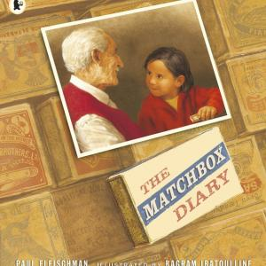
The Matchbox Diary
By Paul Fleischman
A man shares the story of his early life with his great-granddaughter. In the days before he could read and write he found an inventive way of keeping a diary by preserving objects in matchboxes, each one a reminder of something significant in his past.
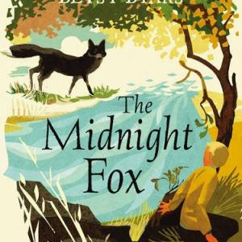
The Midnight Fox
By Betsy Byars
‘Boy Overcomes Fears To Rescue Fox’ might be a headline created for this story by Petie, friend of the narrator Tom, a city boy who spends the summer on a farm.

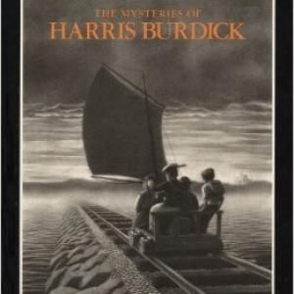
The Mysteries of Harris Burdick
The premise behind this unique book of pictures is that the fourteen drawings within it were left with a publisher by a man named Harris Burdick who subsequently disappeared.
The Mystery of the Clockwork Sparrow
By Katherine Woodfine
A detective story set in Edwardian London where Sophie and Lil work, as a salesgirl and a model respectively, at the magnificent Sinclairs department store which is about to open with great fanfare

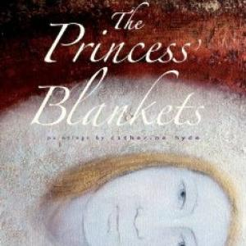
The Princess' Blankets
By Carol Ann Duffy
A princess can never be warm and one day a stranger ‘with hard, grey eyes like polished stones’ arrives at the palace declaring that he can cure her malady.

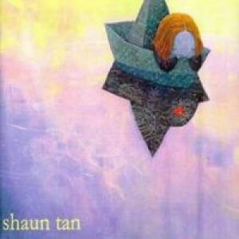
The Red Tree
By Shaun Tan
A small girl is having a bad day. Nothing makes sense, terrible troubles surround her.

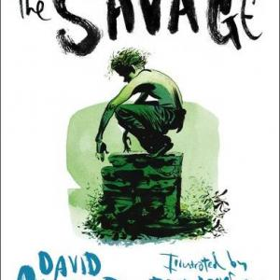
The Savage
By David Almond
A very striking illustrated story with an interesting structure. The story is narrated by Blue, a boy coping with bullying in addition to recent bereavement.
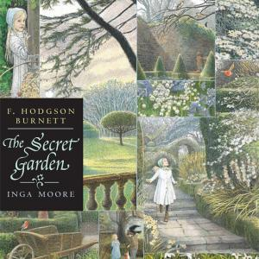
The Secret Garden
By Frances Hodgson Burnett
Orphan Mary Lennox, disagreeable and unhappy, is sent from India to live at her uncle's home on the Yorkshire moors.

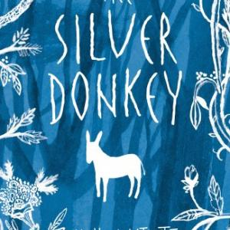
The Silver Donkey
By Sonya Hartnett
Two French girls find a soldier in the woods during the First World War. He has left the army and needs to return home to see his sick brother as well as escape the horrors he has seen and which have affected his eyesight.
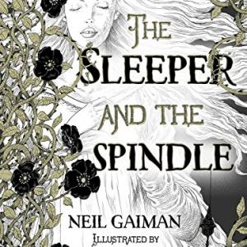
The Sleeper and the Spindle
By Neil Gaiman
A queen with raven-black hair abandons her wedding day in favour of going on a quest accompanied by three dwarfs.

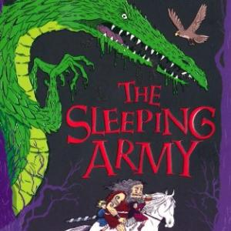
The Sleeping Army
By Francesca Simon
In this funny, fast paced adventure, Freya blows a Viking horn in the British Museum and is whisked to Asgard...
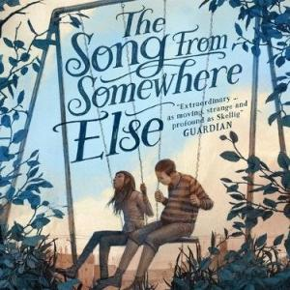
The Song from Somewhere Else
By A F Harrold
A poignant, darkly comic and deeply moving story about the power of the extraordinary, and finding friendship where you least expect it.

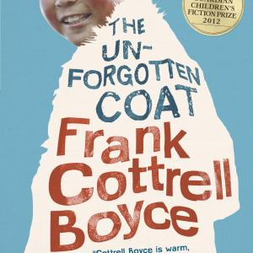
The Unforgotten Coat
By Frank Cottrell Boyce
When two Mongolian brothers Chingis and Nergui turn up at her school, they insist that Julie becomes their Good Guide.
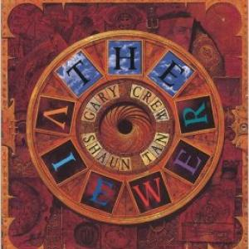
The Viewer
By Gary Crew
A boy finds a curious box on a rubbish dump. Inside are many treasures but the one that intrigues him most is like the Viewmaster toy he had when he was younger.

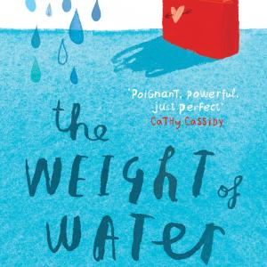
The Weight of Water
By Sarah Crossan
In this moving verse novel Kasienka and her mother travel from Poland to the UK to search for her father.

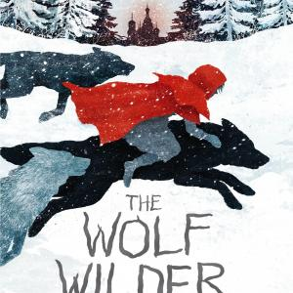
The Wolf Wilder
By Katherine Rundell
Set in the depths of the wintery Russian woods where Feodora lives with her mother, a wolf wilder, and she is a wilder in training.

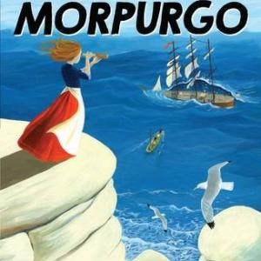
The Wreck of the Zanzibar
By Michael Morpurgo
Through the diary of the independent-minded Laura, readers learn of the struggle to survive for small communities living on the Scilly Isles at the turn of the nineteenth and twentieth centuries.
There's a Boy in the Girls' Bathroom
By Louis Sachar
Bradley Chalkers is the boy no-one wants to sit next to in class. His only friends are a collection of animal ornaments in which he confides.

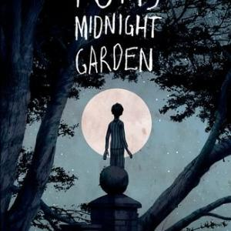
Tom's Midnight Garden
By Philippa Pearce
Tom foresees a lonely summer spent with his aunt and uncle to avoid catching his brother’s measles. One night the grandfather clock in the hall strikes thirteen...
Tom's Midnight Garden (Graphic novel)
By Philippa Pearce
Philippa Pearce’s classic novel has previously been adapted dramatically for theatre, film and television.

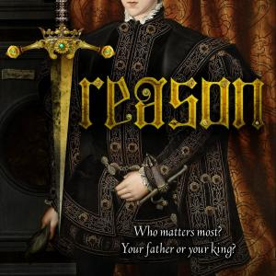
Treason
By Berlie Doherty
Will Montague becomes page to the future Edward VI, a role in which he is jealously regarded by the son of the Duke of Norfolk.
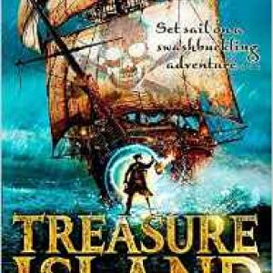
Treasure Island
By Robert Louis Stevenson
Sail the seas with cabin boy Jim Hawkins as he embarks on perilous voyage. A stirring tale of pirates, buried treasure and doubtful loyalties.

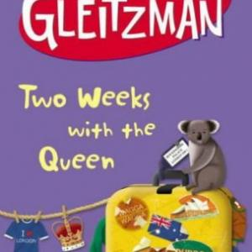
Two Weeks with the Queen
By Morris Gleitzman
A deeply moving yet humorous novel about a boy desperate to get help for his brother who is dying.
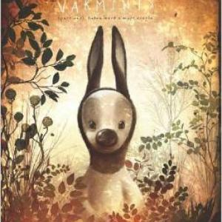
Varmints
By Helen Ward
With dramatically lit artwork and a spare, intriguing text, Varmints tells of a pastoral world in need of protection and of the souls who love it enough to ensure its regeneration.

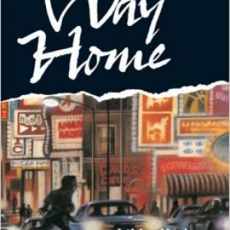
Way Home
By Libby Hathorn
This award-winning picture book is a startling evocation of life for a young homeless boy on the city streets.

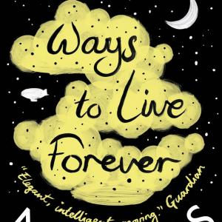
Ways to Live Forever
By Sally Nicholls
Sam, narrator of this novel, knows he is going to die but this is far from being a depressing read. On the contrary, he wants to make every minute he has left count and makes a list of all the things he wants to do in his diary.

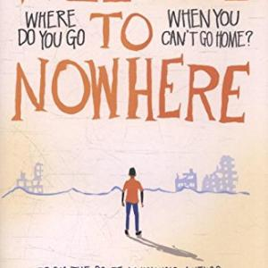
Welcome to Nowhere
By Elizabeth Laird
Elizabeth Laird has drawn on her experience of volunteering in refugee camps in Jordan to write this novel which highlights the tragic situation that has developed in Syria.
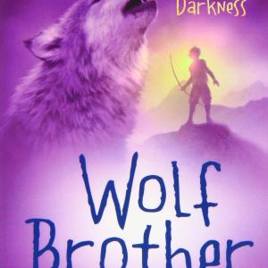
Wolf Brother
By Michelle Paver
The first in a series Chronicles of Ancient Darkness. Following the death of his father, Torak discovers that he must embark on a quest for which he does not feel prepared, pursued by the enormous bear that killed his father.

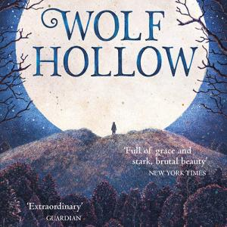
Wolf Hollow
By Lauren Wolk
This beautifully written novel is set in the 1940s in rural America.
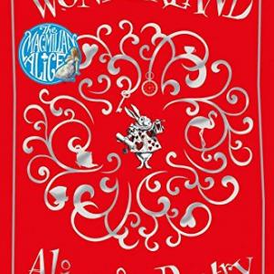
Wonderland. Alice in Poetry
By Michaela Morgan
In this anthology, Michaela Morgan curates the poetry of Lewis Carroll and his sources, inviting new and established contemporary poets to pen their responses.

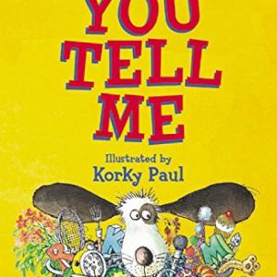
You Tell Me
By Rosen, Michael and McGough, Roger
A new edition of this poetry collection including some additional poems.

