**Literacy:**

**Letters from the lighthouse – Focus Text**

Letter writing– A recount letter home from an evacuee

Story writing – Using setting, character description and speech to create a story based during WWII times.

**Science:**

**Light:**

* How we see and to recognise that light appears to travel in straight lines.
* Reflecting light and to investigate the angles of incidence and reflection.
* Refraction andinvestigate how refraction changes the direction in which light travels.
* To investigate how a prism changes a ray of light.

**P.E:**

Real PE - dynamic balance and counter balance

Netball

-Ball skills

-Attacking and defending

-Evaluating and developing performance

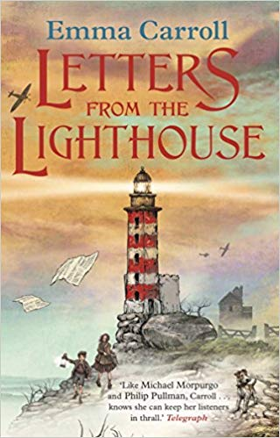

**History:**

* The outbreak of war
* Evacuees
* Rationing
* The role of women
* The holocaust
* Key events from WWII.

**Art:**

London silhouette images.

Silhouette soldiers

Propaganda poster

**DT:**

Anderson shelters

**WORLD**

**WAR**

**II**

**Maths:**

**Fractions:**

* Simplifying fractions
* Comparing and ordering
* Adding and subtraction
* Multiplying and dividing

**Decimals**

* Writing and reading decimals
* Dividing and multiplying decimals
* Writing fractions as decimals

**Trip:**

TBC

**Geography:**

* Countries of fighting during the war
* Location of these countries.

**Music:**

focus on pulse, beat, ostinato, pulse and rhythm. Identifying  
repeating patterns in a range of music including Ravel's Bolero. Creating  
music with an ostinato, using a range of pitched and percussion  
instruments.

**French:**

Focus on learning phrases about the weather and incorporating these  
into conversational skills learned last term.