Healthy Lunchbox News 29.09.11
Let’s get healthy and win a prize!
We are starting a new competition in school. Everybody will be given a Healthy Food Passport with 4 spaces ready to collect four stickers.
Each week we will have an area of the eatwell plate to focus on and during the Thursday lunch box check you will be given that weeks sticker if you have that weeks focus item in your lunch box. This Thursday, 06.10.11, your class teacher will be looking to see if you have included bread, potatoes and pasta in your lunch box.
Turn the page to find some great ideas to help you.
What about if I eat school dinners?
This Thursday lunchtime you can get your sticker if you eat the bread, potatoes or pasta portion of your school dinner. You don’t need to take your passport into the hall, put it on your jumper and stick it in your passport when you get back to class.
What can I win?
After 4 weeks we will collect in all the passports and if you have a completed passport you will win a special, limited edition Ashton Vale pen. Also, all of the completed passports will be put into a draw where the prizes include 2 match day tickets for Bristol City FC!
So, what are you waiting for?
LET’S GET HEALTHY!
School guidelines for a healthy lunchbox.
Crisps and savoury snacks.  These are only allowed on a Friday.  By crisps we mean any form of crisp (including low fat), corn snack, pringles, cheese biscuits, snack-a-jacks etc. | Drinks.  It is really important that you drink lots of water to keep you healthy.  At Ashton Vale we provide water for you at lunchtime but if you would like to bring your own drink you can bring.  * Plain (unflavoured/ unsweetene d/ flat) water.  * A small carton of pure / diluted fruit juice.  * A small carton of milk. | Cakes and biscuits.  As part of a balanced meal we allow one sweet biscuit/ cake per day in your healthy lunch box.
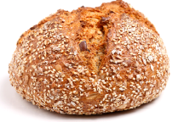
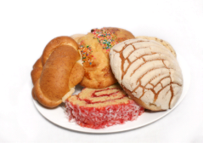
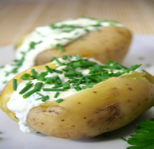
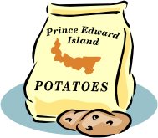


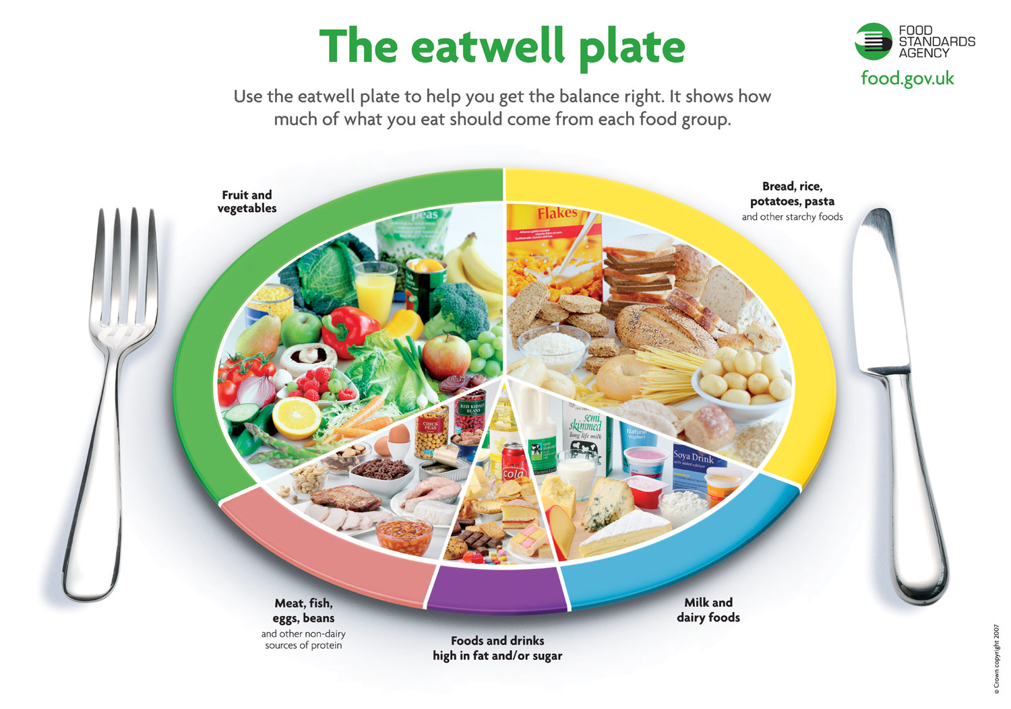

Here are some ideas for how to include bread, rice, potatoes and pasta.
Try all sorts of different breads including rolls, flatbreads bagels and wraps. | REMEMBER; wholemeal and granary bread have a lot more goodness in the then white bread.
Rice salads can be really tasty and a good way of using up cooked rice (but remember to store cooked rice in the fridge). Mix it up with vegetables, chopped fruit, raisins etc. | Couscous is very quick and easy to cook and also makes very good cold salads.
Have you tried potato salad in your lunchbox? Cooked potatoes mixed with mayonnaise, yoghurt and herbs are delicious. You might also want to add cooked meat like chopped ham or chicken. | Cold pizza slices can be a great addition to a lunchbox. Even better if they are homemade pizza slices so you can control the amount of fat and salt.
Useful websites.
These website have some great ideas for healthy lunchboxes.
http://www.food.gov.uk
http://www.raisingkids.co.uk/food/fea106_packedlunches.asp
http://www.netmums.com/food/Lunchbox_Ideas.101/
http://www.nhs.uk/Change4life

