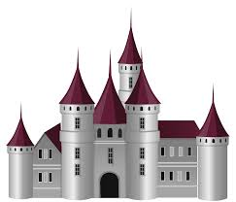

Computing

We will be discussing how to be safe on the internet.

Art

Our art sessions will be built around castles. We will be working on our sketching skills and block painting.

Science

We will look at the suitability of different material for specific purpose. We will be looking at material properties (waterproof, absorbent)

Music

We have a company called Bristol plays music coming in to teach year 2 music this year.

History

We will be learning about the different types of castles and how they have changed through time.

We learn about the different features of a castle for example; drawbridge, tower, keep.

We will be discovering what castles were used for and what life was like living inside.

Maths

We will be following our Maths no problem scheme. This term we will be focussing on place value and addition and subtraction. We will count numbers up to 100, understand that a digit has its own value and count in tens and ones.

We will learn how to add and subtract a 1 digit number to a two digit number.

Knights and Castles

PSHE- Being Me in my World

We will be discussing the year ahead in year 2. We will look at our hopes and fears for the year and how we can overcome and achieve this.

RE

We will be learning about Christianity. We will be discussing the following question ‘Is it possible to be kind all the time?’

Literacy

Our class story for this term is Hector and the Big Bad Knight. We will be creating our own versions of the story as a class and individually. We will also be writing some instructions on how to trap a dragon.

Reading

We will be having a weekly comprehension session. We will be looking at extracts from fiction and non-fiction books and poems.

Phonics – Year 2 spelling and grammar

We will be practising spelling rules and grammar

PE

This term we will be focusing on movement.

Outside PE will be ball skills. Catching and throwing

Cardiff Castle

Wow Day