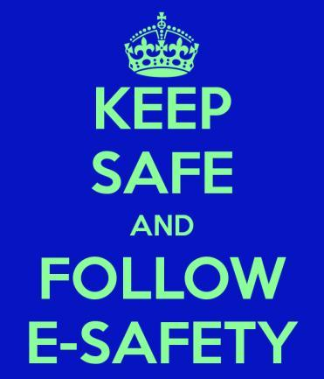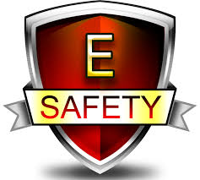

SMART

S=Safe, staying safe online and not looking at anything you shouldn’t look at.

M=Meet, don’t meet anyone that you don’t know ort have just met they could be lying with everything they have said in an email.

A=Accept, don’t except anything you are sent by a user that you don’t know, you should only friend people that you know.

R=Reliable, people like your mum/dad relies on you to be safe online and not to get into any trouble.

T=Tell, if somebody sends you something you don’t like then you should report them or tell on them, if you do this you will know to keep it on privacy settings.

E-SAFETY is all about being safe on the internet, by not talking to strangers and opening emails or texts that you don’t know who it’s from. If somebody text you something mean you should report them to your mum/dad. This could stop them from doing it again.

If you think that your pictures are only being seen by your friends you are wrong, without privacy settings on you are in danger of strangers seeing your face and finding out where you live, this could be bad for you. Many people could see your pictures and lie about their age and where they live!!!

**E-SAFETY**