**Art: To produce war art including propaganda posters**

**Music**

**The children will begin weekly clarinet lessons.**

**Computing:**

**Data bases using war time statistics**

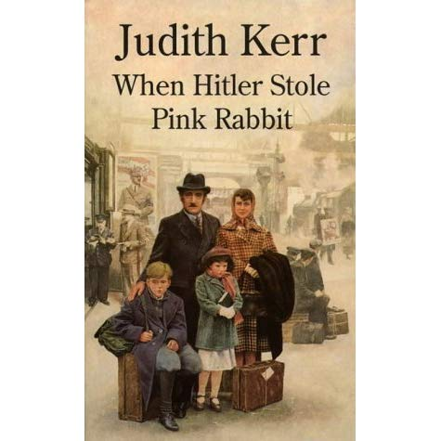

**PE:**

**The children will have a weekly swimming lesson and will have outdoor sessions of rounders.**

**Maths:**

**The children will to use the No Problem maths scheme. This term children will be working on reading and Writing and comparing numbers to 100 000, rounding and making number patterns and adding and subtracting using numbers to 1000000**

**PSHE: To understand how our actions affect ourselves and others.**

**To empathise with people in this country whose lives are different to their own.**

**DT Design, make own model gas mask, evaluating the final product.**

**French: The children will revise vocabulary from the previous term and will learn the vocabulary of food and drink to use in scenarios involving a café.**

**Science:**

**Materials**

**To recognise simple properties of materials, such as strength, flexibility, transparency.**

**To understand that materials are suitable for making a particular object because of their properties**

**History:**

**The children will learn about WW2 Timeline of events. Refugees Propaganda Focus on famous people and events Damn busters, Douglas Bader, Oscar Shindler, Irena Sendler**

**English:**

**The children will write a manifesto to explain their intentions if voted onto the student council.**

**They will use the features of debate to write a discussion text on whether children should be seen and not heard.**

**They will also write a diary entry as a character from the story.**

**RE: Hinduism The theme of prayer**

**Key Question: What is the best way for a Hindu to show commitment to God?**

**Geography**

**Locate the countries involved in WW2. Identify features on aerial photographs as if you were a pilot.**