Ashton Prime News

Second

Edition

Word

search

Assemblies

Trips

Christmas events

Movie

Night

Bikeability

Digit

Maker

SNAG/

Student Council

Report

Children in Need

Bikeabilty

This term ks2 have been learning about bike safety, they rode on their bikes for an hour for two days a week over three weeks and they also practiced how to ride on the road. The teachers who taught them were very nice and patient.

The most important thing they taught us was signalling at T junctions.

We would recommend that you take the chance to do this course if you can.

By Harry and Ruben

SNAG **By Lola and Ted**

In the SNAG group (school nutrition action group) we help the school health. In our last SNAG meeting we talked about how much veg and fruit our school eats every day and how we can improve on that. These are our ideas:

* Lola thought about every table has two members of SNAG on them to see how much veg children are eating.
* Ted thought about weighing the bins after lunchtime to see how much veg is there.
* Keira thought about asking the dinner ladies how much veg they give to each pupil to see how much veg they give children.
* Adrianna thought of giving a raffle ticket to anybody who eats all of their vegetables to see who gets pulled out and gets a prize.

Other members of SNAG are still thinking of good ideas. WE LOVE SNAG. 

**Digit** **makers** **Year 5**

On Wednesday the 16th of November a man called Ed came in to year 5 from the University of Bristol. And some helpers came in too who were really nice and they told us how to make space invaders on a Micro bit. Ed took us through it step by step.

It was really hard at one point and we didn’t finish it. However, at the end we played on the one that Ed made which was great fun. Space invaders are a classic game and rare to find in the game store it has a defender and the invaders who try to shoot you and you shoot. Kingfisher wants to give you and your team special thanks. The star rating is 5/5.

By Lucas and Louie

REMEMBRANCE DAY

By

Henry and Kenzie

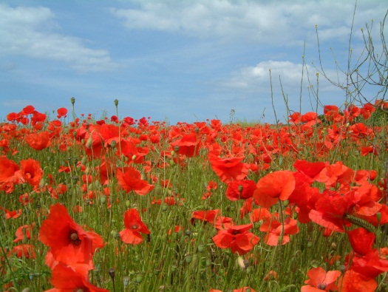



The date of Remembrance is 11th November It is a time where you think about all the soldiers and people that died

Remembrance is a time to remember the people who have died in conflict.

On the 9.11.16 our class Kingfisher gave an assembly for the school all about remembrance day. First we read some facts about the war. Kiera brought in a poem that her great granddad, who was in the war, wrote. We also showed his medals. Next we mimed a play which showed a young couple starting out in life and the man goes off to war and then he is killed. Then we sang a song about changing the world.

We also put up a display so that the audience could write messages of hope.

If you would like to see the play? Go to our face book page.

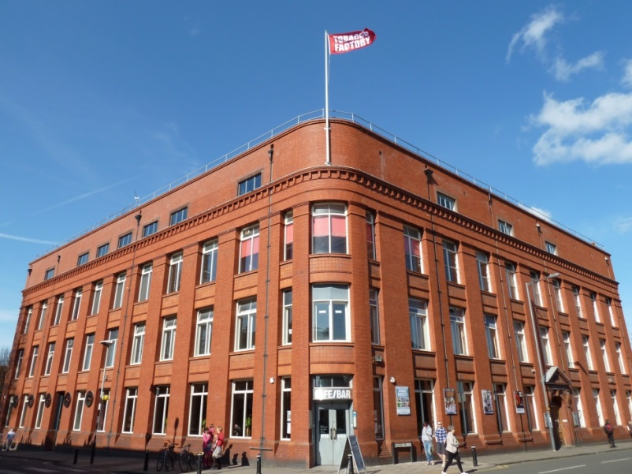Tobacco Factory

Reception

This term Reception went to the Tobacco factory and saw Little Tim.

All the children we met liked it they said ‘’10/10 experience. They liked it very much and would like to see it again.

We think this was a good experience for them because they can imagine that they will be Tim one day.

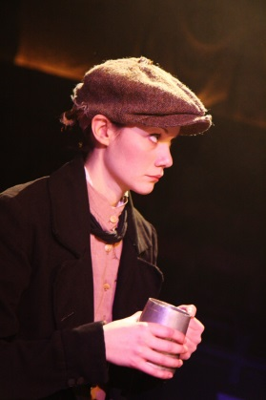It was a good idea because it was live action so they believed it. Maisie said ‘’I liked all of it. ‘’ But Kyle said ‘’I liked it when she dropped the fish out the boat.’’ They said it was about Tim and the Pirate and they also said ‘’Tim was a girl.’’ and that Tim wanted to be a sea captain.

Bella said that her favourite bit was the rainbow beard with bubbles.

By Ruby Chao and Lexi Liddell

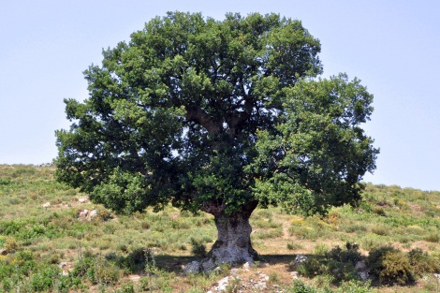**TREES**

**by Jena and Keira**

Introduction

A man called John came into Yr5 Kingfisher class to talk to us about trees. What he did first, is tell us why he was here.

Types of trees

There are all different kinds of tree here are the most common trees and here are some of them Oak, Blossom and Maple but there are many more trees.

Outside

When we went outside John asked Ruby G to stand by the Oak tree ( our school logo ) and we had to count how tall the Oak tree was by counting how many Ruby’s there was by using our index finger and our thumb from about 5 metres away. We all had different ideas and then we added them all together and found an average.

GAME TIME

After that John kindly let us play a game called find your family pack there were 4 different types of birds there were 2 types of pigeons and we forgot the other two names of the birds. All had a bird call and we had to go round saying them and finding our class mates with the same as us.

**Movie Night**

**by Ethan & Amy**

**The film was The Polar Express on 1st of December 2016**

**The children loved it, it was fun and enjoyable it’s a great family friendly film. I think that many people will love it as much as we did :)**

**An all age’s film it’s an intense one too. Myself and Amy recommend you go watch- it’s an amazing film.**

**It’s all about a boy who goes on a train called the Polar Express and ends up meeting loads of new friends and has a heart-warming ending.**

**See if you can spot some famous actors doing the voices of the main people in the story.**

**Thanks for reading hope you watch it from Ethan & Amy**

**5\5 star rating from Me & Amy**

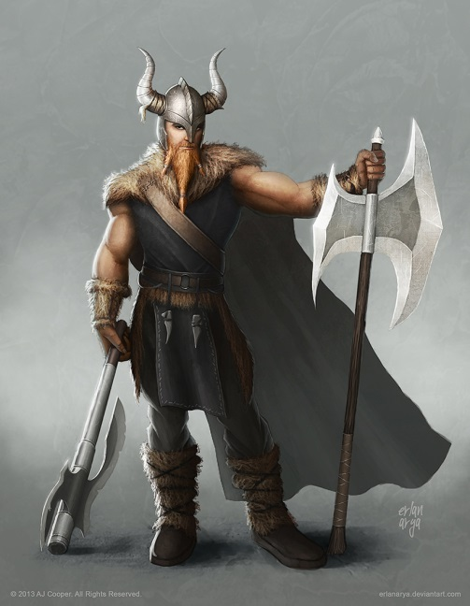YEAR 4 VIKING VISIT!

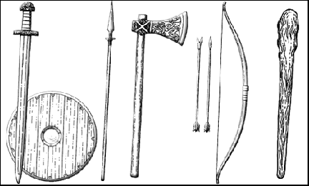

Some Vikings don’t have horned helmets but some do

This term, the year 4 class spent the day with a Viking warrior.

The year 4 also played a game with the Viking it is called king’s table, it’s a game where you have to try and capture the other player’s king with your pieces whilst the other player tries to capture your king!

They also did a play, there was a funeral in it and the Viking spilt water on someone’s face.

They had fun doing the play.

The Viking had a lot of weapons such as spears, knives and other dangerous weapons as well as armour!

The Viking had some animal rugs and there were normal rugs as well.

They also made a fire out of flint and stone outside.

The year 4 had lots of fun doing this all. It was also educational.

Thank you for reading.

By Katie and Mason

**Student council**

We are supporting these charities;

Young Epilepsy and Water Aid, all the donations from Christmas will go between these charities, hurry and donate now and either help someone with epilepsy or save a person’s life with clean water. 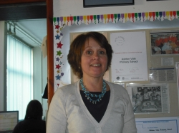

**BY CIARAN AND DAISY**

Y C-IARA

By Daisy and Ciaran



WE NEED A NEW HEAD TEACHER

Mrs Champeney is retiring. We need a new one, us and the governors are on the hunt we will miss her a lot.

**CHILDREN IN NEED**

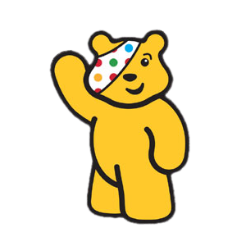

The cartoon bear has been around for ages

If you were wondering our school raised the final

amount of £ 364.43 a lot

To raise money we dressed up in bright closes and stripes

To make as much money as we could

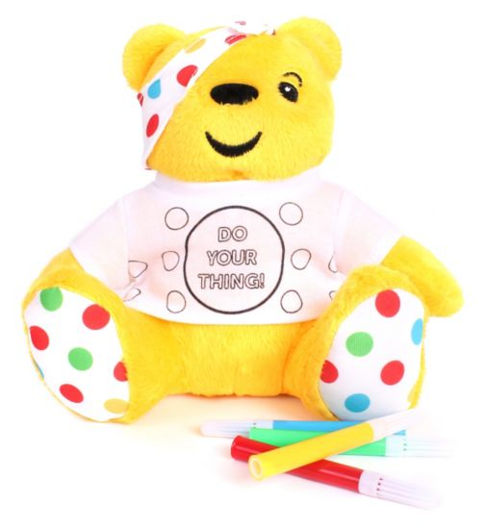We also bought wristbands, bracelets and Pudsey head bands.

As it says on his t-shirt

DO YOUR THING TO RAISE MONEY AND HELP.

***ATHLETICS By Kiera and Jena  
On the 8th December 2016 Yr5 and 6 had an athletics competition. Everyone had 4 events/races or more***

***TEAMWORK***

***We all worked as a team to do what we could. The most positive teamwork was cheering on others when it was their go, whether they found it difficult or easy .If we came last in the race it didn’t matter because, we might win the next one .***

***WHAT WE ENJOYED***

***All of our favourite parts of the competition were taking part. Unfortunately we did not get a medal. We all had fun thank you Mr Inskip and all of the parents that came and supported us.***

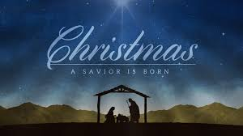Infant Performance**on thursday THE 8TH of december THE INFANTS performed their dress rehearsal for their NATIVITY WHICH they performed VERY PROFESSIONALLY for us.**

There were lots of characters ranging from sheep to wise men to angels, Mary, Joseph and of course the little baby Jesus. These parts were all played by stunning actors and actresses it was a performance that was not to be forgot. We would like to congratulate our infants on a fantastic performance!

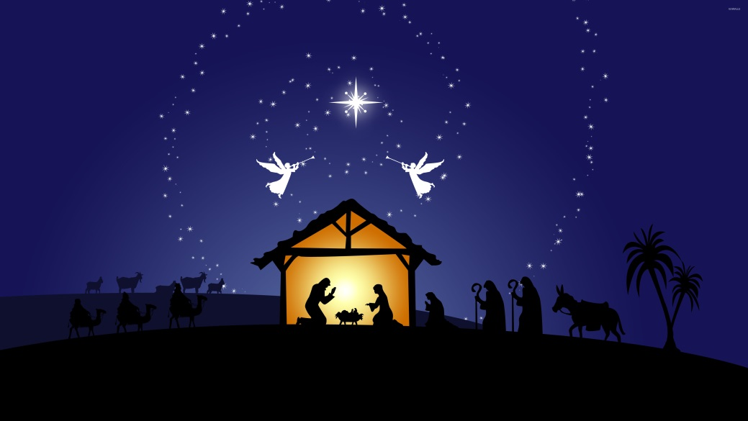

By Maddie

And Ruby G

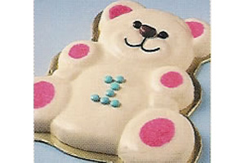Christmas Dinner

On Thursday the 8th of December we had our Christmas dinner We got crackers!

There was Christmas music on but we couldn’t hear it as we were having fun.

Pigs in blankets [sausages wrapped in bacon], chicken, peas, carrot, parsnips, brussels sprouts and roast potatoes.

We found it really delicious and for pudding teddy bear ice cream mmm.

MERRY CHRISTMAS AND A HAPPY NEW YEAR

By Evie and Roxy

**Christmas Fair**



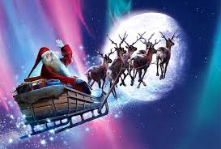

On Saturday the 3rd of December 2016 there was a Christmas fair at Ashton Vale Primary School, organised by the PTA. There were lots of activities to do ranging from Arts and Crafts, Tombola, Santa’s Grotto and even more fun activities.

There were different kinds of arts and crafts, Painting, scratch art, drawing and more. On scratch art you had a decoration and you had to have a stick and scratch it, then coloured it, it was so much fun.

At Santa’s Grotto there was a waiting area and it was really pretty with the tinsel and other decorations Santa asked how old we were our name and what we want for Christmas.

In total at the Christmas fair we raised £1.189

A big thank you to the PTA for organising the Christmas Fair.

By Gemma and Freya!

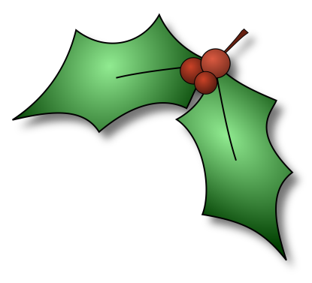Christmas Word Search

|  |  |  |  |  |  |  |  |  |  |  |  |  |
| --- | --- | --- | --- | --- | --- | --- | --- | --- | --- | --- | --- | --- |
| K | O | P | D | G | W | T | F | F | S | F | L | E |
| H | F | S | J | Y | M | K | M | R | L | P | Z | X |
| F | O | Q | E | S | N | H | Y | V | C | R | I | K |
| H | J | L | H | A | P | P | O | E | A | S | I | I |
| T | G | P | L | N | M | T | W | Z | X | V | B | I |
| G | H | S | J | Y | K | D | J | H | L | E | C | R |
| V | F | N | K | G | Y | P | I | O | P | J | X | J |
| L | G | O | C | P | K | N | T | B | M | H | H | H |
| V | H | W | O | Q | L | I | O | F | S | J | Y | X |
| Y | C | M | P | O | G | Y | T | A | H | N | J | F |
| X | F | A | W | E | H | M | V | P | H | P | F | V |
| S | Z | N | O | U | M | K | R | P | A | Q | W | R |
| P | C | P | F | P | H | E | P | F | T | P | R | S |
| D | V | I | V | L | S | N | B | A | S | O | G | A |
| U | G | H | E | E | K | H | K | B | O | G | I | M |
| F | K | D | N | X | H | L | K | P | R | V | G | T |
| V | Q | T | N | X | Z | J | N | R | F | P | Z | S |
| P | S | O | J | N | E | R | N | I | K | H | N | I |
| O | F | L | A | K | E | S | X | W | C | M | L | R |
| S | C | V | M | I | H | G | H | K | A | H | P | H |
| Y | B | O | F | P | F | A | P | H | J | B | X | C |

SNOWMAN HOLLY ELFS FLAKES JACKFROST PRESENTS CHRISTMAS

YR5 Chess Day

By Ben and Shay

When we got there we watched grand masters and a film then they asked some people to come up on to the stage to play a game of chess from our class Ben Clark went up to play and he won. Then we went to have our lunch later we played a tournament against other schools.

We met at the Colston Hall at 7.00 in the morning. We left the Colston Hall at half past seven in the morning to get to London. 

On Tuesday 13th Ashton Vale Primary School went on a chess day . 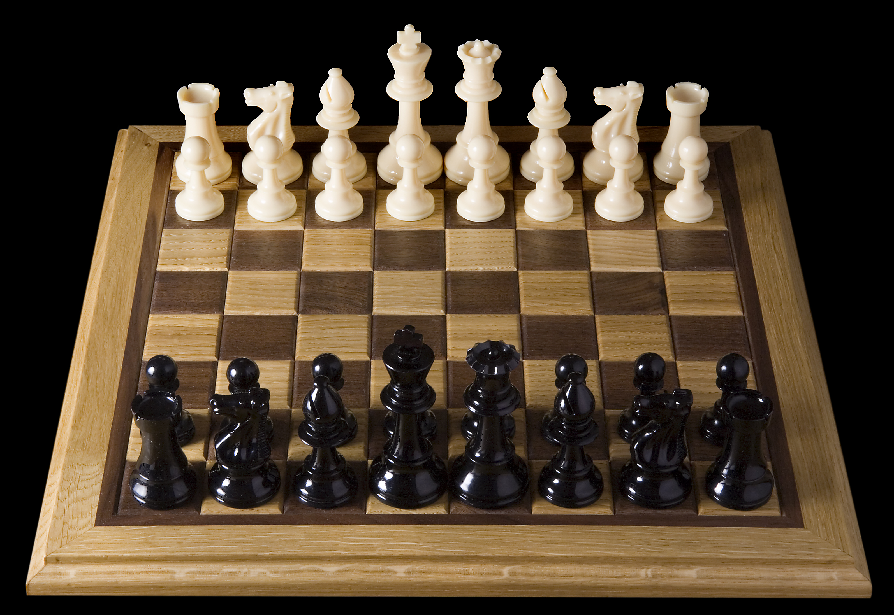

C:\Program Files\Microsoft Office\MEDIA\CAGCAT10\j0183290.wmf

A little later y4 sang Rockin around the Christmas tree they did very well.

There was so much more with several songs and dances.

Thank you for coming to watch we had a great time.

BY FALLON AND HENRY

Roxy, Gemma and Freya gave us a Christmas poem using clear voices.

Two acts later y6 did what Christmas means to me they were EXTREMLY GOOD.

Falcon Class did an excellent A-Z with great photos.

Y3 danced to crazy Christmas it was soooooooo funny they were very good.

Crow Class gave us a very funny version of 12 Days of Christmas

After that it was the year 4 playing Come And See on the recorders. Again a superb performance.

Just after the recorders Y6 did Twas the Night before Christmas poem it was AMAZING

..Next it was Ewan on his clarinet also taught by Mrs Sheard and he played a superb God Rest Ye Merry Gentlemen.

At the start Y5 [kingfisher class] played their clarinets, they were taught by musician Mrs Sheard, they played Jingle bells and Good King Wenceslas. Mrs Wigginton was in awe of how well we played as we have only been learning the clarinet since September

**Christmas cabaret**