Savoury Rice

Ingredients
Long Grain Rice cooked 200g
Onions diced 50 g
Peppers diced 50g
Sweet corn 50g
Peas Frozen 50g
Turmeric for colour 1 tsp
Method
- Put the rice, peppers, sweet corn and peas into a bowl and mix in the turmeric
- Put in the steamer and cook for 10 minutes until hot

Key Nutritional Points and Facts
- Rice is a source of carbohydrate, providing the body with energy.
- Using finely chopped vegetables within this rice dish is a great way to increase vegetable consumption. Red and orange peppers are great sources of vitamins A and C. Vitamin A is essential for healthy vision and vitamin C is great for healing wounds and aiding the absorption of iron.
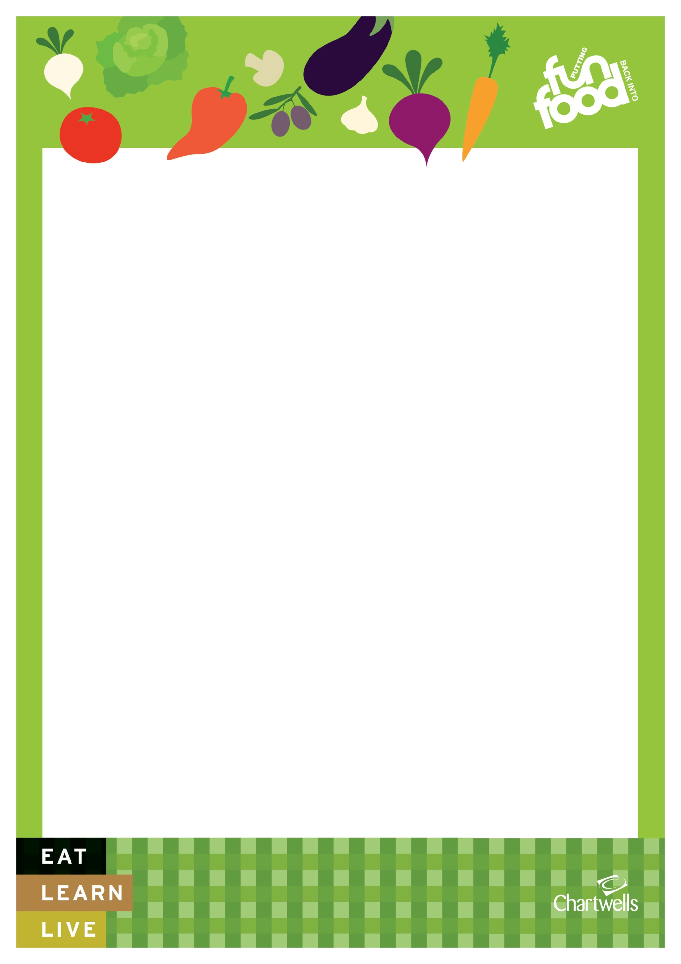
- Peas are an excellent source of iron – great for healthy blood.

