Literacy:
All writing will be based on the book ‘Floodland’.
Letter writing to different characters in the book.
Poetry
Role play/Hot seating activities
Story writing – Based on setting descriptions found in the story.
SPAG :
-Sentence/phrase/clause -Conjunctions
-Relative Clauses -Sentence types
-Adverbials -Apostrophes
-Modal Verbs -Subordinate
-Active and passive voice -Speech
-Subjunctive form -Parenthesis
-Complex sentences -Brackets

STAND ALONE FROM THE TOPIC:
R.E- Is anything ever eternal?
Music- The aim of this unit is to consolidate skills reading and notating rhythm through composition inspired by the idea of a train journey. They are introduced to a triplet rhythm.
PSHE- Dreams and goals - Personal learning goals, steps to success, making a difference, recognising achievements.

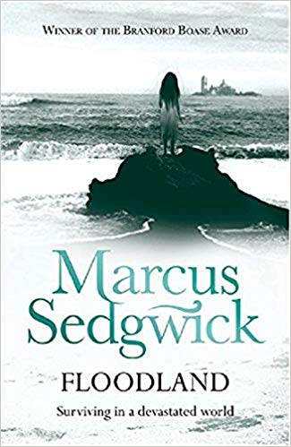
Science:
Evolution and Inheritance –
- Inheritance - I can explain the scientific concept of inheritance.
- Adaptation - I can demonstrate understanding of the scientific meaning of adaptation.
- Theory of Evolution - I can identify the key ideas of the theory of evolution.
- Evidence of evolution - I can identify evidence for evolution from fossil records.

Art:
- Bottle cap art work of fish
DT:
- Milk carton piggy bank
- Milk carton bird feeder
P.E:
Netball

Real P.E

Trips:
- Theatre trip – The Borrowers
- Walk to ‘Zero Waste’ on North Street.
- Bristol Waste coming in to school.
REDUCE. REUSE. RECYCLE.
HOW THE WORLD IS CHANGING.
Maths – Fractions
- Simplifying fractions
- Comparing and ordering fractions
- Adding and subtracting fractions
- Multiplying and dividing fractions

French:
My Town - we will learn key vocabulary to identify significant places in a town or French town.
Geography:
Changes in the environment
Changes in the oceans
Countries most effected by environmental problems
History:
Changes in plastic – what has changed? Why do people use plastic more now?

