Ashton Prime News
Third
Edition

Class special events
Sport
Report

New
Stadium
Tour

Tour
Internet
Safety

Crossword

Magic
Maths
Word search

ASHTON VALE YEAR 7
This term Year 5 had a teacher from year 7 come in to work on independence, to begin to prepare us for Year 7. Her name was Ms Berry. She taught us what it is like to be a year 7. Everybody liked her explanation. Ms Berry also gave us some work to see how close to Year 7 we already are! We all really enjoyed it! We also looked at how to make wise choices and had 20 challenges for independence which we are all working on.
Ms Berry was a very nice teacher and we all liked learning with her. It was a great time!

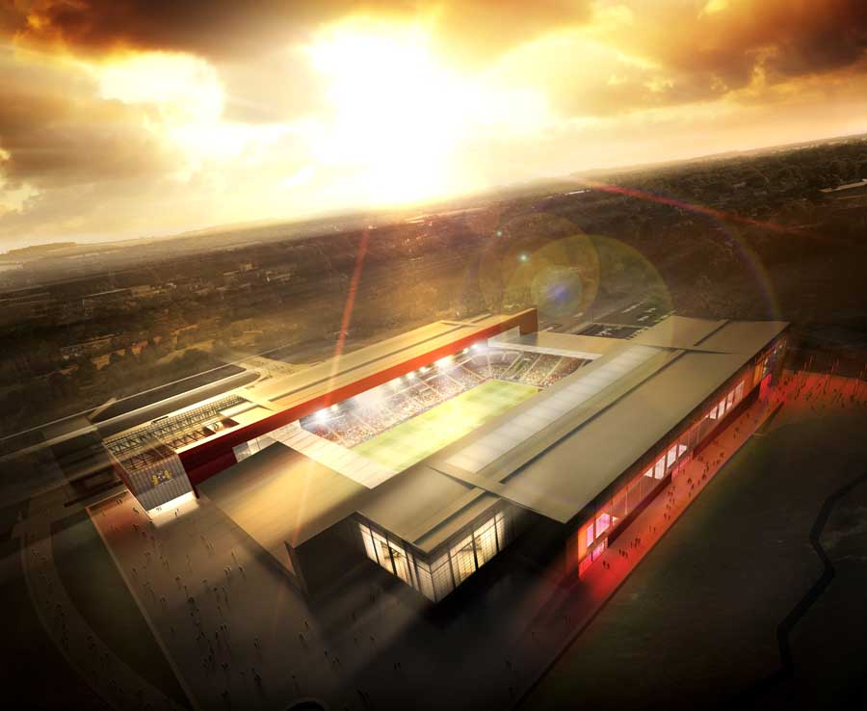
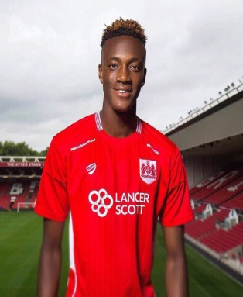
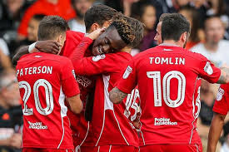
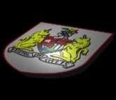 RECEPTION TOUR NEW ASHTON GATE STADIUM .

They had a great time.
By Henry and Daisy

Reception went on a trip to the new Ashton Gate Stadium for a tour. They walked from school to the new Ashton Gate Stadium, then they met their tour guide Lilly and off they went for their hour visit.
First they went to the training ground and saw the exercise bikes and artificial grass that the players use to train on.
The ratings from Charlie and Ava looked really good here is what they said [really really really good ] said Charlie Ava said [really good.]

On Wednesday reception went to the Bristol city ground for a tour. First they met a lady called Lily she took them to the bar where they sat down to have a drink .
Then they went to the training area . They then saw the exercise bikes and artificial grass. After that changing rooms then they went and sat on the benches and were sat under the players pegs.
After they finished they went to visit the showers, they noticed it wasn’t a normal shower it was a massive area. Then they went to the terrace and looked at the pitch.
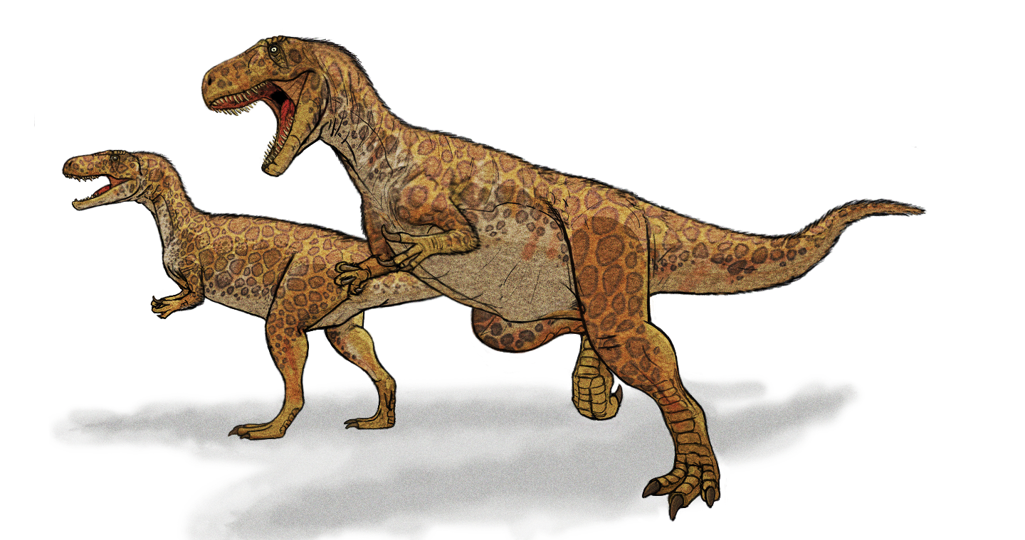
Dinosaur Word Search

BY Fallon Sanders and Ethan Maule

Trex Jurassic eggs carnivore omnivore herbivore spinosaurous
A | K | G | H | D | K | C | A | R | N | I | V | O | R | E | D | D | O | V | S
C | R | M | N | S | I | X | M | D | A | B | A | V | C | N | A | P | G | D | N
G | B | R | N | O | S | F | H | F | O | U | P | H | J | D | I | S | P | H | P
H | E | R | B | I | V | O | R | E | Z | N | H | H | N | E | G | G | F | J | N
G | U | T | R | E | X | G | U | H | S | J | K | O | M | N | I | V | O | R | E
H | U | I | A | E | K | T | U | p | L | L | G | I | S | I | G | O | P | F | O
L | O | L | P | I | U | T | J | J | N | T | Y | Z | H | J | O | J | Z | M | L
D | U | M | H | K | N | J | H | O | H | Y | O | B | J | K | O | J | H | J | H
E | G | F | E | K | H | J | U | R | A | S | S | I | C | D | H | F | D | L | H
B | D | S | H | J | U | U | G | F | I | K | D | Y | E | Y | Y | M | V | V | N
F | X | P | N | G | H | M | R | G | G | G | J | D | R | A | S | F | D | U | D
T | H | I | K | B | B | U | R | F | Y | M | I | F | H | U | O | J | K | S | G
U | F | N | J | H | N | O | H | B | I | N | J | J | O | K | F | K | Q | P | H
K | J | O | H | T | K | I | K | I | J | K | P | I | J | D | O | J | T | J | H
T | D | S | G | U | K | I | U | S | G | G | E | G | T | H | Y | O | B | H | L
S | L | A | J | J | D | U | U | J | J | N | G | J | B | I | O | F | J | J | H
Z | H | U | G | F | G | I | H | J | J | K | O | I | U | J | J | H | K | J | 0
V | H | R | G | D | H | K | X | K | K | J | E | R | O | V | I | B | R | E | H
K | O | O | L | J | Y | G | F | M | E | N | I | H | J | E | M | I | M | K | K
M | R | U | F | Y | I | O | B | K | I | J | J | J | H | F | J | J | O | B | H
U | U | S | J | H | I | J | 0 | H | G | R | J | A | E | I | H | H | D | H | I,

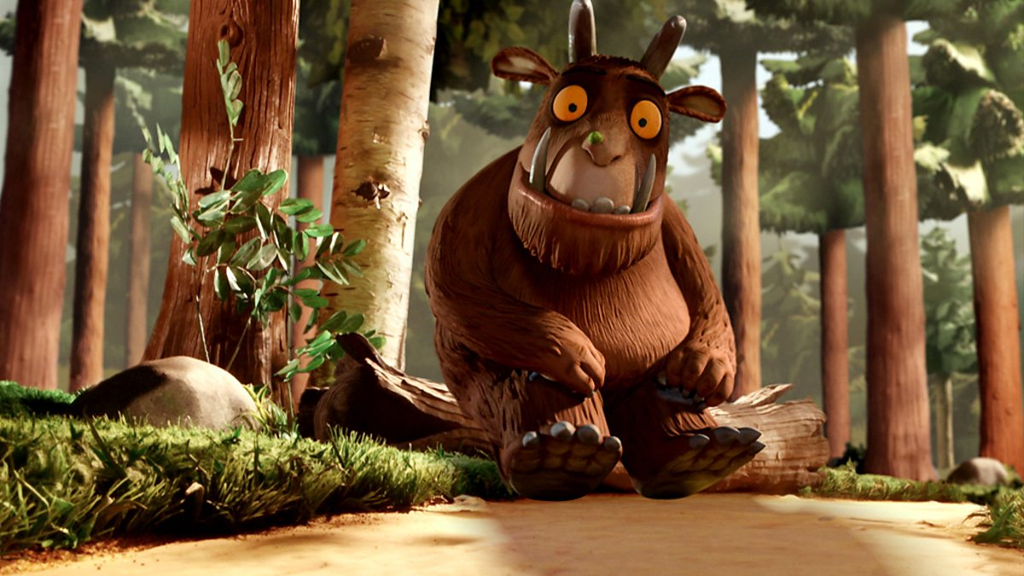
Gruffalo Hunting

Year 1 visited Ashton Court this term to go Gruffalo hunting.
The children rolled down the hill with excitement, and even the class teacher Mr Inskip rolled down with them.
●●●
Year 1. Said that they had to wrap up warm, because it was very cold.
●●●

When Year 1 came back and saw the photos they saw THE GRUFFALO, Year 1 quotes were,
“It was so much FUN!”
“I LOVED it”
They had many more quotes.
When year 1 were on the way they saw snake trails, And Gruffalo feet that were humungous they also saw Fur, Gruffalo fur!
The whole class said that they got stuck in mud and some lost their wellies.
●●●

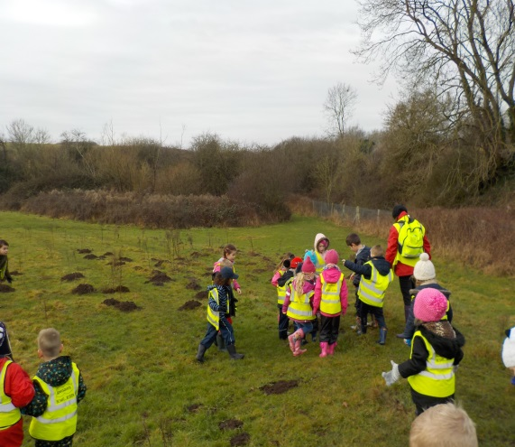
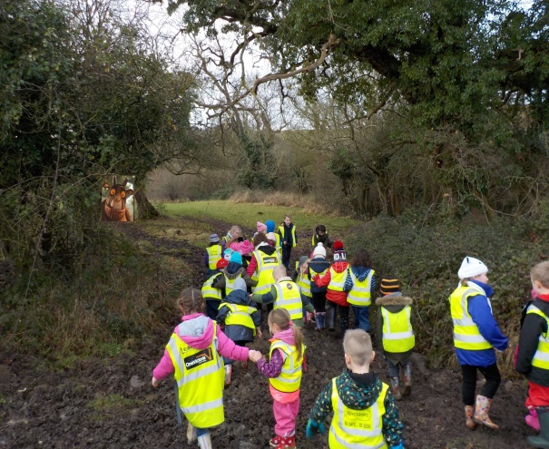

INTERNET SAFETY
we interveiwed
If an advertisment comes up on your screen then ignore it and get a trustworthy adult.
the year 6 on
internet safety.
They told us
To before you
Click, click, click you need to think, think, think, and tell someone!

By Maddie
and
Ruby G

If someone sends you a message or image don’t click on it, tell an adult. You could get internet security or adult supervision,
At the en of the parade there was a firework display.

LANTERN PARADE
Year 6 and 1 originally thought they were going to the lantern parade in December but it was called off because of the weather, so they did it in January.
The year 6 and 1 made
Lanterns with Alan and Mark.
The weather was so much better and many people turned up to watch the parade. The lanterns were spectacular.
Search Bedminster Lantern parade for pictures

They rated it 10/10.

At the end of the parade there was a firework display.

thank you for reading. By Lexi l and Ruby c.

Science Week
Mary Anning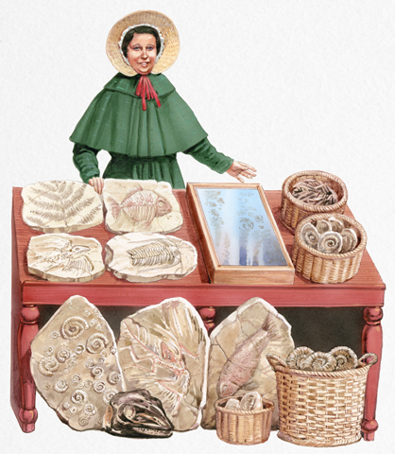
Dinosaurs
For homework Year 2 had to make anything with the theme of dinosaurs.
We asked them some questions about what they made, it was very interesting because we had great answers.
Why did you make them?
They made them because it was dinosaurs week, also because they were learning about Dinosaurs . They made it with their family, some made them at school.

Mary Aning
Who was she?
She was famous fossil hunter .She started hunting at the age of 7 or 8.
Why did she do it?
She lived by the sea and she was very poor. So she found Fossil`s at the Beach, so she sold them for 1 pence.
How many years ago?
She started over 200 years ago, and lived until her 40`s.

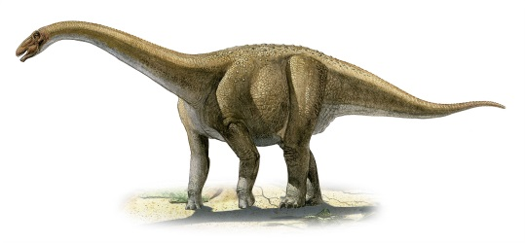How did dinosaurs’ become extinct?
Dinosaurs might have become extinct by an Asteroid that made a volcano erupt .
They might have become extinct because of disease.
There are other possible reasons.
What do you think it is?

Mrs Baxter organised two activities for us.
Scientists from the University came in to show us some amazing fossils.
We also had sand boxes so that we could excavate our own fossils. We learnt how archaeologists have to be very careful not to damage fossils they find.
Thankyou Mrs Baxter.

Sport Report
Another big one is YR2 dance, Barnaby Bear goes round the world and also girls football run by Bristol City on a Friday.
A busy term just past for Ashton Vale Primary and an even busier one coming up.
Coming up is YR3 and 4 football tournament and YR5 and 6 netball club and also YR6 have started playing badminton in P.E.
For the last 4 weeks YR5 and 6 have played in a football tournament at Merchants Academy.
This term we have been entered into multiple tournaments by Mr Inskip and Mr Burley.

TERRIFIC

SCIENTIFIC
JACOB AND KENZIE
List of ingredients
First you get a cup of blue dye then you dip the cotton bud in the dye, yourself or someone else will put the cotton dye with blue dye on and put it on your tongue. One other person will put the hole punch card on the persons tongue with blue dye and count the spots on it then you put it on a chart.

Super taster
With a percentage of 25% supertasters can taste really well.

- blue dye
- plastic cup
- cotton wool buds
- hole punch/card
- magnifying glass
- torch

The BBC have sent us a invitation to the terrific scientific experiment to do with taste, and Kingfisher class had so much fun and we would like to thank the BBC.

Non-taster
A percentage of about 25% Non-taster can taste not as well and will eat the majority of foods.
Taster
A high percentage of the population is a taster. Tasters are able to taste but not as good as a supertaster.

The New Head Teacher

The new head teacher is a man and he seems really nice and also very keen to meet us. His name is Mr Hollis. Mr Hollis is going to run a marathon. He will keep the school the same, but might change the playground. He likes sport
By Casey and Shay.

Mr Hollis is a deputy head at High Down Primary School.
He will be a very good head he will take assembly in the hall as always and if you have any problems he will be willing to help you out he is great.

tobacco factory by jena & katie
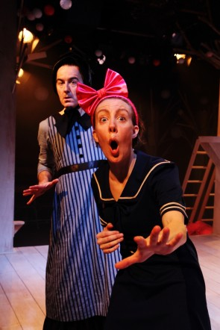
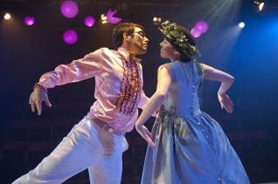
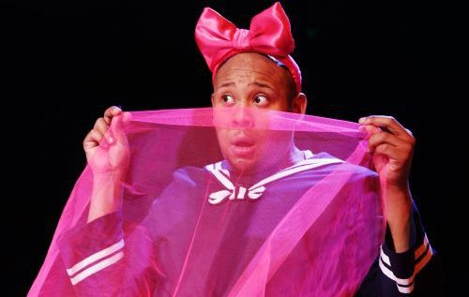
This term Yr1 to Yr6 went to watch Cinderella at the Tobacco Factory. We asked year 3 what they thought. AJ said it was funny and he liked the bird noises. He rated it 8/10. Harry said it was good when the stepsister kissed the prince, he rated it 8/10. Evie said it was good when the son dressed up in the pink dress, she rated it 7/10. Roma said it was funny when the stepmother dressed up, she rated it 10/10. Jena and Katie rated it 10/10. There were only 5 people that played all of the parts. They were very taslented. If you didn,t get to go you should ask your family to take you.

SCHOOL CROSSWORD
By Joyo Agbani
1
2 3 4

5 6
7

8

DOWN
1. A famous fairy tale in which a slave goes to a ball.
3. Reptiles that died around 65 million years ago.
7. 1/2, 1/3 and1/4 are all examples of________.
6. A bird-watching society.

4. The name of the school.

ACROSS
2. An act of watching birds.
5. Rugby, Football and basketball are all examples of_____.
8. Water vessels.

YEAR 6 BOATS
Year 6 built boats out of polystyrene to test over water. They used : batteries to power the motor , a motor to make the whole thing move in water , hot glue guns to stick all the materials together , propelers to make the boat move and last but not least wires to connect all of the electrics.

Luca and Archie’s boat was called WHITE FURY
Danny and Anna’s boat was called YO
Taegen and Katie’s boat was called RAPTOR
There were many more boats as well.
A man came in to show year 6 how to actually build these boats. His name was Mark and he is an engineer. Building the boats took 5-6 hours.
By Lola and Harry
THANK YOU FOR READING!!!!!!

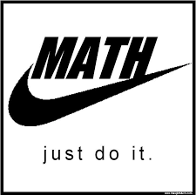
MAGIC MATH
Intro
In Yr5 we have doing fractions and the rating (keira) would give it ten out of ten and I (Amy) will give it a nine and a half out of nine and a half.
Lets start
So lets start with one and two quarters making it into an improper fraction. First we have to times one by four which is four and then add two onto four which makes six and then you have six quarters
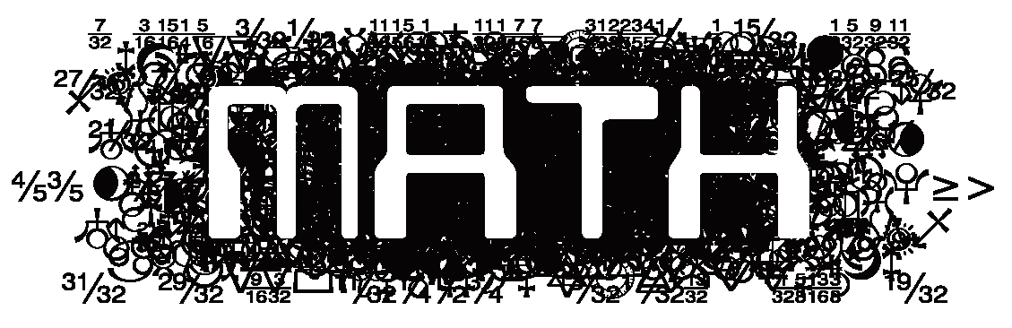
Lets do another one like seven quarters then we will make it into a mixed number. First you get seven quarters and divide seven by four which is one remainder three and the fraction will be one and three quarters.
By Keira and Amy

